Wall-mounted collection station adds hard disk simple operation documents
Tools
- flat blade screwdriver
- HDD screw ( including in the package of HDD, the part number is 193100335, SC-CUNC6-32×5 )
- HDD (Maximum : 6*8TB)
- HDD data cable ( Need to be ordered independently )
- The following shows the part number and quantity of SATA Cable would need ( marked with red colour)
  - For example: to add four more HDD, you will need to have to order additional
    - 1pcs 101511305, SATA cable, female to right angle female, 48cm, blue
    - 2pcs 101511304, SATA cable, female to right angle female, 31cm, blue
    - 1pcs 101500540, SATA cable, female to right angle female, 26.5cm, 30AWG, blue
    - 16pcs 193100335, SC-CUNC6-32×5 ( if the dock station is ordered before 30/06/2021)

 | 101511305, SATA cable, female to right angle female, 48cm, blue | 101511304, SATA cable, female to right angle female, 31cm, blue | 101500540, SATA cable, female to right angle female, 26.5cm, 30AWG, blue | 193100335, SC-CUNC6-32×5  the new devices ordered after 30/06/2021 will include this item
1 HDD ( default) | 1 | 0 | 0 | 4
2 HDD | 1 | 1 | 0 | 4+4
3 HDD | 1 | 1 | 1 | 4+8
4 HDD | 1+1 | 1 | 1 | 4+12
5 HDD | 1+1 | 2 | 1 | 4+16
6 HDD | 1+1 | 2 | 2 | 4+20

1.Remove the back cover
Remove the fixing screws of the back cover and take off the back cover;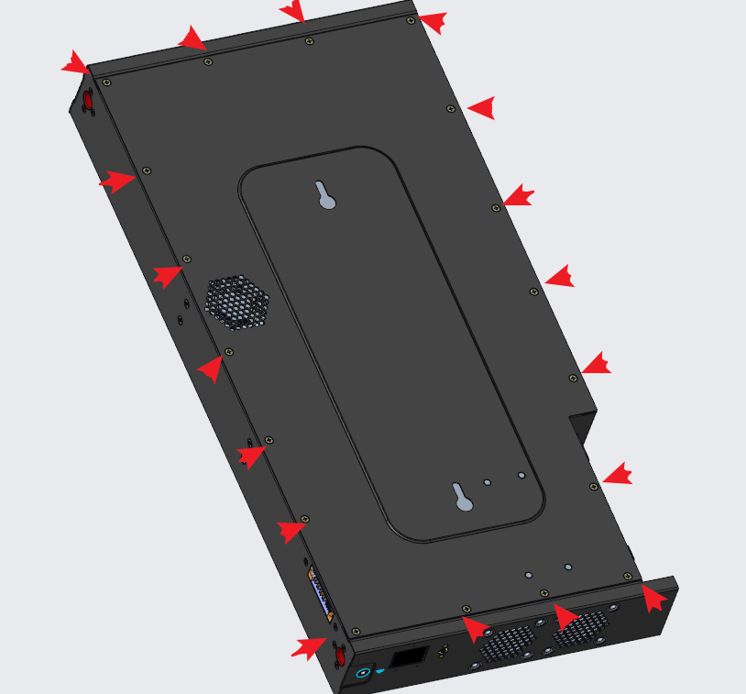

2.Remove the hard drive bracket
1. Remove the hard disk bracket and fix the 4 screws, push out the hard disk bracket in the direction of the arrow, and then remove the hard disk bracket;

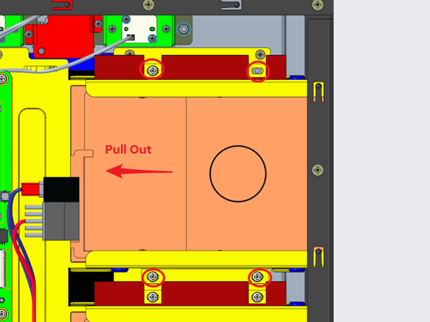

3. Fixed hard drive
Take out the hard disk, slide and push the hard disk in the direction of the arrow, and then fix the 4 hard disk fixing screws on the side;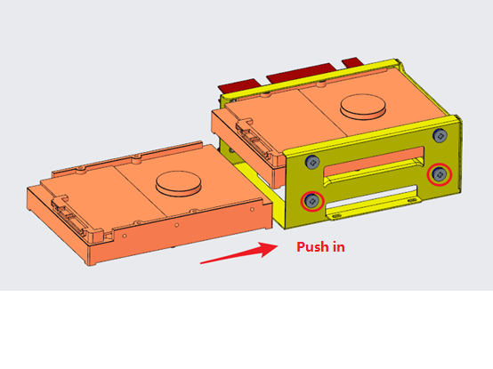

4.Install the hard drive bracket

Put the hard disk bracket assembly after installing the hard disk into the chassis rail bracket, push it in the direction of the arrow, and fix the 4 bracket fixing screws;
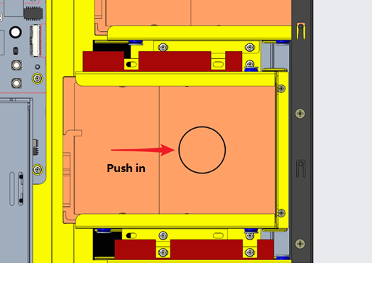
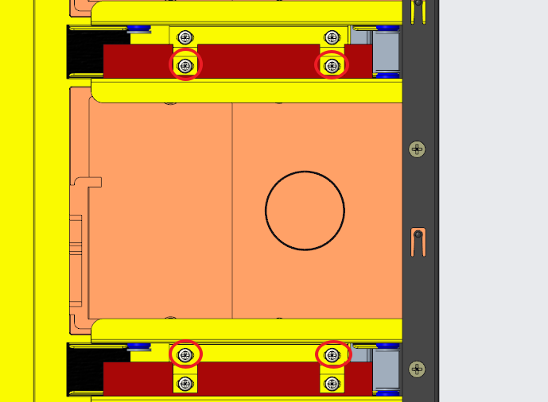

5. wiring
According to the silkscreen logo on the chassis and main board, select a data cable with a suitable length for wiring;
Note: The wiring here needs one-to-one correspondence, and the hard disk installation position priority: 1-up>2-up>3-up>1-down>2-down>3-down
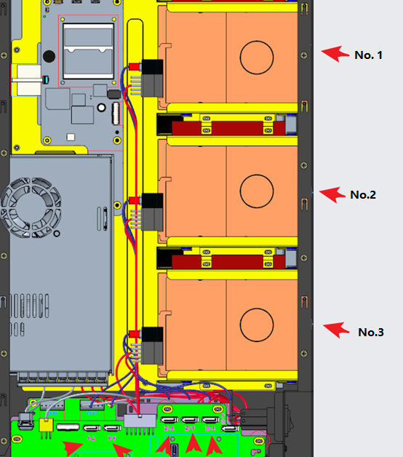

6.Lock the back cover
Finally, tighten the screws of the rear cover. It is recommended to tighten the screws in the following order 1-6, and then tighten them in sequence.
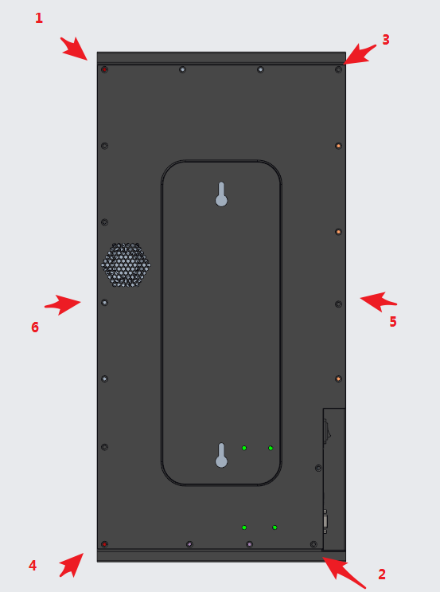

7. Low-level formatting
Login web interface，enable SSH service

Then open the putty

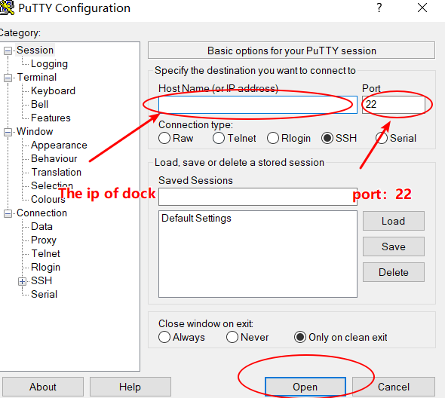

Login as: root
The password:the password of dock.
After logging in successfully, enter”t1 -o 9”

8. Format on the dock
Steps
1. Go to Configuration → Basic.
2. Select OK of Format Database.
3. Select OK in the popup window.

9. Check to see if the system is properly recognized

