Desktop collection station adds hard disk simple operation documents

Tool description:
- A Phillips screwdriver
- several hard drive fixing screws (included in the accessory kit)
  - Each HDD would need 4 pcs 193100335, SC-CUNC6-32×5
- hard drive ( Maximum : 4*8TB)
- hard drive data cable
  - Each HDD would need 1 pcs 101500632, SATA cable Female to female , 28cm

Steps

1. Turn on the device
Remove the fixing screws of the upper and lower shells (3 on the bottom on both sides + 2 on the top on the back), and lift the upper cover;
Note: There is a cable connection between the upper cover and the lower shell. Do not lift the upper cover too high to avoid damage to the device.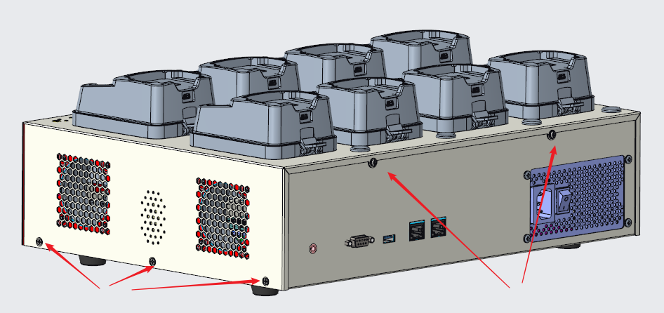
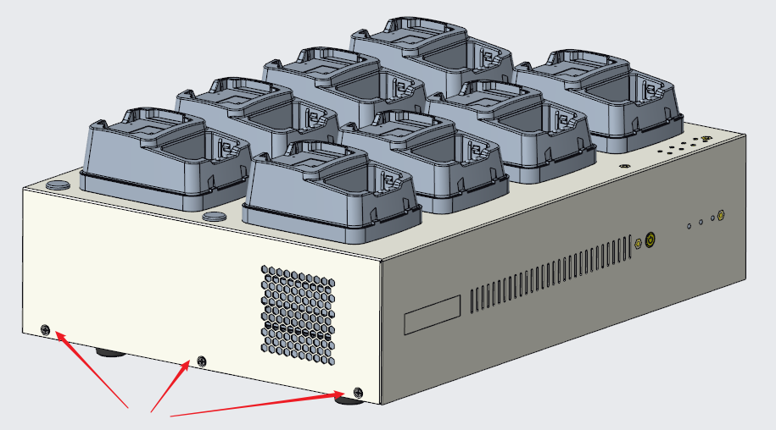

2. Remove the upper cover
There are 4 cables connected between the upper cover and the lower shell, unplug them one by one, and the upper cover and the lower shell are completely separated;
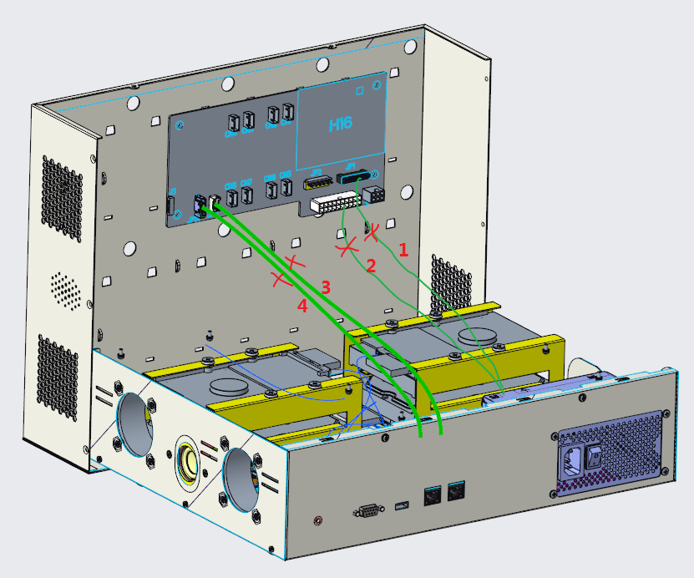

3. Remove the hard drive bracket
Remove the 4 screws fixing the hard disk bracket, disconnect the cable between the hard disk and the motherboard, and take out the hard disk bracket;

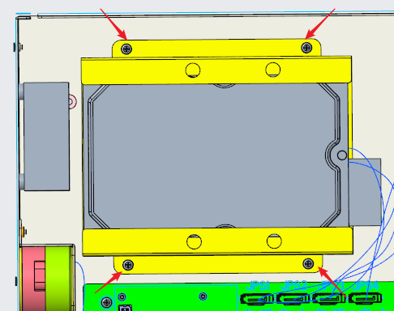

4. Install the hard disk
Take out the hard disk, slide and push in the hard disk in the direction of the arrow, and then fix the 4 hard disk fixing screws on the top or bottom surface (part number: 193100335);
Note: There must be a blue hard drive cushion on the hard drive bracket (part number: 190601079)

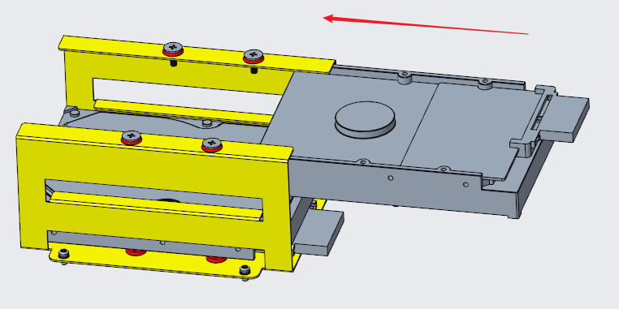

5.Install the hard drive bracket
Put the hard disk bracket assembly after installing the hard disk into the original position of the lower shell, and then fix the 4 bracket fixing screws;
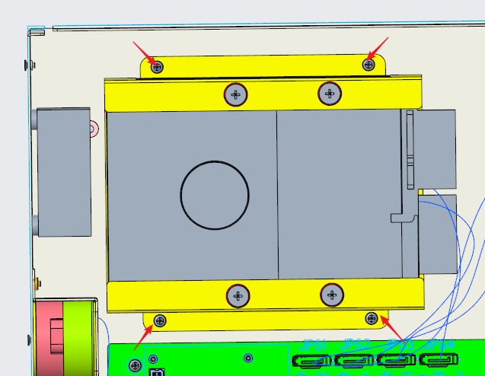

6.Wiring
According to the location of the hard disk and the silkscreen logo on the motherboard, select a data cable with a suitable length for wiring, and remove the connecting cable from the power harness to connect the hard disk to power supply;
Note: The wiring here needs one-to-one correspondence, and the hard disk installation position priority: right-up>right-down>left-up>left-down
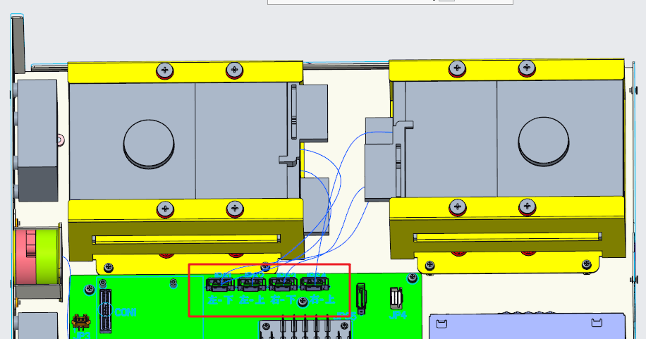
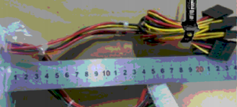
Power harness
Connect the 4 cables on the main board of the upper cover and the lower case, the positions are the same as the original ones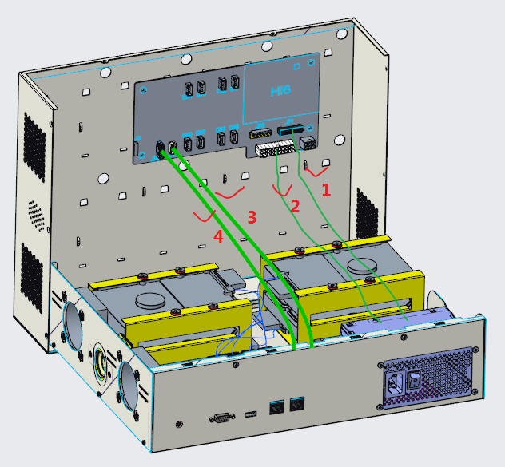

7. Install the upper cover
Cover the lower shell with the upper cover from top to bottom, pay attention to the wiring, and do not press the wires inside.
First fix the 3 screws on the bottom on both sides, and finally fix the 2 screws on the top of the back

8. Low-level formatting
Login web interface，enable SSH service

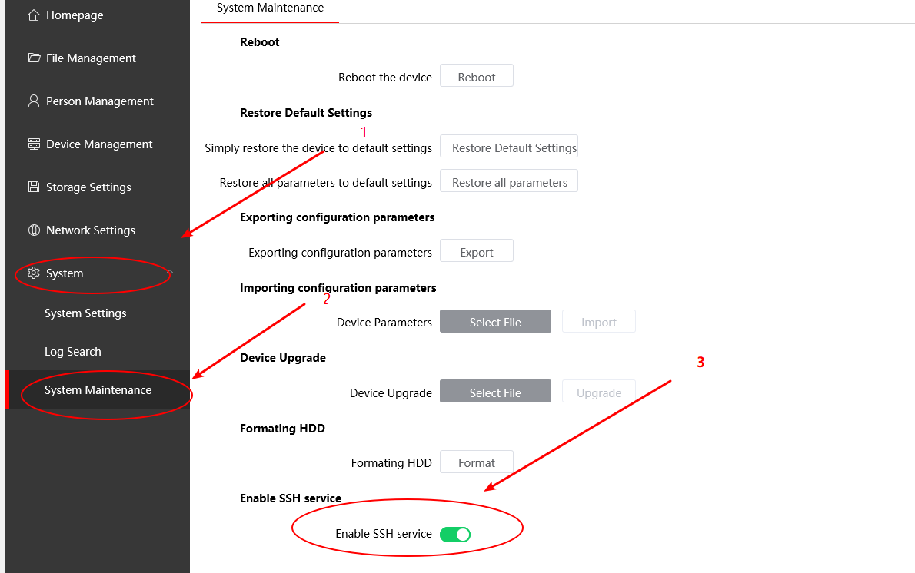

Then open the putty

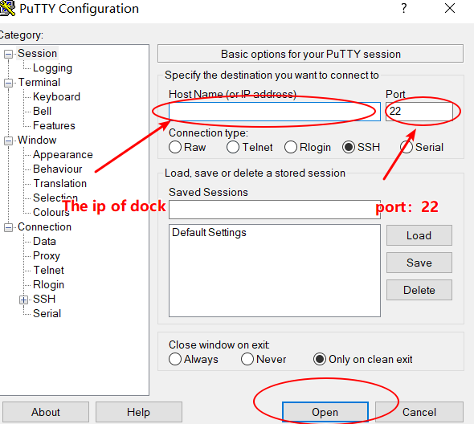

Login as: root
The password:the password of dock.
After logging in successfully, enter”t1 -o 4”
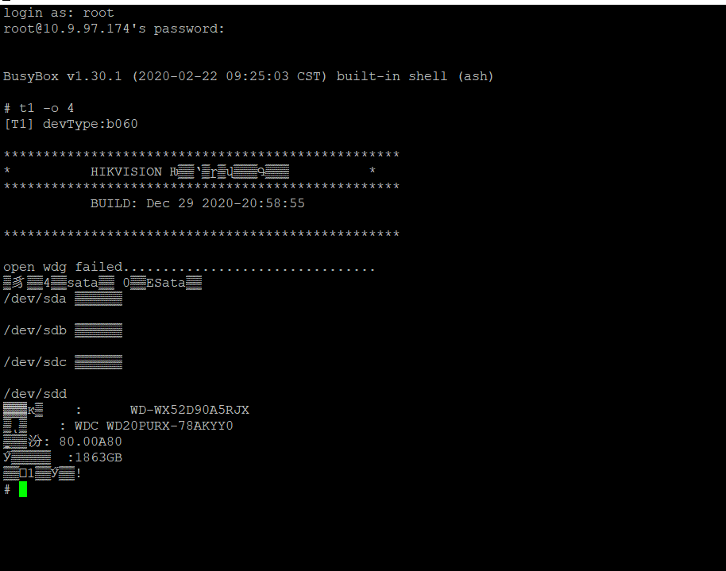

Then restart the dock

9. Format on the web
