Catalogue
Part 1: How to check device model and version? 2
Check device model type 2
Check device firmware version 2
Part 2: How to confirm that your device model is within the risk range and get the repair firmware? 5
Part 3: How to upgrade by Web Browser? 6
Part 4: How to upgrade by iVMS-4200 ? 8
Part 5: How to upgrade by USB in local GUI4.0 ?（Only for NVR） 11
Part 6: How to upgrade by USB in local E-UI ? （Only for NVR） 13
Part 7: How to Upgrade Device by Batch Configuration Tool ? 15
Part 8: How to upgrade online(from Hik-Connect server) ? 18
Method 1: Online upgrade by iVMS-4200 18
Method 2: Online upgrade by Local GUI (Only for NVR) 19
Method 3: Online upgrade by Web page (If there is an "online upgrade" interface) 21
Method 4: Online upgrade by Hik-Connect (If there is an "online upgrade" interface) 22
【Appendix】 Suggestions on upgrading ways 24

Part 1: How to check device model and version?

Check device model type
You can find device model type on the package label or the device label.
Take below picture as an example, the model type in below picture is
DS-2CD2347G2-LSU/SL (C)
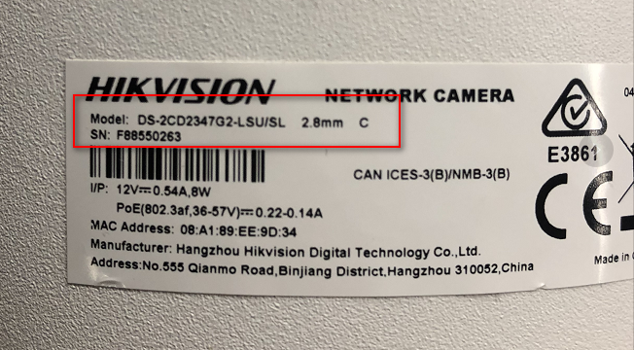

Check device firmware version
You can find device firmware version according to below methods.

Method 1: Find model type and firmware version on device local menu.

From NVR Local GUI:
GUI 4.0: Please enter device local Maintenance- System Info- Device Information to check device model and firmware version.
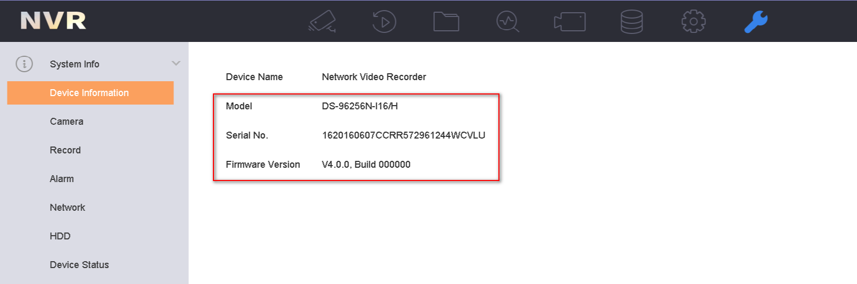
E-UI: Click Maintenance icon in upper right corner to check device model and firmware version.
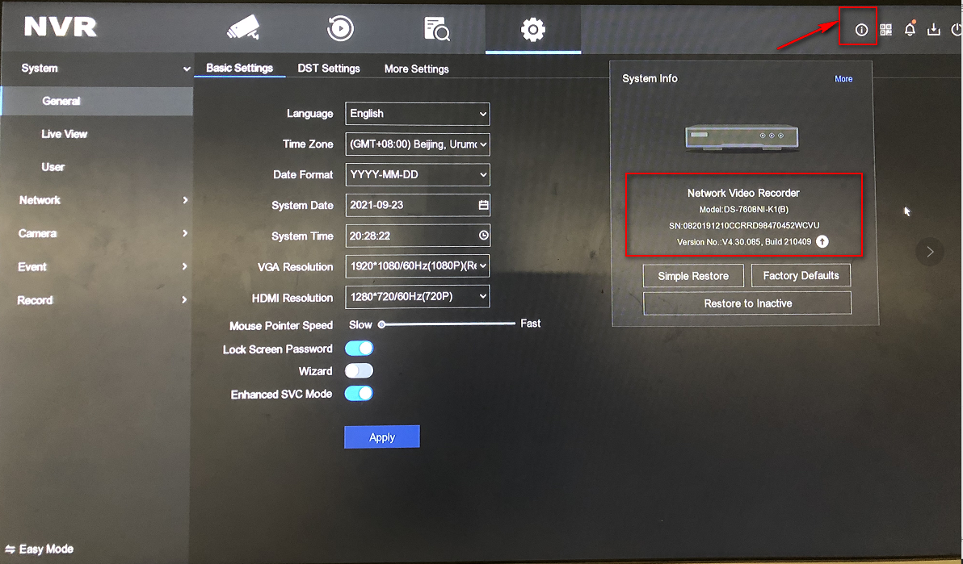
GUI 3.0: Please enter device local Menu- Maintenance- System Info- Device Info to check device model and firmware version.
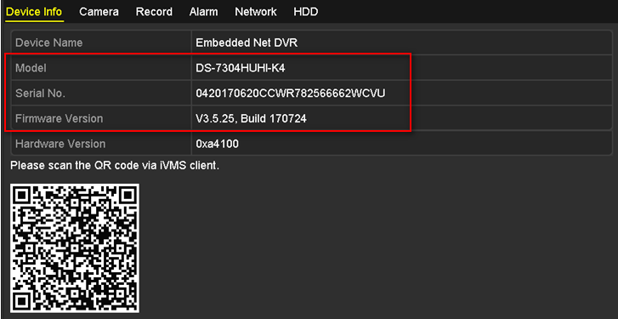

From web page (NVR/ IPC /PTZ):
Please login device via web browser, enter Configuration- System- System Settings to check device model and serial number.
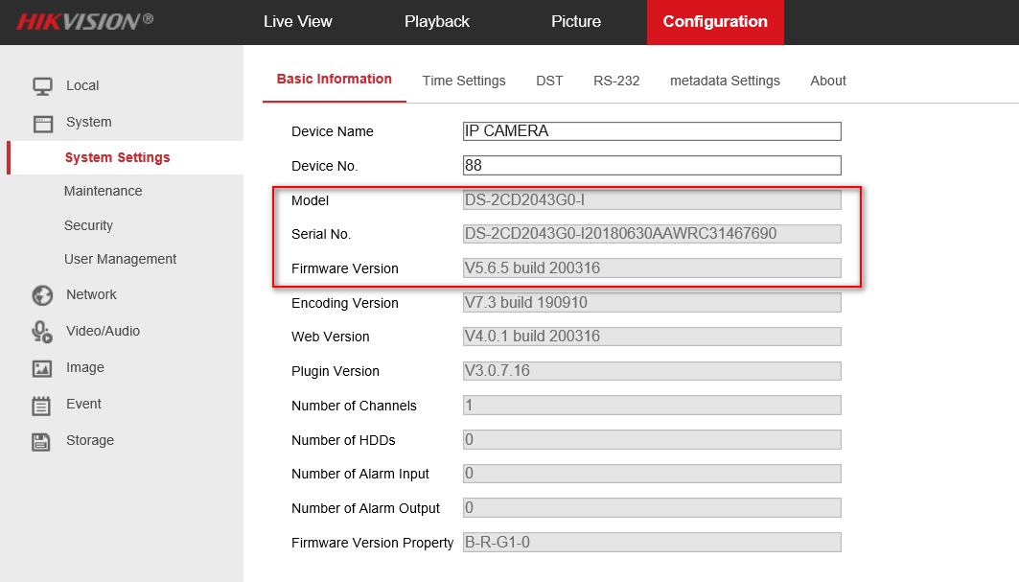

Method 3: Find firmware version with SADP tool.
- Follow the link to download the latest version of SADP tool on your computer.
https://www.hikvision.com/en/support/tools/hitools/TS20200826033/
- Use SADP software to automatically search active online devices in the same subnet with the PC running the software, and then select the required device to view its device type and software version.
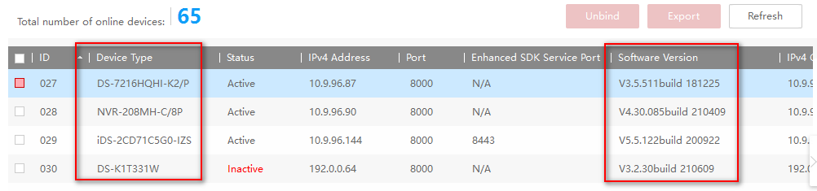

Part 2: How to confirm that your device model is within the risk range and get the repair firmware?
1. Please check the following notice to see the affected model range.
Link: https://www.hikvision.com/en/support/cybersecurity/security-advisory/security-notification-command-injection-vulnerability-in-some-hikvision-products/

2. You can try the following ways to obtain the corresponding repair firmware.
Mode 1: Please see the method of obtaining firmware in the notice.
https://www.hikvision.com/en/support/cybersecurity/security-advisory/security-notification-command-injection-vulnerability-in-some-hikvision-products/
Method 2: Please contact the technical support of HIKVISION.
Method 3: Please refer to HIKVION official website in the local country (in preparation for updating).

Part 3: How to upgrade by Web Browser?
- Enter the device IP address in the IE browser. Login by inputting username and password.
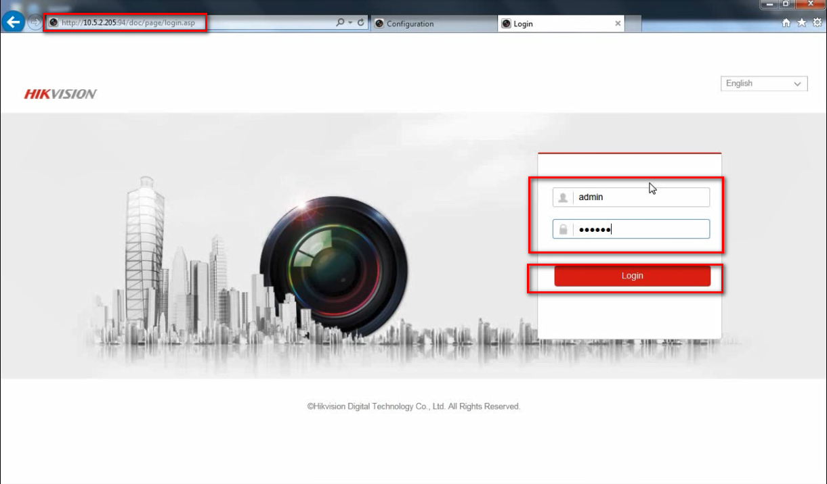

- Go to Configuration ->System -> Maintenance ->Upgrade & Maintenance.

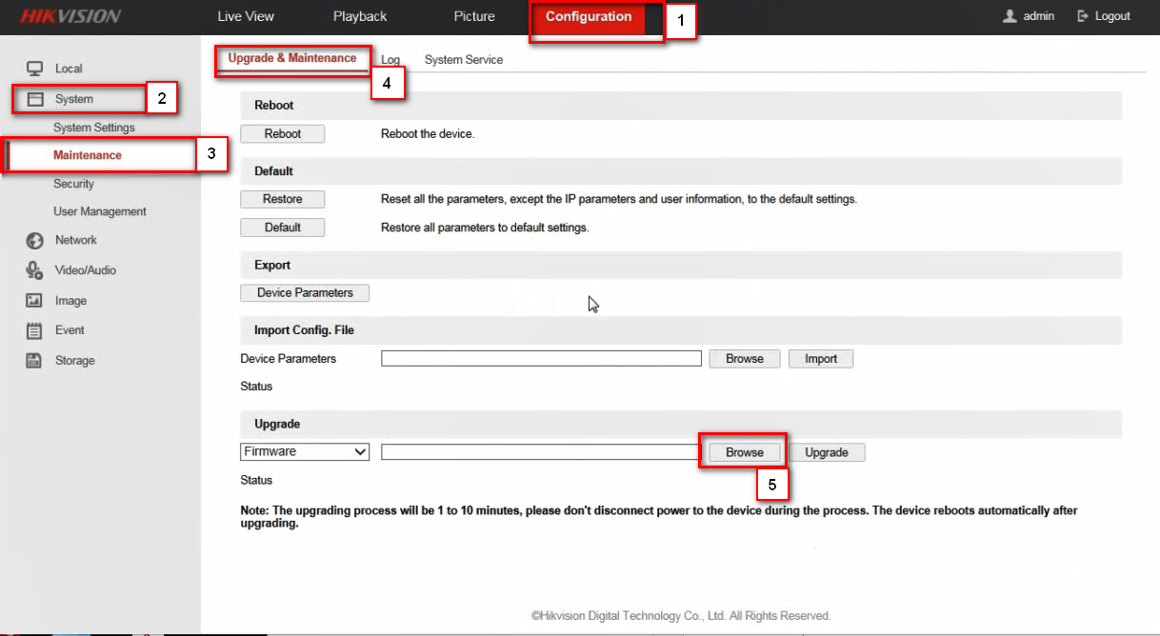

- Choose the firmware which has been saved in advance.

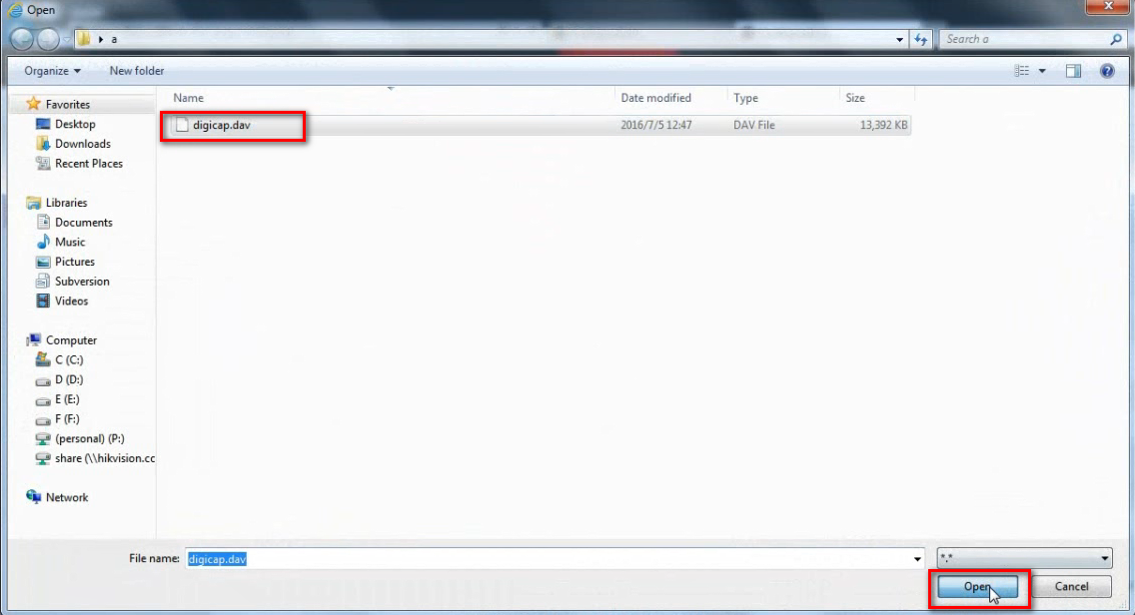

- Click “Upgrade” button，the upgrading process will be 1 to 10 minutes. The device reboots automatically after upgrading.

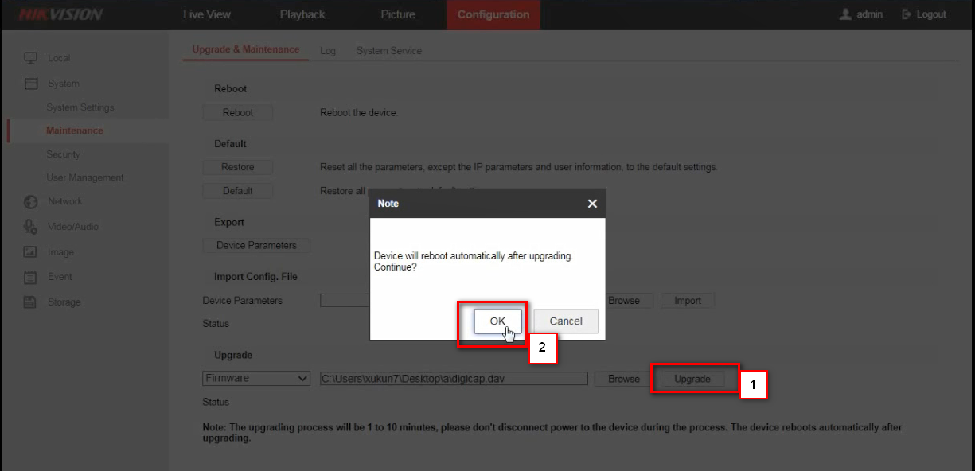

Notes
The device cannot power off during the upgrade.

Part 4: How to upgrade by iVMS-4200 ?
Preparations

Download iVMS-4200 from following link, and install it on your computer.
https://www.hikvision.com/en/support/download/software/ivms4200-series/
.

Steps:

- Open the iVMS-4200 software, and go to Maintenance and Management -> Device Management.
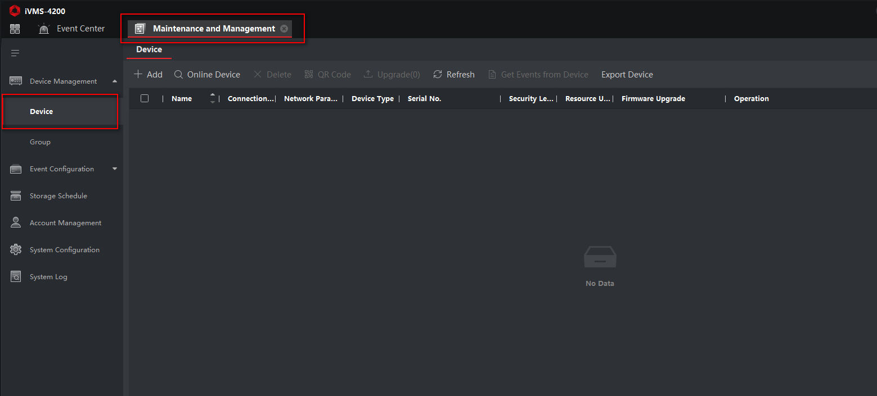

- Find the device which need to be upgraded. Click “Add” icon, input device name, user name and password, click add to add device.
- Choose the device added before, go to remote configuration-Basic Settings.
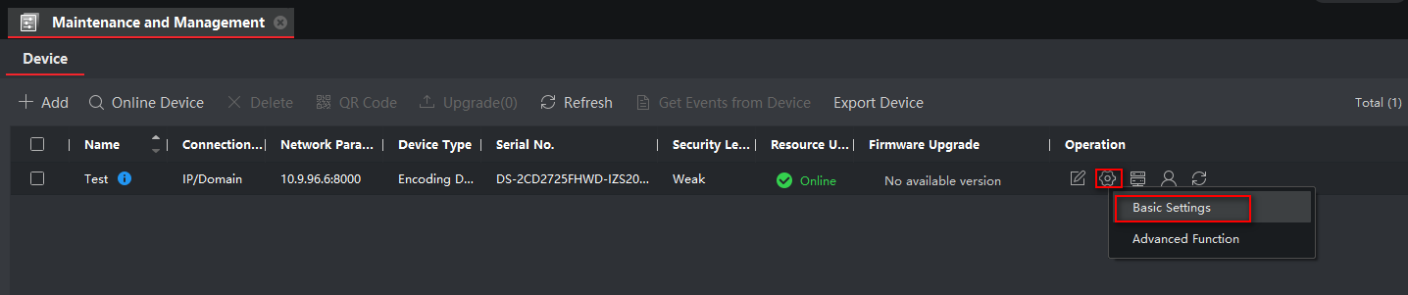

- Go to System- Maintenance- Upgrade, click Browse, choose the firmware which has been saved in advance.
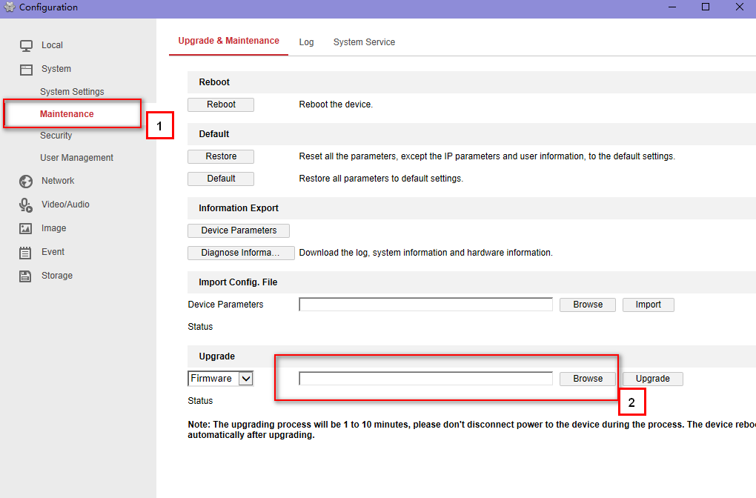
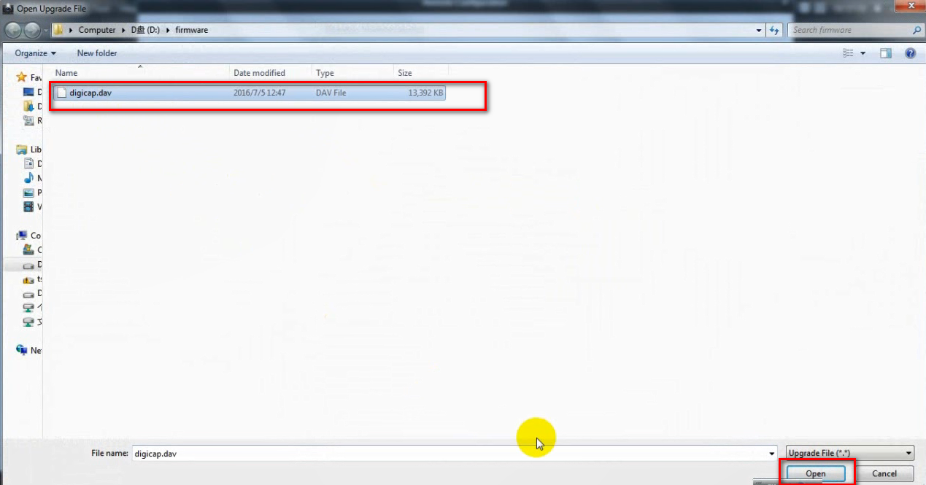

- Click “Upgrade”button，the upgrading process will be 1 to 10 minutes. The device reboots automatically after upgrading.

Note:
The device cannot be cut off during the upgrade.

Part 5: How to upgrade by USB in local GUI4.0 ?（Only for NVR）
Preparation

- Arrange the NVR a monitor.
- Plug the USB flash drive which contain firmware into NVR USB port.

Steps:

- Login the device by inputting username and password.
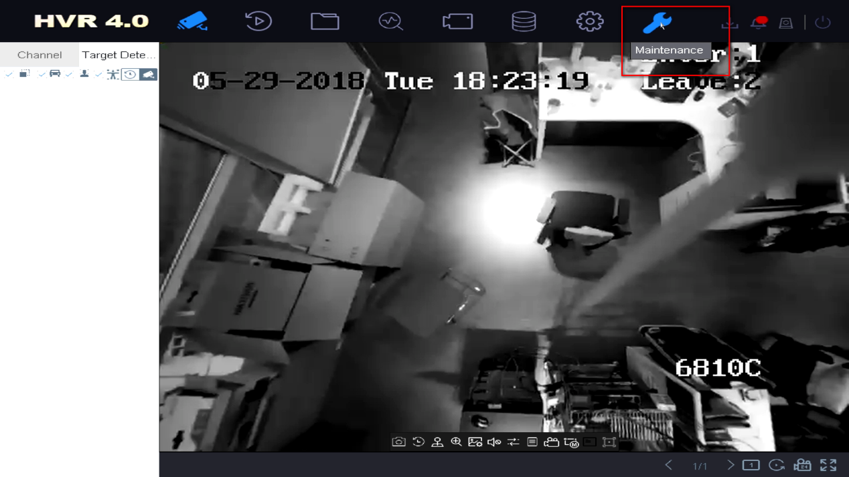

- Go to Maintenance -> Upgrade -> Local Upgrade.
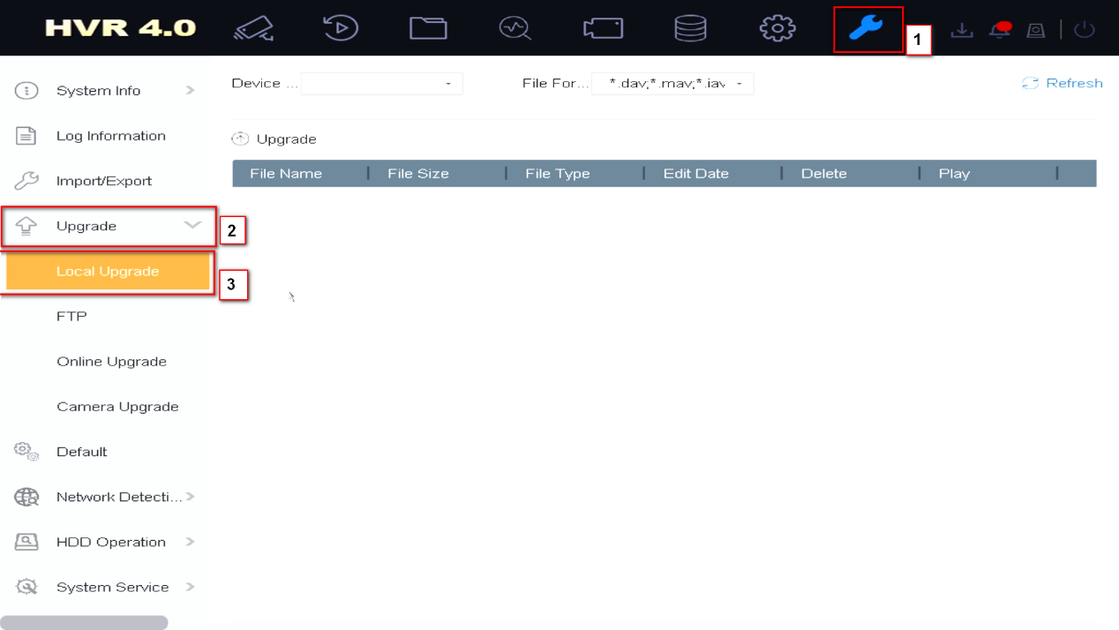

- Choose the USB flash drive, find the new firmware file stored in USB plugged to NVR USB port, click Upgrade to continue.

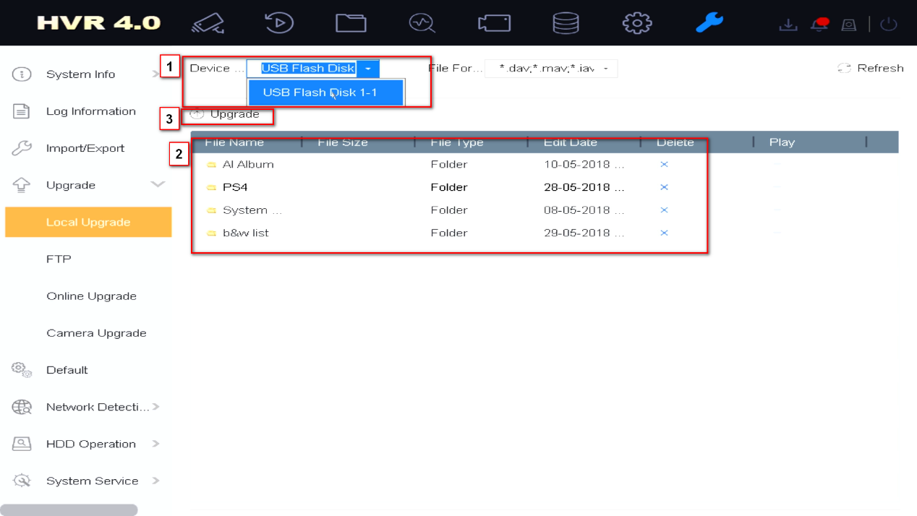

- The NVR will reboot automatically when it is finished.

Note:
The device cannot power off during the upgrade.

Part 6: How to upgrade by USB in local E-UI ? （Only for NVR）
Preparation
Store the upgrade firmware to a backup device, and connect it to your device.

Steps:
- Click “Maintenance” at the upper-right corner, click “Upgrade”
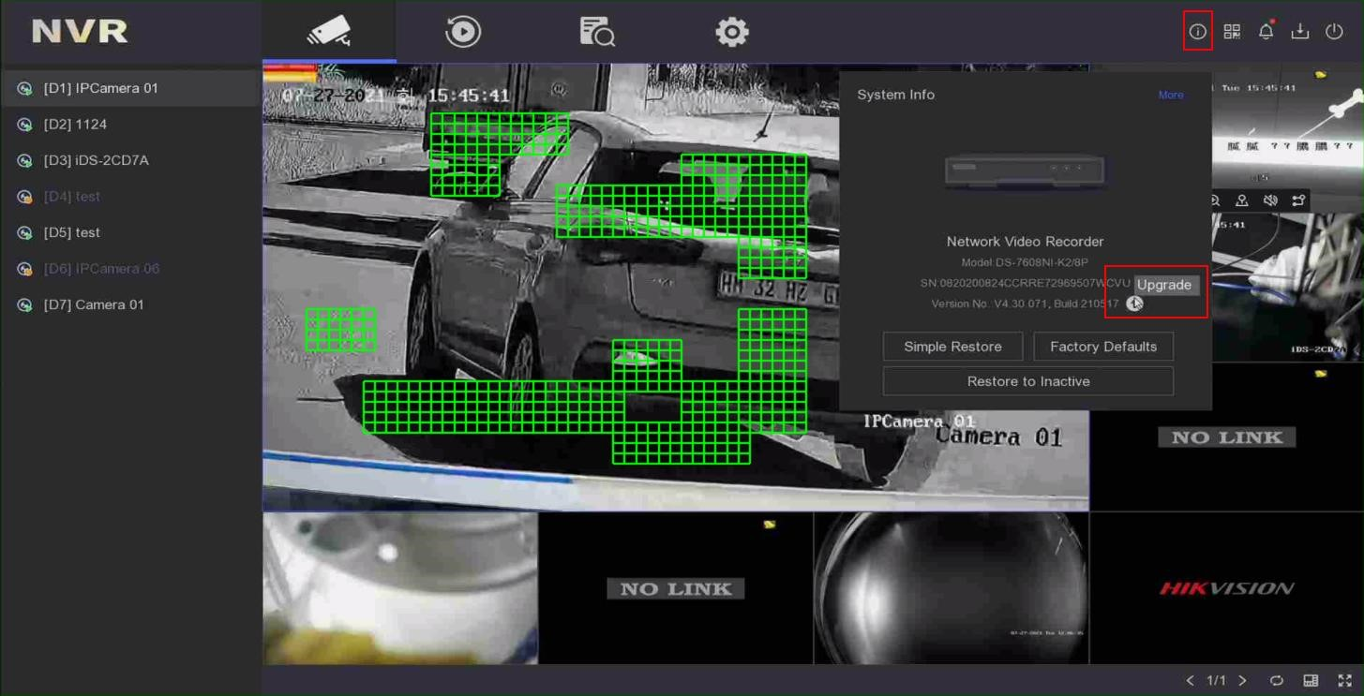

- Click “Local Upgrade”, select a backup device in Device Name, select the upgrade firmware. Click “Upgrade”.
1

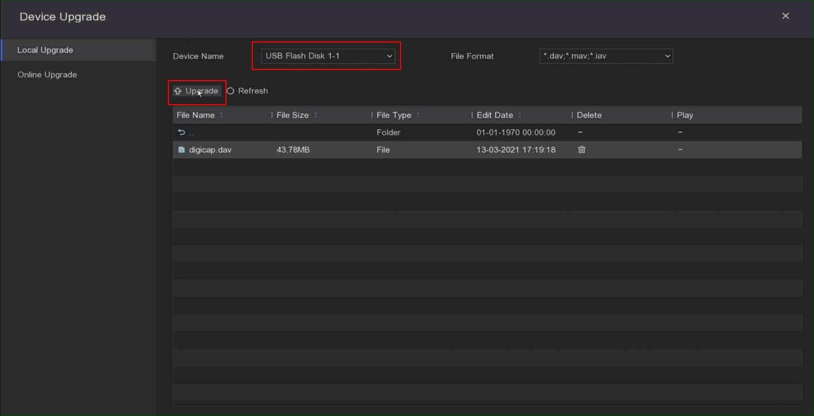

- Upgrading, Your device will reboot automatically when upgraded.
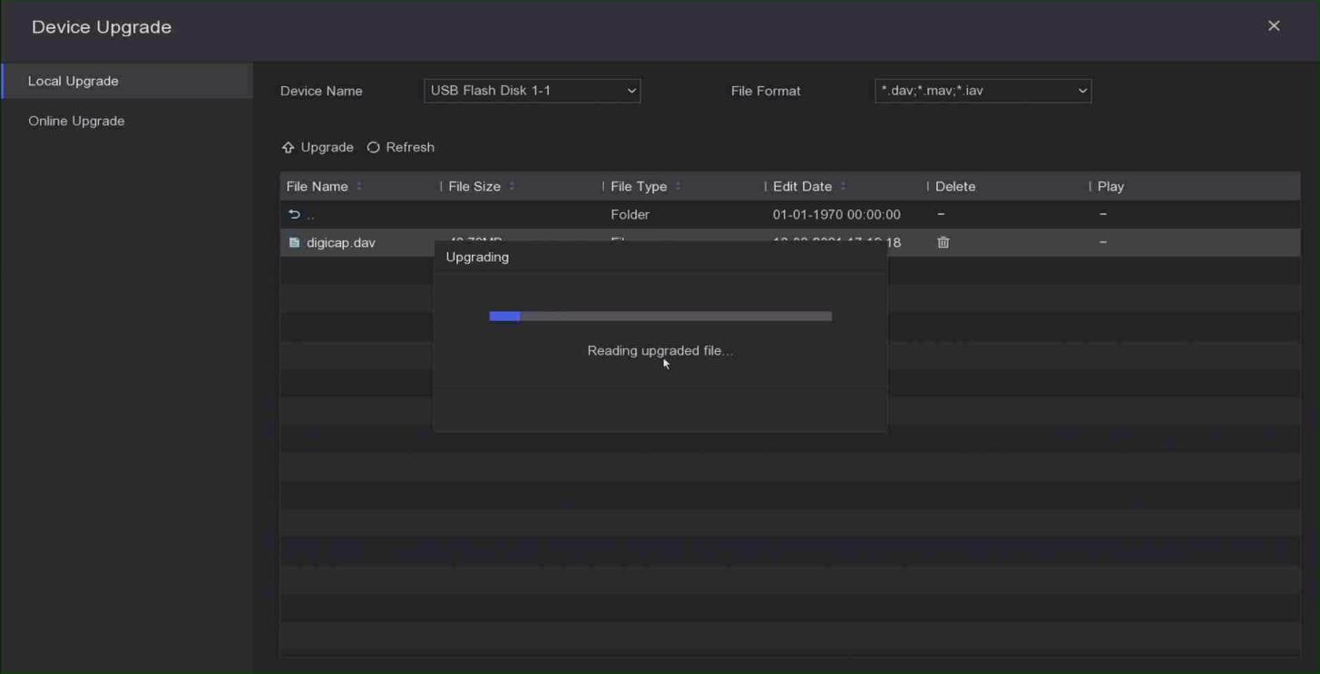

Part 7: How to Upgrade Device by Batch Configuration Tool ?
Preparation
- Download Batch Configuration tool from following link, and install it on your computer.
https://www.hikvision.com/en/support/tools/hitools/TS20200826032/
- Network topology: Use the Ethernet cable to connect the devices and PC to one switch.

Note: The device you want to upgrade should use same firmware.

Steps:
- Install the software Batch Configuration Tool

The interface should be like this.
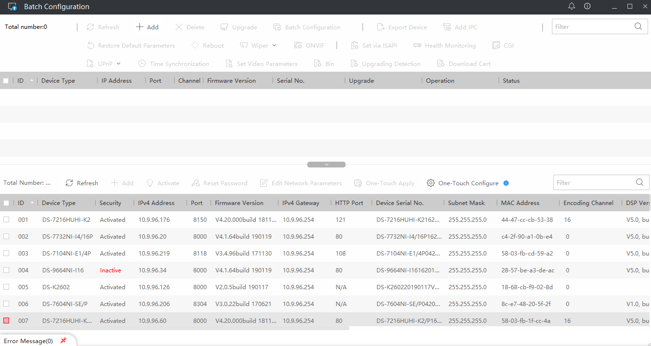
- Click the ‘Add’ to add all devices you want to upgrade to the region that devices will be upgraded.
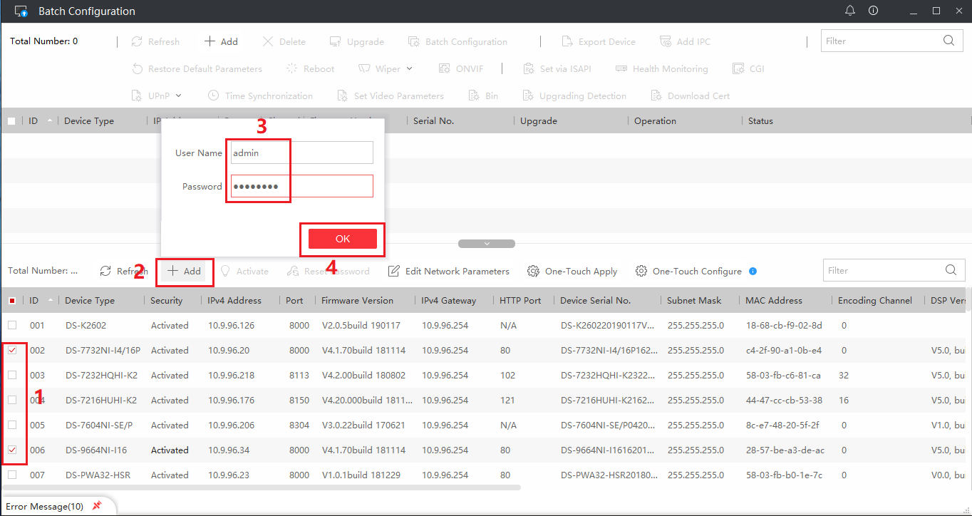
- Choose all the devices and upgrade.
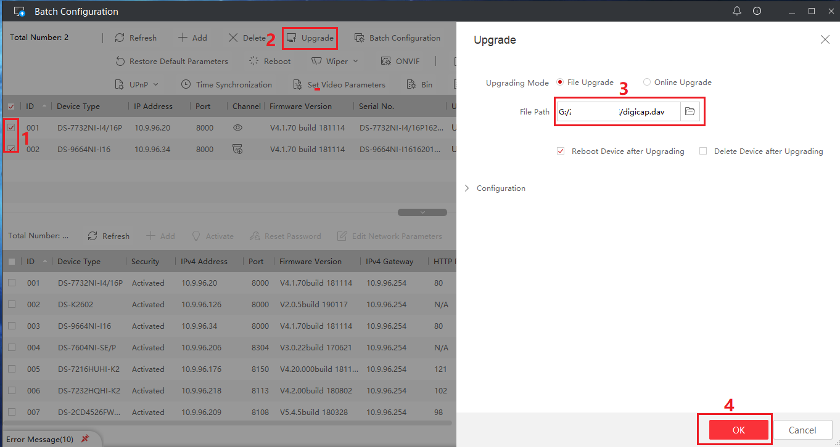
- It will upgrade automatically.
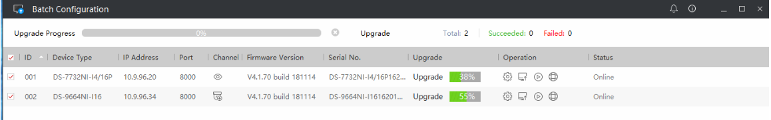
- The devices will be upgraded successfully. 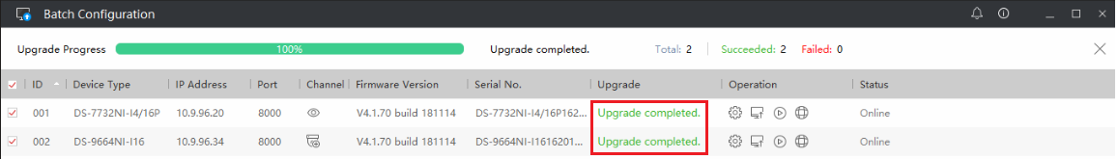

Part 8: How to upgrade online(from Hik-Connect server) ?
Now there are four methods to online upgrade devices: iVMS-4200, Local GUI, Web page and Hik-Connect. The devices’ firmware can be upgraded online, if there is a new version on platform, you can receive notification and upgrade it.
Note:
Method1: When you use iVMS-4200, it just need connect network on your PC client.
Method2/3/4: You need to enable Hik-Connect platform and install a HDD firstly when using Local GUI, Web page and Hik-Connect online upgrade.

Method 1: Online upgrade by iVMS-4200
- Add device to iVMS-4200;
- Check the Firmware upgrade status in Maintenance and Management > Device Management > Device, it will display the latest version;
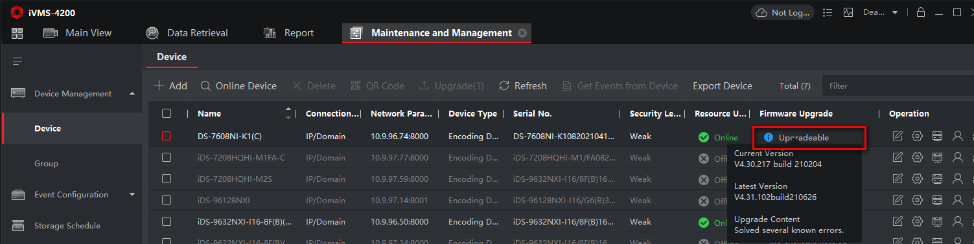
- Select the device and click Upgrade;
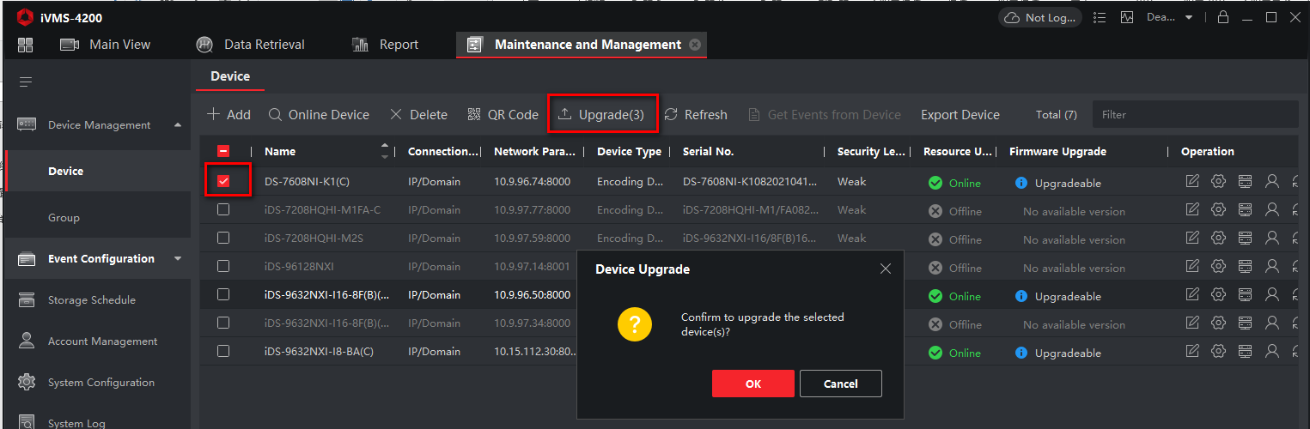
- Then device will upgrade latest firmware automatically.
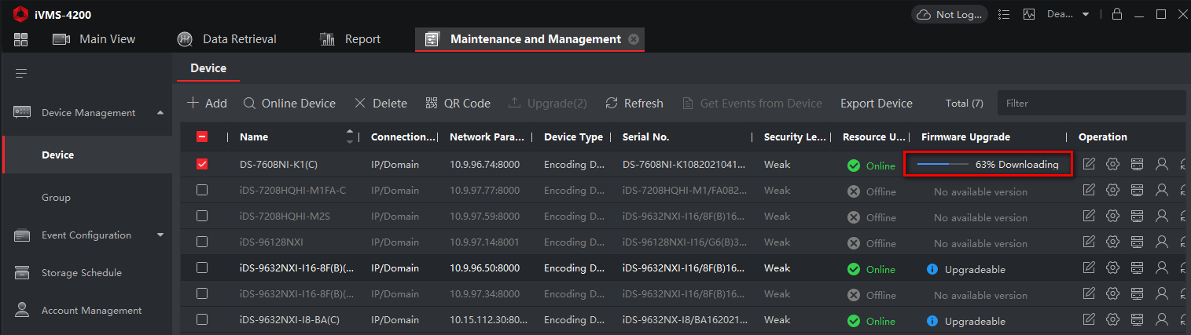
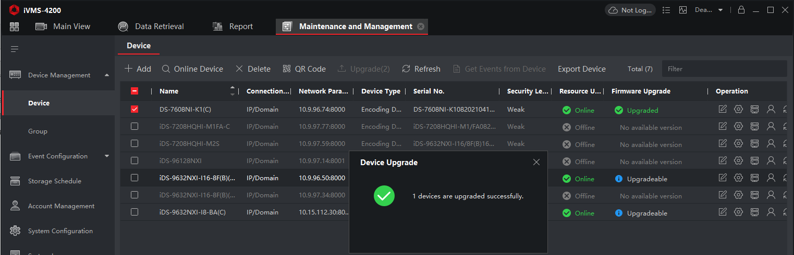

Method 2: Online upgrade by Local GUI (Only for NVR)
  - Enable platform in Network > Hik-Connect;
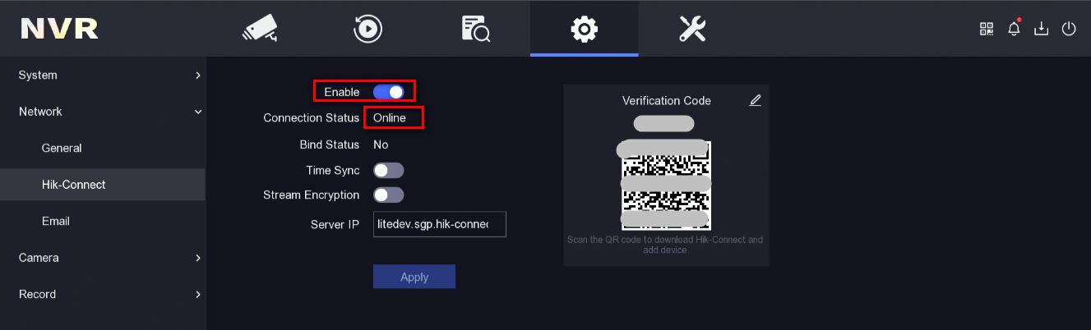
  - After device is online, you can click update button and enter the Online upgrade interface;
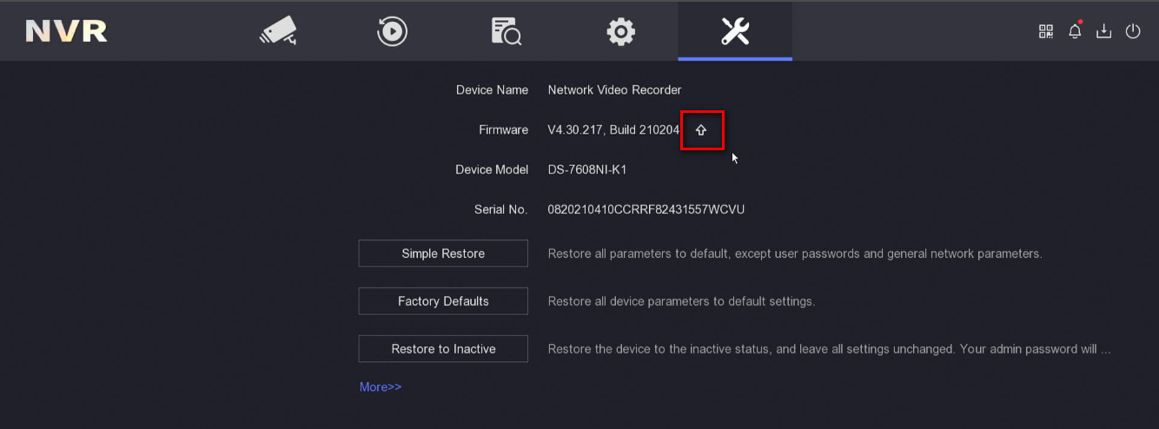
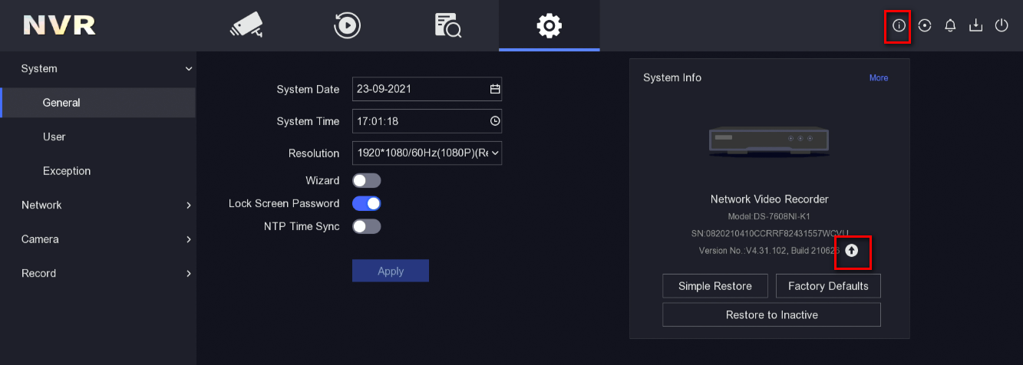
  - Click Test Upgrade to obtain latest version info, then download firmware file and upgrade your device.
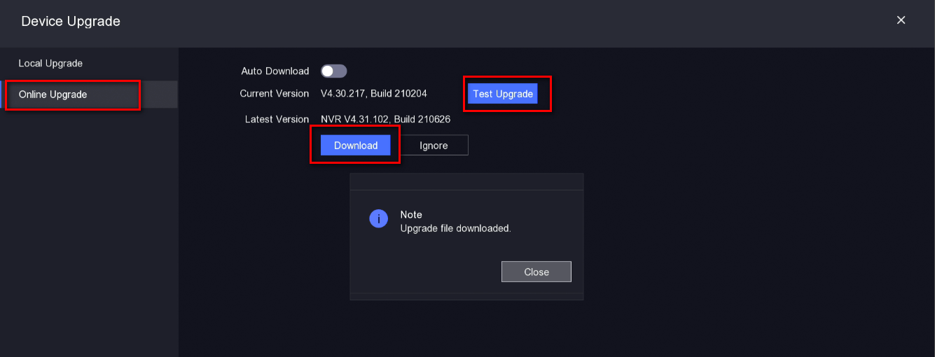

Method 3: Online upgrade by Web page (If there is an "online upgrade" interface)
- Firstly, enable the platform: Configuration > Network > Advanced Settings > Platform Access;
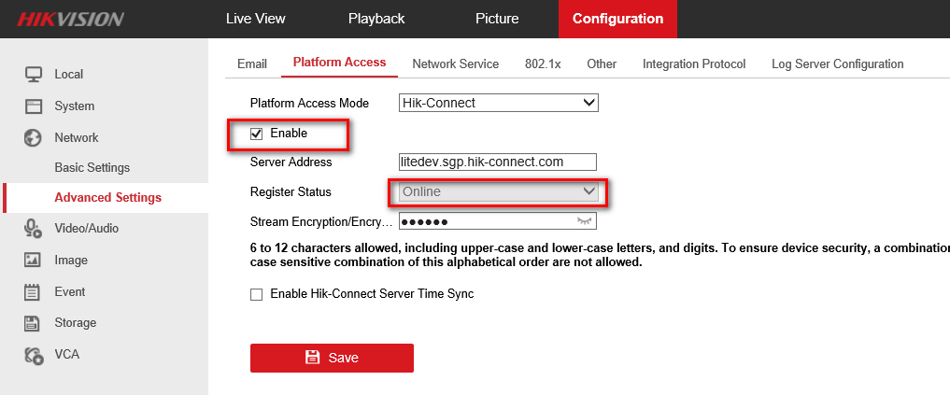
- After device is online, go to Configuration > Maintenance > Online Upgrade, click Check Upgrade to obtain latest version info, then download firmware file and upgrade your device.
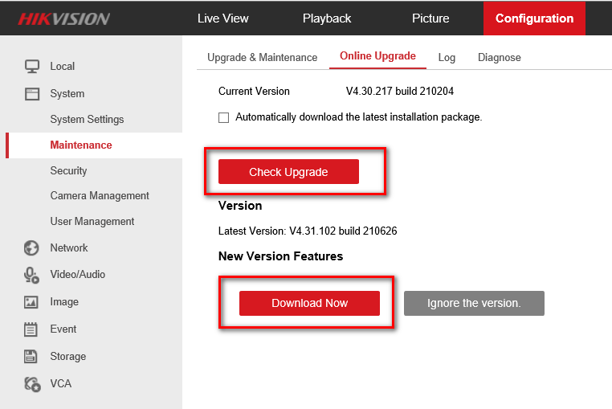

Method 4: Online upgrade by Hik-Connect (If there is an "online upgrade" interface)
- Add device to Hik-Connect, and click device settings icon, then enter Device Version
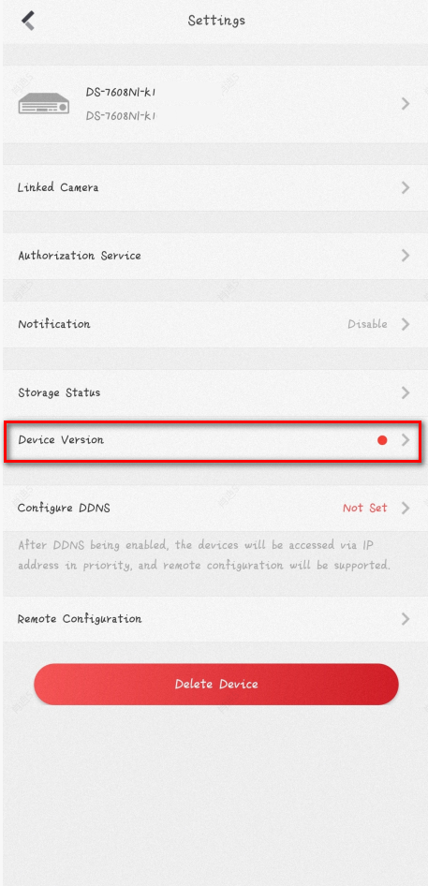
- Check the firmware info and click Upgrade, the device will upgrade new version automatically.
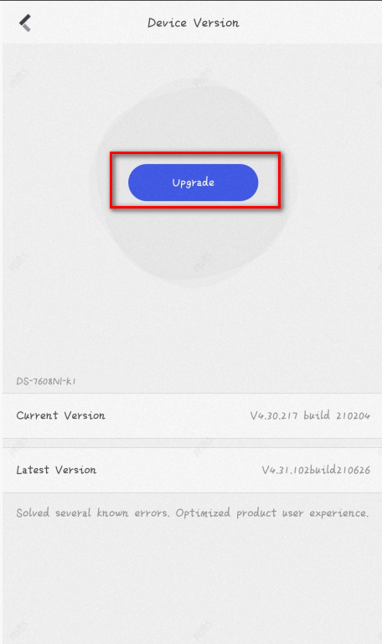

【Appendix】 Suggestions on upgrading ways
Case | Recommended way
If you have a large number of devices of the same model to be upgraded. | Part7
If your device is configured with Hik-Connect service (you don't need to download firmware, just upgrade online). | Part8
If it is an NVR and a monitor is connected. | Part5, Part6
In addition to the above cases. | Part3, Part4

