**How to use DS-K1T201A to connect to**

**DS-K1109 card reader**

**Preparation**

|  |  |  |
| --- | --- | --- |
| Type | Model | Version |
| Software | IVMS-4200 or HCP or HCAC |  |
| Access Control Terminal | DS-K1T201AMF |  |
| Card reader | DS-K1109DKFB |  |

**How to use DS-K1T201A to connect to DS-K1109 card reader**

**Introduction:** This article will introduce how to use DS-K1T201A to connect to DS-K1109 card reader.

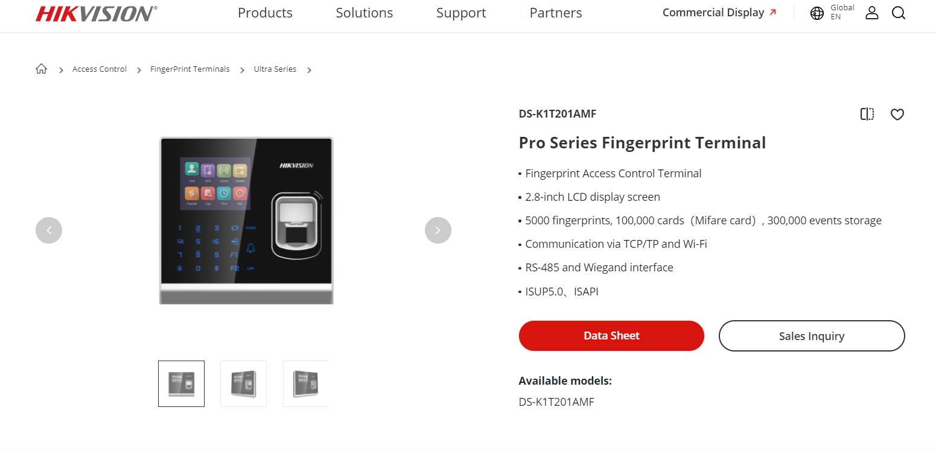

1. **Wiring**

Use RS-485 cable of K1T201A terminal connect to K1109 card reader.

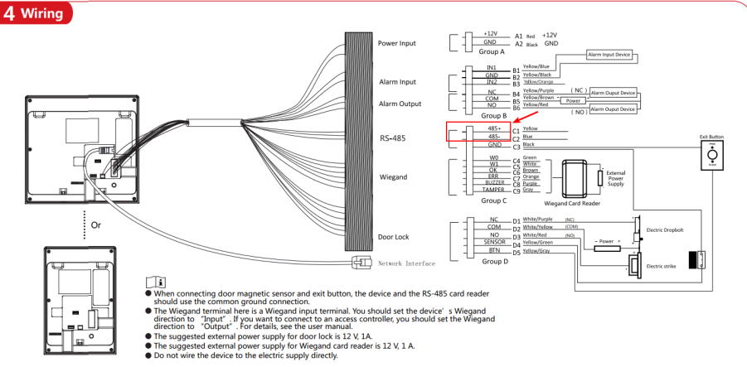

1. **Configuration**
2. Add K1T201A to platform.

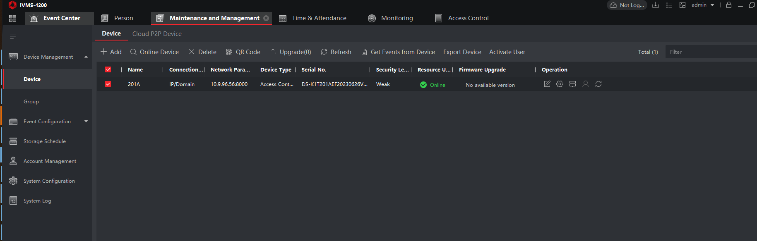

1. Enter the device remote configuration page, check the connection mode of RS-485.

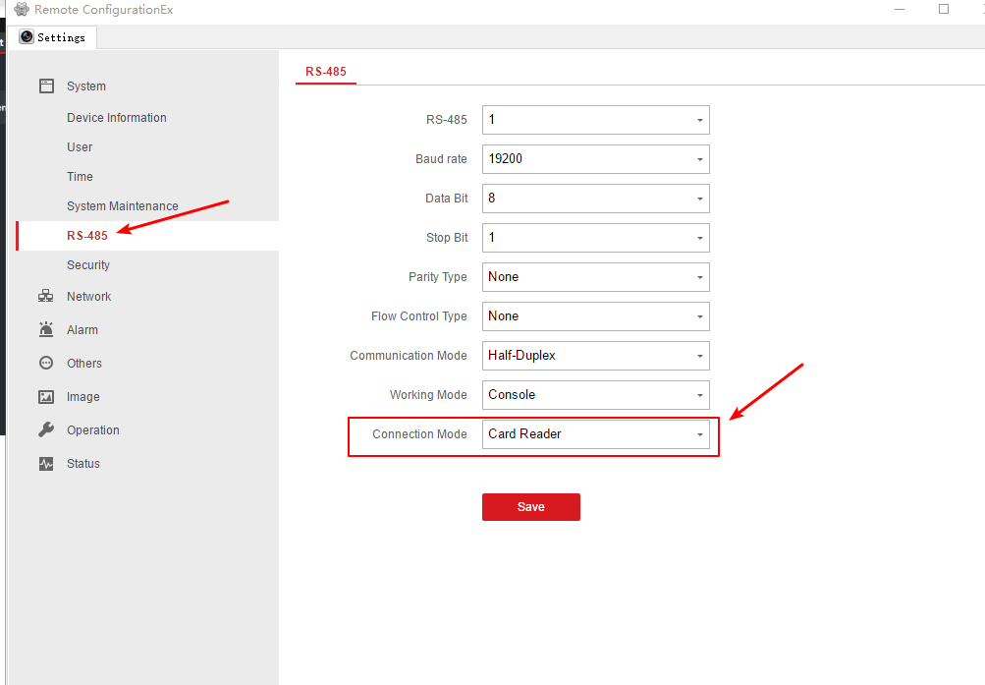

1. Configure dip switch of card reader, make sure the dip switch is 0100 0000.

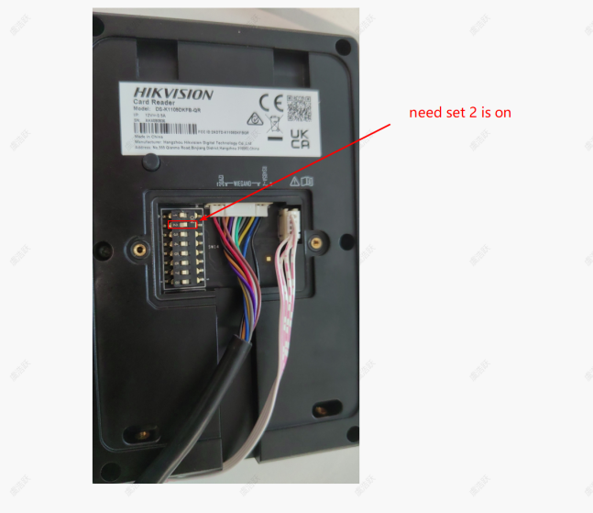

1. And then restart the card reader, you can check the exit card reader is online on the door of K1T201A.

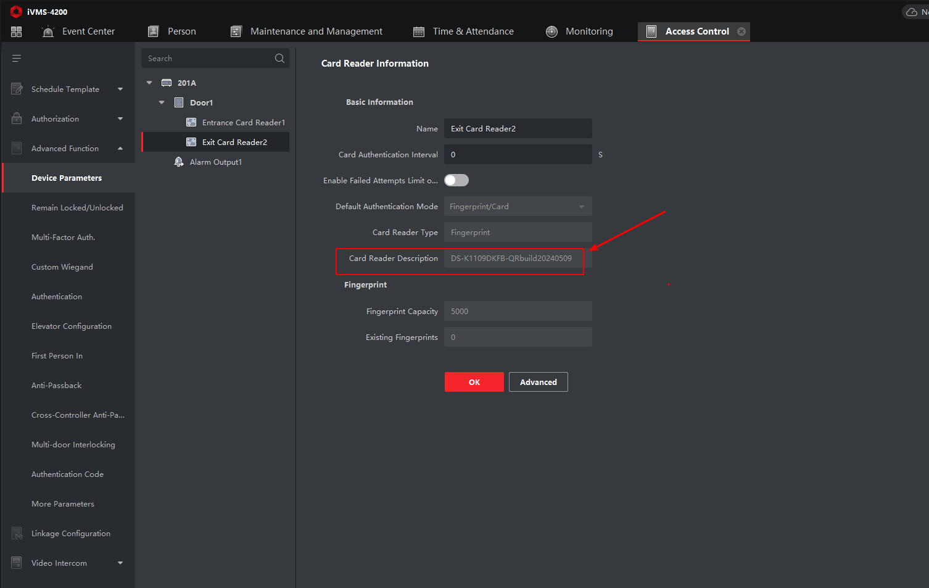

1. **Test**

You can check the swipe card records on Event Center, test result as shown below.

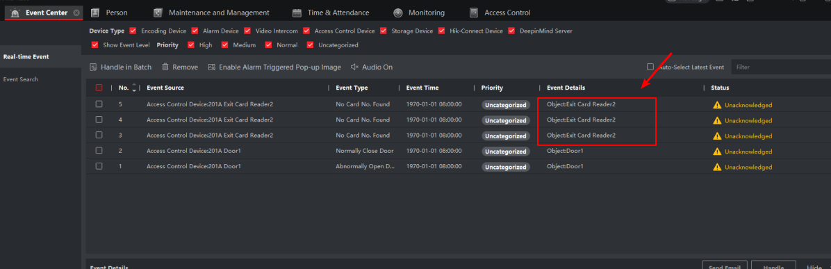

**Note:**

1. Check the K1T201A version, make sure use the latest firmware.

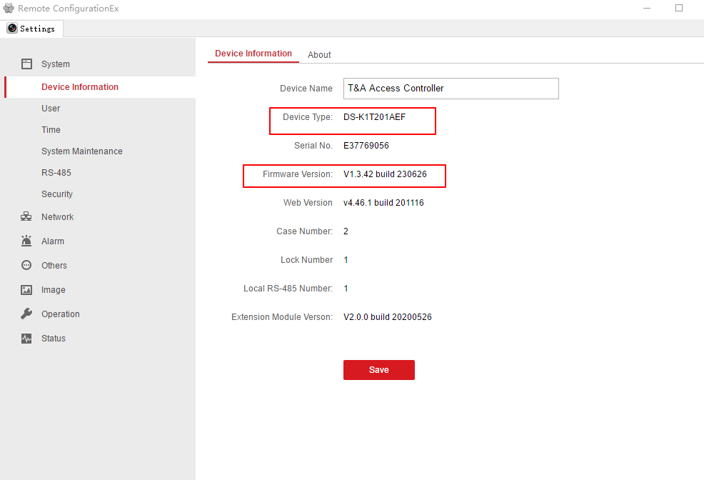

1. Check card reader DS-K1109DKFB version, make sure use the latest firmware.

