HikCentral Control Client
User Manual

Legal Information
User Manual
©2018 Hangzhou Hikvision Digital Technology Co., Ltd.
About this Manual
This Manual is subject to domestic and international copyright protection. Hangzhou Hikvision Digital Technology Co., Ltd. ("Hikvision") reserves all rights to this manual. This manual cannot be reproduced, changed, translated, or distributed, partially or wholly, by any means, without the prior written permission of Hikvision.
Please use this user manual under the guidance of professionals.
Trademarks
and other Hikvision marks are the property of Hikvision and are registered trademarks or the subject of applications for the same by Hikvision and/or its affiliates. Other trademarks mentioned in this manual are the properties of their respective owners. No right of license is given to use such trademarks without express permission.
Disclaimer
TO THE MAXIMUM EXTENT PERMITTED BY APPLICABLE LAW, HIKVISION MAKES NO WARRANTIES, EXPRESS OR IMPLIED, INCLUDING WITHOUT LIMITATION THE IMPLIED WARRANTIES OF MERCHANTABILITY AND FITNESS FOR A PARTICULAR PURPOSE, REGARDING THIS MANUAL. HIKVISION DOES NOT WARRANT, GUARANTEE, OR MAKE ANY REPRESENTATIONS REGARDING THE USE OF THE MANUAL, OR THE CORRECTNESS, ACCURACY, OR RELIABILITY OF INFORMATION CONTAINED HEREIN. YOUR USE OF THIS MANUAL AND ANY RELIANCE ON THIS MANUAL SHALL BE WHOLLY AT YOUR OWN RISK AND RESPONSIBILITY.
REGARDING TO THE PRODUCT WITH INTERNET ACCESS, THE USE OF PRODUCT SHALL BE WHOLLY AT YOUR OWN RISKS. HIKVISION SHALL NOT TAKE ANY RESPONSIBILITIES FOR ABNORMAL OPERATION, PRIVACY LEAKAGE OR OTHER DAMAGES RESULTING FROM CYBER ATTACK, HACKER ATTACK, VIRUS INSPECTION, OR OTHER INTERNET SECURITY RISKS; HOWEVER, HIKVISION WILL PROVIDE TIMELY TECHNICAL SUPPORT IF REQUIRED.
SURVEILLANCE LAWS VARY BY JURISDICTION. PLEASE CHECK ALL RELEVANT LAWS IN YOUR JURISDICTION BEFORE USING THIS PRODUCT IN ORDER TO ENSURE THAT YOUR USE CONFORMS THE APPLICABLE LAW. HIKVISION SHALL NOT BE LIABLE IN THE EVENT THAT THIS PRODUCT IS USED WITH ILLEGITIMATE PURPOSES.
IN THE EVENT OF ANY CONFLICTS BETWEEN THIS MANUAL AND THE APPLICABLE LAW, THE LATER PREVAILS.

Symbol Conventions
The symbols that may be found in this document are defined as follows.

Symbol | Description
Danger | Indicates a hazardous situation which, if not avoided, will or could result in death or serious injury.
Caution | Indicates a potentially hazardous situation which, if not avoided, could result in equipment damage, data loss, performance degradation, or unexpected results.
Note | Provides additional information to emphasize or supplement important points of the main text.

Contents
Chapter 1 Overview 1
Chapter 2 Install and Uninstall Client 2
2.1 Install Control Client 2
2.2 Uninstall Control Client 2
Chapter 3 Login 3
3.1 First Time Login 3
3.2 Normal Login (Not First Time) 4
3.3 Domain User Login 6
3.4 Change Password for Reset User and Login 7
Chapter 4 Manage View 10
Chapter 5 Live View 12
5.1 Start Live View in Area Mode 12
5.2 Start Live View in View Mode 14
5.3 View Map in Live View 15
5.4 Auto-Switch Camera in Area Mode 16
5.5 Auto-Switch Cameras in View Mode 17
5.6 PTZ Control 18
5.6.1 Configure Preset 20
5.6.2 Configure Patrol 20
5.6.3 Configure Pattern 22
5.7 Manual Recording and Capture 22
5.7.1 Manual Recording 22
5.7.2 View Manually Recorded Videos 23
5.7.3 Capture Pictures 24
5.7.4 Edit Captured Picture 25
5.7.5 View Captured Pictures 26
5.8 View Fisheye Camera's Live Video 27
5.9 View ANPR Camera's Live Video 28
5.10 View UVSS's Live Video 29
5.11 Add Recognized Vehicle to Vehicle List 31
5.12 View Detected and Matched Face in Live View 32
5.13 Add Mismatched Person to Person List 35
5.14 Control Access Point in Live View 36
5.15 View Detected Event in Live View 38
5.16 Stop Live View 39
5.17 More Functions 40
5.18 Customize Icons on Live View Window 40
Chapter 6 Playback 43
6.1 Normal Playback 43
6.1.1 Search Video File 43
6.1.2 Play Video File 44
6.2 Start Playback in View Mode 45
6.3 View Map in Playback 46
6.4 Synchronous Playback 47
6.5 Fisheye Playback 48
6.6 Customize Icons on Playback Window 48
Chapter 7 Video Search 51
7.1 Search Tagged Video Footage 51
7.2 Search Locked Video Footage 53
7.3 Search Interval Video Footage 55
7.4 Search Segmented Video Footage 57
7.5 Search Transaction Event Triggered Video Footage 59
7.6 Search ATM Event Triggered Video Footage 61
7.7 Search VCA Event Related Video 63
7.8 Search Captured Face Picture and Related Video by Picture 66
7.9 Search Matched Face Picture and Related Video 68
Chapter 8 Manage Downloading Tasks 70
Chapter 9 Check Alarm and Event 71
9.1 Perform Arming Control 71
9.2 Search and View Resource's Alarm 73
9.3 Search Event/Alarm Logs 75
9.4 Manually Trigger User-Defined Event 76
9.5 View Pop-up Window Triggered by Alarm 76
Chapter 10 Map Management 79
10.1 Operate Hot Spot 79
10.1.1 Preview Hot Spot 79
10.1.2 Perform Arming Control 80
10.1.3 View History Alarm 81
10.2 Preview Hot Region 82
10.3 Operate Map 83
Chapter 11 Search Recognized Vehicles 84
Chapter 12 Search Access Event 87
Chapter 13 Manage Smart Wall 88
13.1 Decode and Display 88
13.2 View Settings 90
13.2.1 Add View Group 90
13.2.2 Add View 90
13.3 Perform View Auto-Switch 91
13.4 Perform Auto-Switch of an Area's Cameras 91
13.5 Create a Roaming Window 92
13.6 View and Export Window No. and Camera ID 93
Chapter 14 Report 94
14.1 Generate People Counting Report 94
14.2 Generate Queue Analysis Report 97
14.3 Generate Heat Map Report 101
14.4 Generate Temperature Report 103
14.5 Generate Vehicle Analysis Report 106
Chapter 15 Health Monitoring 109
Chapter 16 Log Search 112
16.1 Search Server Logs for Current Site 112
16.2 Search Server Logs for Remote Site 113
16.3 Search Device Logs 114
16.4 Back Up Logs 114
Chapter 17 Tools 116
17.1 Play Video via VSPlayer 116
17.2 Broadcast to Connected Devices 116
17.3 Perform Two-Way Audio 117
17.4 Control Alarm Output 117
Chapter 18 System Settings 118
18.1 Set General Parameters 118
18.2 Set Image Parameters 119
18.3 Set File Saving Path 120
18.4 Set Keyboard and Joystick Parameters 121
18.5 Set Alarm Sound 121

Chapter 1 Overview
As one of the key components of the system, Control Client provides multiple operating functionalities, including real-time live view, PTZ control, video playback and download, alarm receiving, log query, and so on.
This user manual describes the function, configuration, and operation steps of the Control Client. To ensure the proper usage and stability of the client, refer to the contents below and read the manual carefully before operation.
Note
The functions on the Control Client vary with the License you purchased. For detailed information, contact our technical support.

Chapter 2 Install and Uninstall Client
You can install the Control Client on your PC to access the system remotely.

2.1 Install Control Client
You must install HikCentral Control Client on your computer before you can access the system via Control Client.
Perform this task when you want to install the Control Client.
Steps
1. Double-click (HikCentral_Client) to enter the welcome panel of the InstallShield Wizard.
2. Click Next to start the InstallShield Wizard.
3. Optional: Click Browse and select a proper directory on your computer to install the Control Client.
4. Click Next to continue.
5. Read the pre-install information and click Install to begin the installation.
A panel indicating progress of the installation will display.
6. Read the post-install information and click Finish to complete the installation.

2.2 Uninstall Control Client
You can remove the Control Client from your PC if you don't need it.
Perform this task when you need to uninstall the Control Client.
Steps
Note
The following procedure of standard system module removal may be slightly different according to the different OS versions.

1. Exit the Control Client.
2. Select Control Panel in Windows' Start menu.
3. Enter Programs and Features page.
- If using Category view, find the Programs category, and click Uninstall a program.
- If using Small icons or Large icons view, select Programs and Features.
4. Right-click the HikCentral Control Client in the list of the currently installed programs.
5. Select Uninstall and follow the removal instructions.

Chapter 3 Login
Log in to the system via the Control Client to perform the operations, such as live view, playback, and so on.

3.1 First Time Login
When normal user (except admin user) logs in to the system for the first time, he/she should change the initial password and set a new password for login.
Before You Start
When you log in to the system for the first time, you are required to create a password for the system pre-defined administrator user (named admin) on the Web Client before you can properly configure and operate the system.
Perform the following steps when you access the system via the Control Client for the first time as a normal user (except admin).
Steps
1. Double-click on the desktop to run the Control Client.
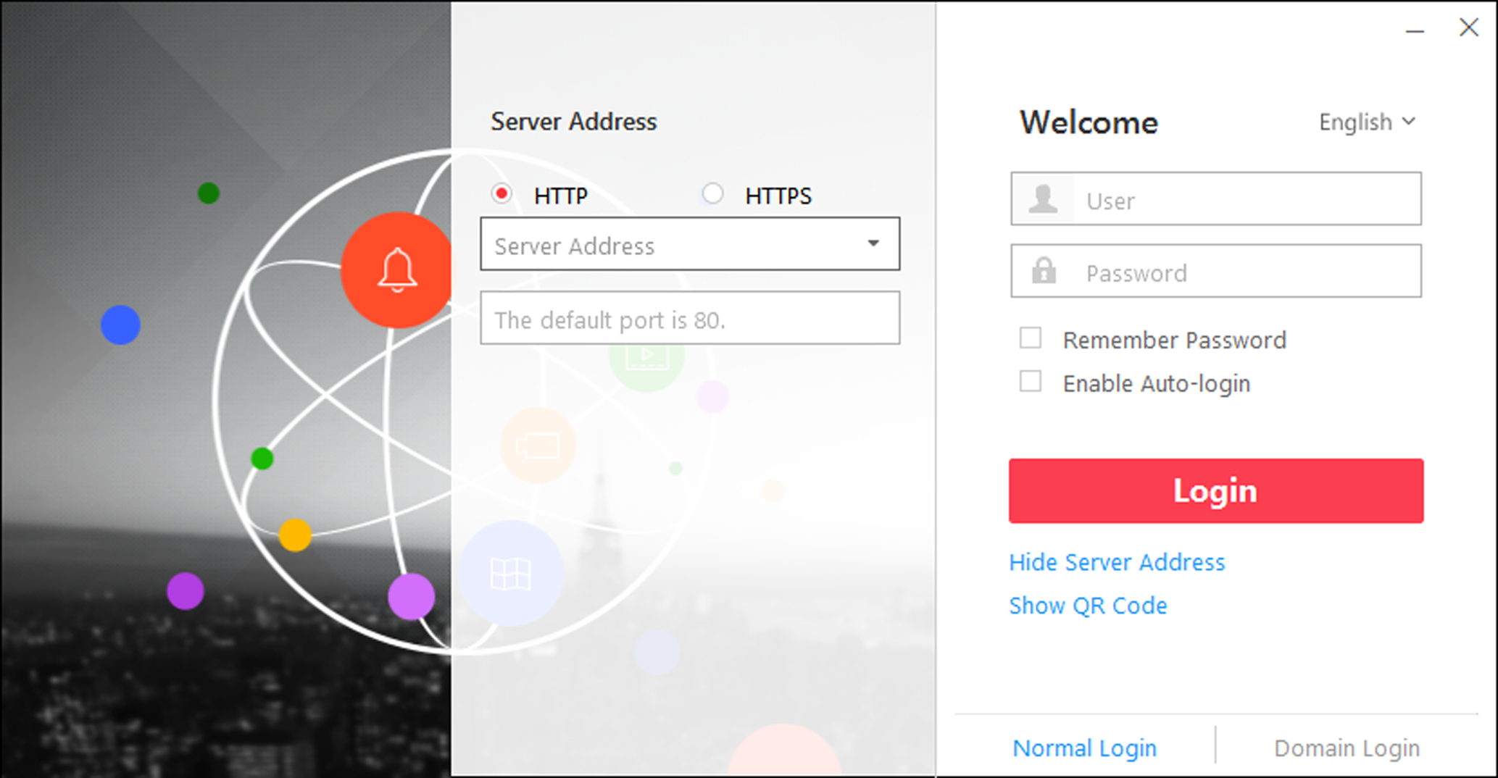
Figure 3-1 Login Page
2. Select Normal Login tab on the bottom.
3. Enter the server parameters.
Note
You can click Hide Server Address or Show Server Address to hide or show the server network information.

Transfer Protocol
Select the transfer protocol. You can select HTTP or HTTPS as configured on the Web Client.
Server Address
Enter the address (IP address or domain name) of the server that running the VSM service you want to connect to.
Port
Enter the port number of the server that running the VSM service. By default, it's 80 for HTTP and 443 for HTTPS.
4. Enter the user name and password of the HikCentral.
Note
Contact the administrator for the user name and initial password.

5. Click Login.
6. Click Close in the pop-up dialog to continue.
7. Set a new password and confirm the password.
Caution
The password strength of the device can be checked by the system. We highly recommend you change the password of your own choosing (using a minimum of 8 characters, including at least three kinds of following categories: upper case letters, lower case letters, numbers, and special characters) in order to increase the security of your product. And we recommend you reset your password regularly, especially in the high security system, resetting the password monthly or weekly can better protect your product.
Proper configuration of all passwords and other security settings is the responsibility of the installer and/or end-user.

8. Click Login to change the password.
You enter the Control Client home page after you change the password.

3.2 Normal Login (Not First Time)
Normally, you can log in to the system with the user name and password of HikCentral as a normal user.
Perform this task when you need to login as a normal user.
Steps
1. Double-click on the desktop to run the Control Client.
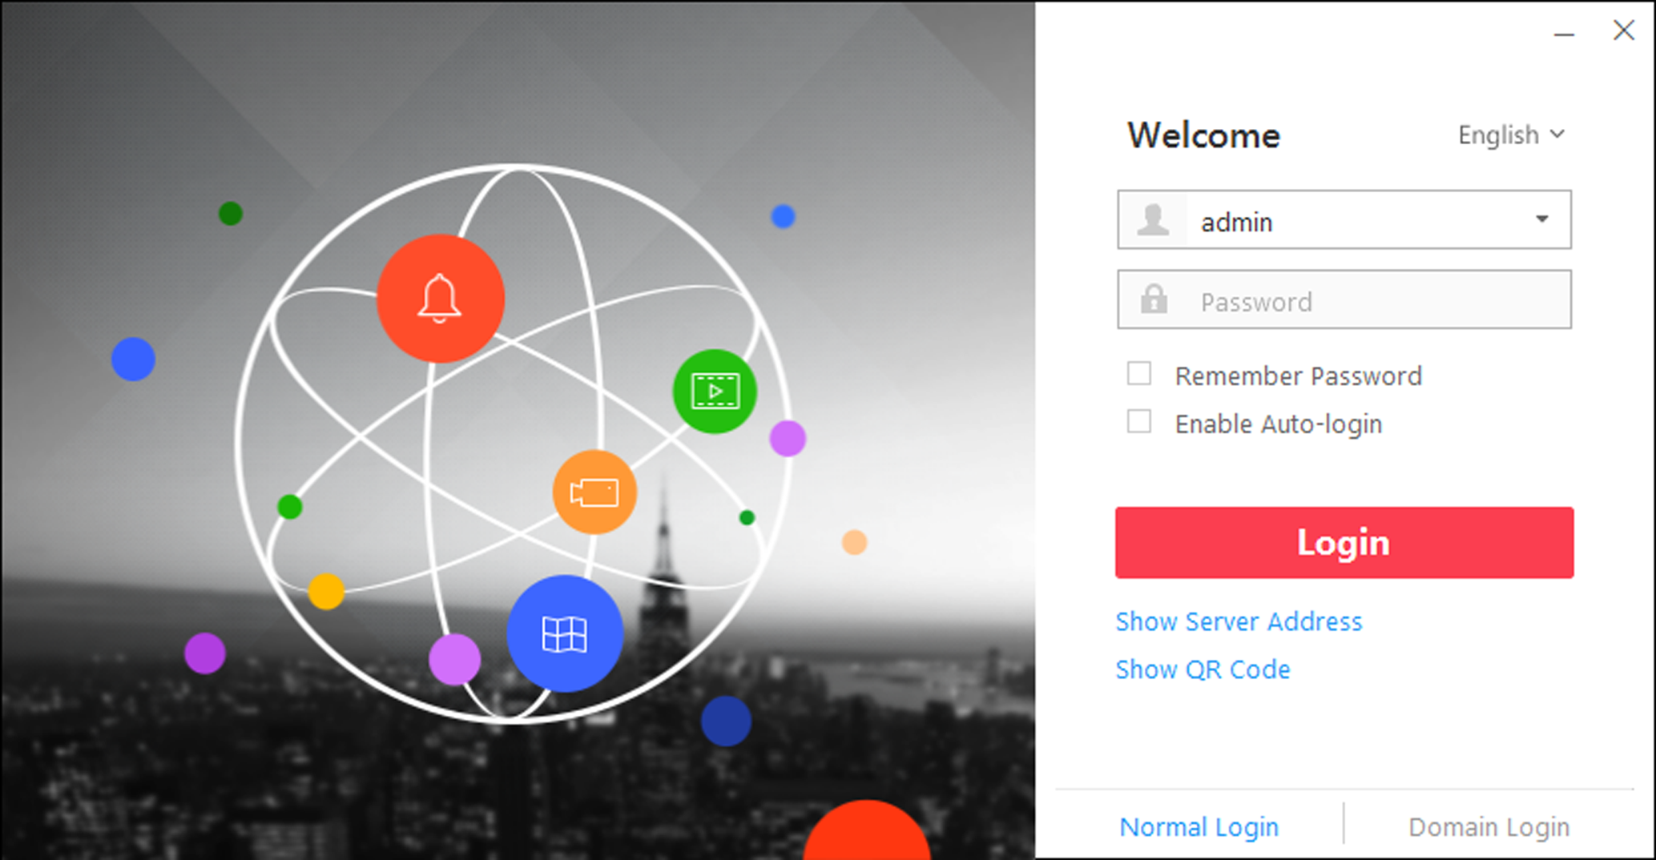
Figure 3-2 Login Page
2. Select Normal Login on the bottom.
3. Input the server parameters.
Note
You can click Hide Server Address or Show Server Address to hide or show the server network information.

Transfer Protocol
Select the transfer protocol. You can select HTTP or HTTPS as configured on the Web Client.
Server Address
Enter the address (IP address or domain name) of the server that running the VSM service that you want to connect to.
Port
Enter the port number of the server that running the VSM service. By default, it's 80 for HTTP and 443 for HTTPS.
4. Enter the user name and password of the HikCentral.
5. Optional: Check Remember Password checkbox to keep the password.
6. Optional: Check Enable Auto-login checkbox to log in to the software automatically for the next login.
7. Click Login.
Note
- If failed password attempt of current user is detected, you are required to input the verification code before you can log in. The failed password attempt from current client, other client and other address will all require the verification code.
- The failed password attempt from current client, other client (e.g., Control Client) and other address will all be accumulated. Your IP address will be locked for a specified period of time after specific number of failed password or verification code attempts. For detailed settings of failed login attempts and locking duration, refer to the User Manual of HikCentral Web Client.
- The account will be frozen for 30 minutes after 5 failed password attempts. The failed password attempt from current client, other client (e.g., Control Client) and other address will all be accumulated.
- The password strength can be checked by the system and should meet the system requirements. If password strength is lower than the required minimum strength, you will be asked to change your password. For detailed settings of minimum password strength, refer to the User Manual of HikCentral Web Client.
- If your password has expired, you will be asked to change your password when login. For detailed settings of maximum password age, refer to the User Manual of HikCentral Web Client.

You enter the Control Client home page.

3.3 Domain User Login
If the domain users have been imported to the system, you can log in to the system with domain account in Domain Login mode.
Before You Start
Set the domain users via the Web Client. See User Manual of HikCentral Web Client for details.
Perform this task when you need to access the system via the Control Client as a domain user.
Steps
1. Double-click on the desktop to run the Control Client.
2. Select Domain Login on the bottom.
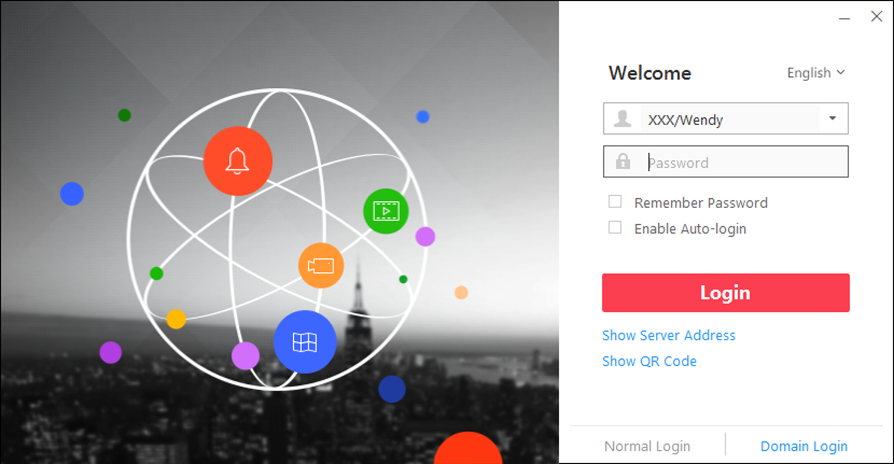
Figure 3-3 Login Interface
3. Optional: Click Show Server Address to show the server's network information.
4. Enter the server parameters.
Transfer Protocol
Select the transfer protocol. You can select HTTP or HTTPS as configured on the Web Client.
Server Address
Enter the address (IP address or domain name) of the server that running the VSM service.
Port
Enter the port number of the server that running the VSM service. By default, it's 80 for HTTP and 443 for HTTPS.
5. Enter the domain user name and password.
6. Optional: Check Remember Password checkbox to keep the password.
7. Optional: Check Enable Auto-login checkbox to log in to the software automatically for the next login.
8. Click Login.
Note
- If failed password attempt of current user is detected, you are required to input the verification code before you can log in. The failed password attempt from current client, other client and other address will all require the verification code.
- The failed password attempt from current client, other client (e.g., Control Client) and other address will all be accumulated. Your IP address will be locked for a specified period of time after specific number of failed password or verification code attempts. For detailed settings of failed login attempts and locking duration, refer to the User Manual of HikCentral Web Client.
- The account will be frozen for 30 minutes after 5 failed password attempts. The failed password attempt from current client, other client (e.g., Control Client) and other address will all be accumulated.

3.4 Change Password for Reset User and Login
If the normal user's password is reset to the initial password by the administrator, he/she should change the initial password and set a new password when logging in again.
Perform this task when you need to access the system via Control Client by normal user whose password has been reset to the initial one.
Steps
1. Double-click on the desktop to run the Control Client.
Figure 3-4 Login Page
2. Select Normal Login tab on the bottom.
3. Enter the server parameters.
Note
You can click Hide Server Address or Show Server Address to hide or show the server network information.

Transfer Protocol
Select the transfer protocol. You can select HTTP or HTTPS as configured on the Web Client.
Server Address
Enter the address (IP address or domain name) of the server that running the VSM service you want to connect to.
Port
Enter the port number of the server that running the VSM service. By default, it's 80 for HTTP and 443 for HTTPS.
4. Enter the user name and password of the HikCentral.
Note
Contact the administrator for the user name and initial password.

5. Click Login.
6. Click Close in the pop-up dialog to continue.
7. Set a new password and confirm the password.
Caution
The password strength of the device can be checked by the system. We highly recommend you change the password of your own choosing (using a minimum of 8 characters, including at least three kinds of following categories: upper case letters, lower case letters, numbers, and special characters) in order to increase the security of your product. And we recommend you reset your password regularly, especially in the high security system, resetting the password monthly or weekly can better protect your product.
Proper configuration of all passwords and other security settings is the responsibility of the installer and/or end-user.

8. Click Login to change the password.
You enter the Control Client home page after you change the password.

Chapter 4 Manage View
A view is a window division with resource channels (e.g., cameras and access points) linked to each window. View mode enables you to save the window division and the correspondence between cameras and windows as favorite so that you can quickly access these channels later. For example, you can link camera 1, camera 2, and camera 3 located in your office to the certain display windows and save them as a view called office. Next time, you can access the view office and these cameras will display in the linked window quickly.
Perform this task when you need to get quick access to a certain set of channels for live view or playback.
Note
- For live view, the view mode can save resource type, resource ID, stream type, position and scale after digital zoom, preset No., and fisheye dewarping status.
- For playback, the view mode can save resource type, resource ID, position and scale after digital zoom, and fisheye dewarping status.

Steps
1. Click Monitoring on My Dashboard to enter Monitoring page.
2. Click to enter the View page.
3. Optional: Add a custom view group.
1) Select Public View or Private View to add the view group.
Note
The view groups and views belonging to the private view group are hidden from the other user.

2) Click .
3) Create a name for the group or use the default name.
4) Click OK to add this view group.
4. Optional: Select a view group.
5. Add a view.
1) Click .
2) Create a name for the view or use the default name.
3) Click OK to add this view.
6. Select a view name for setting window division mode and linked resource channels.
7. Click (Logical Resource) tab.
8. Drag the channels to the window or double-click the channels to start live view or playback.
Note
For detailed operations about live view and playback, refer to Live View and Normal Playback.

9. Save the view with the displayed view division and channels.
- Click → Save to save the current window division mode and displayed channels as the selected view.
- Click → Save as to save the current window division mode and displayed channels as a new view by creating view name (optional) and selecting the view saving path.
Note
If the added view is not selected before, you can also save the current window division and displayed channels as a new view.

10. Optional: Perform the following operations after adding the view.
Edit View | Edit the view settings (such as window division, correspondence between channels and display windows, etc.), click and edit the view name.
Delete View or View Group | Click to delete the custom view or view group.
Reset | If you did other operations on this view, click reset to restore to the initial view settings.

Result
After adding a view, you can start live view or playback in view mode. See Start Live View in View Mode and Start Playback in View Mode for details.

Chapter 5 Live View
You can view live video of the connected cameras. During live view, you can also control PTZ cameras, manually record video footage, capture images, and view instant playback. For the ANPR camera, you can view the recognized license plate number. For the face identification device, you can view the face comparison information of the detected face. For the access points that related to cameras, you can control the access point status in real-time and check the card swiping records.
Navigation Panel

 | Logic Resource Mode | View a list of available cameras and areas created by the system administrator.
 | Face Comparison Mode | View the face comparison information between the detected faces and the face pictures in the selected face comparison group.
 | View Mode | Create custom view groups and views of available channels.  Edit existing view groups and views.
 | PTZ Control Mode | Control a PTZ camera.  Create presets for PTZ cameras.  Create patrols for PTZ cameras.  Create patterns for PTZ cameras.

5.1 Start Live View in Area Mode
Live view shows you the live video getting from cameras.
Before You Start
Group cameras in areas via the Web Client. For details, refer to the User Manual of HikCentral Web Client.
Steps
1. Click Monitoring to enter the Monitoring module.
The live view or playback page will display according to previous operation on this page.
2. Optional: Click Go to Live View at the bottom to enter the live view page, if the playback page displays.
3. Click (Logical Resource) tab.
The areas which the current user has permission to access are displayed in the list and the logical resources which the user has permission to access are displayed in the corresponding areas.
Note
For setting the user permission, refer to User Manual of X-VMS Web Client.

4. Optional: Click at the bottom to choose the predefined window division to layout the live video.
Note
The types of window division are shown as the followings:
Average
All the divided windows are distributed averagely on the full window.
Highlighted
The highlighted window is used to display the live video of the critical camera.
Horizontal
The divided windows are distributed horizontally on the window.
Vertical
The divided windows are distributed vertically on the window.
Others
Other types of window division besides the types above.

5. Start live view.
For one camera | Drag the selected camera to the display window. Or double-click the camera name to start the live view in a free display window. You also can select a display window and double-click the camera name to start live view in this window.
For all cameras in the same area | Double-click the area name after selecting the display window to start live view. Or you can drag the area to the display window, and click Play in Batch to start the live view.  Note  The display windows adapt to the number of cameras in the area.

6. Optional: Click Event List Hidden on the upper-right corner to view the real-time received events.
Note
For details, refer to View Detected Event in Live View.

7. Optional: Move the mouse to the lower edge of the live view window to access the icons for further operations.
Note
For details, refer to Customize Icons on Live View Window.

5.2 Start Live View in View Mode
You can quickly access the live view of the cameras managed in a view.
Perform this task when you start live view in view mode.
Steps
1. Click Monitoring on My Dashboard to enter Monitoring page.
2. Click to enter the view mode.
Note
If the Playback page is shown, click Go to Live View at the bottom to enter the Live View page.

3. Optional: Add a view if no view is available.
Note
Refer to Manage View for details.

4. Click a view to quickly start the live view of all the cameras related to the view.
Note
You can also quickly switch the added view from the drop-down view list above the displaying windows.

5. Optional: Click Event List Hidden on the upper-right corner to view the real-time received events.
Note
You can click and select the event sources to filter the events. Click to clear the event list.

6. Optional: Move the mouse to the lower edge of the live view window to access the icons for further operations.
Note
For details, refer to Customize Icons on Live View Window.

5.3 View Map in Live View
When you view the resources on the map, you can drag the resources to the display window to view the live video of surveillance scenarios quickly.
Before You Start
Configure the map settings via the Web Client. For details, see User Manual of HikCentral Web Client.
Perform this task when you need to view map in live view.
Steps
1. Click Monitoring on My Dashboard to enter the Monitoring page.
Note
If Playback page is shown, click Go to Live View at the bottom to enter Live View page.

2. Click Map Hidden to display the map.
3. Start live view of the resource on the map.
- Drag one resource to the display window to start live view.
- Click , select , and drag on the map to select multiple resources. Drag the selected resources to the display window to start live view.
Note
- For cameras, you can click Play in Batch to start the live view, or click Single-Screen Auto-Switch to start auto-switch in single display window. Refer to Auto-Switch Camera in Area Mode for detailed operation.
- Up to 16 resources can be selected.
- The display windows adapt to the number of selected resources.

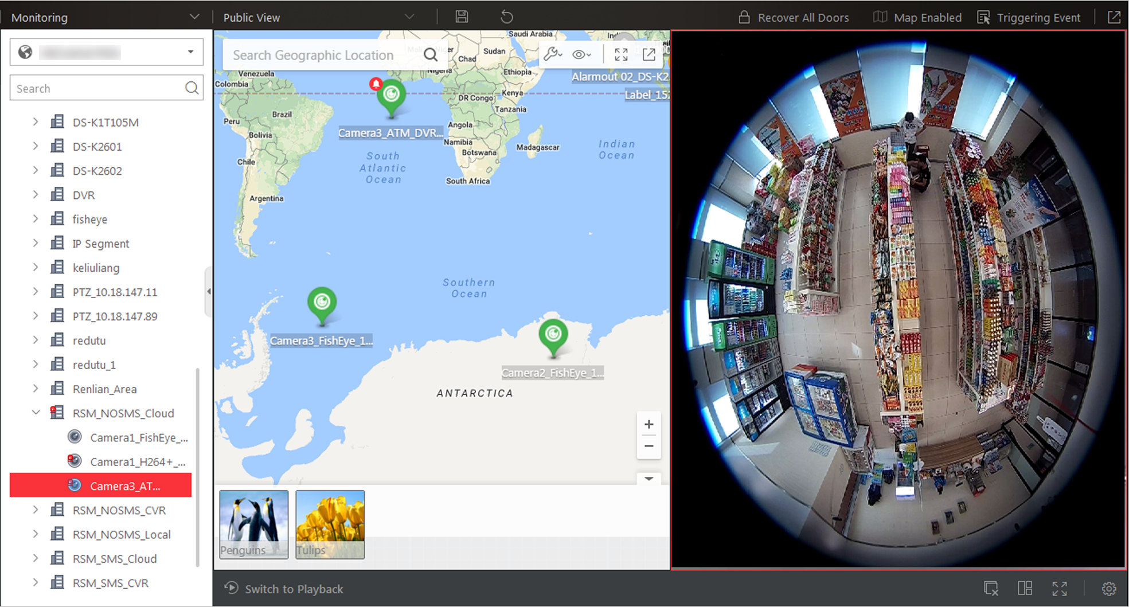
Figure 5-1 View Map in Live View

Figure 5-2 View Map in Live View

5.4 Auto-Switch Camera in Area Mode
You can display the live view of the cameras in one area in turn in one window.
Steps
1. Enter the Monitoring module.
The live view or playback page will display.
2. Optional: Click Go to Live View at the bottom if the playback page displays.
3. Click (Logical Resource) tab.
The areas which the current user has permission to access are displayed in the list and the logical resources which the user has permission to access are displayed in the corresponding areas.
Note
For setting the user permission, refer to User Manual of HikCentral Web Client.

4. Drag the area to the display window.
5. In the pop-up menu, click Single-Screen Auto-Switch.
6. Optional: Perform the following operations after you perform the function of auto-switch camera display.
Adjust Switching Interval | Click or to adjust the interval of the auto-switch.
View Previous or Next Camera | Click or to go to the previous or next camera.
Pause | Click 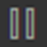 to pause the auto-switch.

7. Optional: Move the mouse to the lower edge of the live view window to access the icons for further operations.
Note
For details, refer to Customize Icons on Live View Window.

5.5 Auto-Switch Cameras in View Mode
A custom view enables you to save the window division and the correspondence between cameras and windows as favorite so that you can quickly access these cameras later. You can display the custom views in one view group in turn.
Before You Start
Customize the views and manage the views in different groups before proceeding. Refer to Manage View for details.
Perform the following steps to automatically switch the custom views of the view group.
Steps
1. Clikc Monitoring to enter the Monitoring module.
The live view or playback page displays.
2. Optional: Click Go to Live View at the bottom if the playback page displays.
3. Click to enter the view mode.
4. Drag a custom view group to the display window.
Note
The two pre-defined view groups (Public View and Private View) do not support auto-switch.

The views belong to the view group will start switching automatically.
5. Optional: Move the mouse to the lower edge of the live view window to access the icons for further operations.
Note
For details, refer to Customize Icons on Live View Window.

5.6 PTZ Control
The Control Client provides PTZ control for cameras with pan/tilt/zoom functionality. You can set the preset, patrol and pattern for the cameras on the PTZ control panel.
Note
The PTZ control function should be supported by the camera.

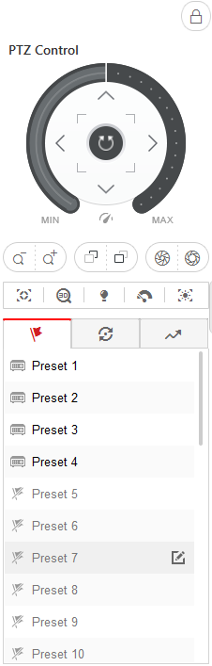
Figure 5-3 PTZ Control Panel

Figure 5-4 PTZ Control Panel
The following buttons are available on the PTZ control panel:

Lock the PTZ for a designated time period. When the PTZ is locked, users with lower PTZ control permission levels cannot change the PTZ controls.
NoteFor details about setting the PTZ control permission level, refer to the User Manual of HikCentral Web Client.

 | Cancel the PTZ lock.
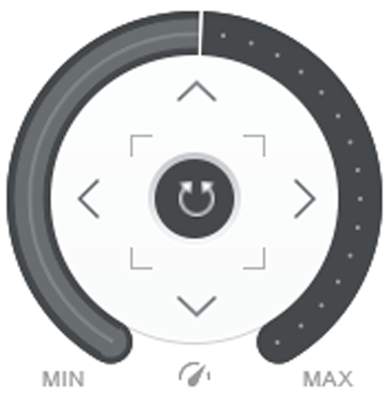 | Direction Button, Auto-scan and PTZ speed.

In the live video display window, you can also click the icon to enable window PTZ control. Move the cursor to the direction you desired and click on the image to pan or tilt. You can also click and drag the cursor with a white arrows to the direction you desired for a quick direction control.

5.6.1 Configure Preset
A preset is a predefined image position which contains configuration parameters for pan, tilt, zoom, focus and other parameters. You can also set a virtual preset after enabling digital zoom.
Perform this task to add a preset.
Steps
1. Enter the Monitoring module.
The live view or playback page will display according to previous operation on this page.
2. Optional: Click Go to Live View at the bottom if the playback page displays.
3. Start live view.
4. Click to enter the PTZ Control mode.
5. Click to enter the PTZ preset configuration panel.
6. Use the direction buttons and other buttons to control the PTZ movement.
7. Select a PTZ preset number from the preset list and click .
8. Create a name for the preset in the pop-up window.
9. Click OK to save the settings.
10. Optional: After adding the preset, you can do one or more of the followings:
Call Preset | Double-click the preset, or select the preset and click .
Edit Preset | Select the preset from the list and click .
Delete Preset | Select the preset from the list and click .

5.6.2 Configure Patrol
A patrol is a scanning track specified by a group of user-defined presets (including virtual presets), with the scanning speed between two presets and the dwell time of the preset separately programmable.
Before You Start
Two or more presets for one PTZ camera need to be added. Refer to Configure Preset for details about adding a preset.
Perform this task to add and call a patrol.
Steps
1. Enter the Monitoring module.
The live view or playback page will display according to previous operation on this page.
2. Optional: Click Go to Live View at the bottom if the playback page displays.
3. Click to enter the PTZ Control mode.
4. Click to enter the PTZ patrol configuration panel.
5. Add presets to the patrol.
1) Select a patrol number from the drop-down list and click .
2) Select Device Preset or Virtual Preset as the preset type.
3) Click to add a configured preset, and set the dwell time and patrol speed.
Note
- The preset dwell time ranges from 1 to 30s.
- The patrol speed ranges from 1 to 40.

4) Repeat the above step to add other presets to the patrol.
Note
By default, the first preset is added to the patrol list. Double-click the preset, speed, and dwell time to access a drop-down configuration list.

6. Optional: Perform the following operations after you add the preset.
Edit Added Preset | Double-click the corresponding field of the preset to edit the settings.
Remove Preset from Patrol | Click to remove the preset from the patrol.
Adjust Preset Sequence | Click to adjust the presets sequence.

7. ClickOK to save the patrol settings.
Note
Up to eight patrols can be configured.

8. Optional: After setting the patrol, you can do one or more of the followings:
Call Patrol | Click to start the patrol.
Stop Calling Patrol | Click to stop the patrol.

5.6.3 Configure Pattern
Patterns can be set to record the movement of the PTZ.
Perform this task to add a pattern.
Steps
1. Enter the Monitoring module.
The live view or playback page will display according to previous operation on this page.
2. Optional: Click Go to Live View at the bottom if the playback page displays.
3. Start live view.
4. Click to enter the PTZ Control mode.
5. Click 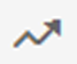 to enter the PTZ pattern configuration panel.
6. Click to start recording the movement path of the pattern.
7. Use the direction buttons and other buttons to control the PTZ movement.
8. Click to stop and save the pattern recording.
Note
Only one pattern can be configured, and the newly-defined pattern will overwrite the previous one.

9. Optional: After setting the pattern, you can do one or more of the followings:
Call Pattern | Click to call the pattern.
Stop Calling Pattern | Click to stop calling the pattern.
Delete Pattern | Click to clear the recorded pattern.

5.7 Manual Recording and Capture
You can record video files and capture pictures manually during live view.
Manual Recording
Record the live video during live view if needed and store the video files in the local PC.
Capture
Capture pictures during live view if needed and store the pictures in the local PC.

5.7.1 Manual Recording
While watching live video, you can record the video manually if you see something of interest and you can export the video as video evidence.
Perform following steps to record the live video.
Steps
1. Enter Monitoring module and click Go to Live View at the bottom if the Playback page is shown.
2. Move the mouse to the live view display window to show the toolbar.
3. Click in the toolbar of the display window to start the manual recording. The icon turns to .
Note
During the manual recording, Recording will display in the upper-right corner of the display window.

4. Click to stop the manual recording.
The recorded video file will be saved automatically and a dialog with the saving path of the file will open.
Note
- The saving path of video files can be set on the Local Configuration interface. For details, see Set File Saving Path.
- The video cannot be stored if the free space is less than 2 GB.

5. Optional: Click Open Folder on the dialog to verify the video file.

5.7.2 View Manually Recorded Videos
The manually recorded files in live view are stored on the PC on which the Control Client is running. You can view the video files.
Perform the following steps to view the manually recorded videos.
Steps
1. On the Control Panel, click Local Recording to enter the Local Recording page.
2. Click to select the camera(s) to be searched from the camera list and click Close to close the camera selection window.
3. Set the time period for search in the Time field.
4. Click Search.
The video files recorded between the start time and end time will display.
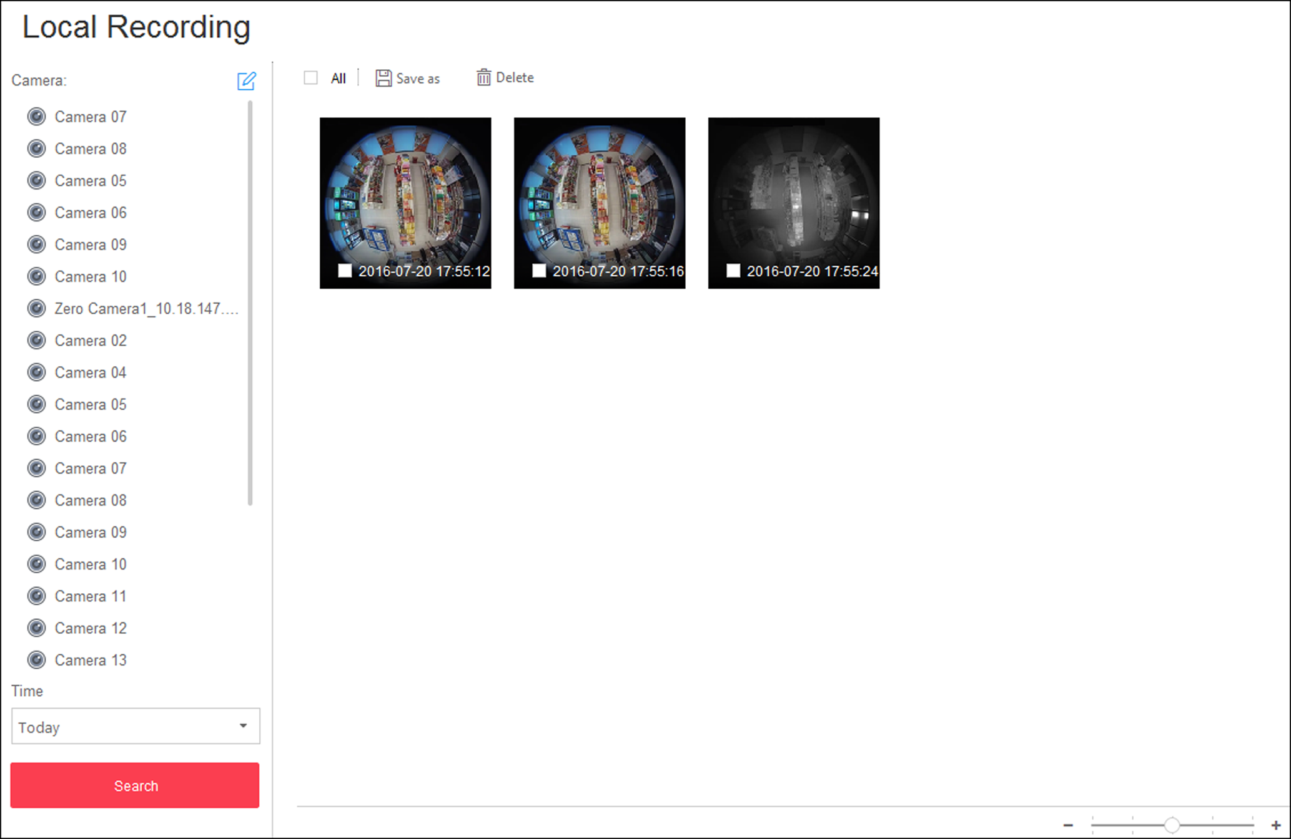
Figure 5-5 Local Recording
5. To play a video file using the VSPlayer, click on the video file.
Note
For detailed instructions about VSPlayer, click and select User Manual to view the VSPlayer user manual.

6. Select the files or check All to select all the found video file(s). You can:
Save Video File to Local PC | Click Save as and then specify a local path to save the selected video file(s).
Delete Video File | Click Delete to delete the selected video file(s).

5.7.3 Capture Pictures
During live view, you can take a quick snapshot of an image for the live video manually via the Control Client if you want to save or share a still image.
Perform the following steps to capture picture during live view.
Steps
1. Click Monitoring to enter the Monitoring module.
The live view or playback page will display according to previous operation on this page.
2. Optional: Click Go to Live View at the bottom to enter the live view page, if the playback page displays.
3. Move the cursor to the live view display window to show the toolbar.
4. Click in the toolbar of the display window to capture a picture.
The captured picture will be saved automatically and a dialog with the saving path will open.
Note
- The saving path of the captured picture can be set on the Local Configuration interface. For details, see Set File Saving Path.
- The picture cannot be saved if the free space is less than 512 MB.

5. Optional: Click Open Folder on the dialog to verify the picture or click Edit to edit the picture.
Note
For details about editing the captured picture, refer to Edit Captured Picture.

6. Optional: Click Search by Picture to open video search window. Refer to Search Captured Face Picture and Related Video by Picture for more details.

5.7.4 Edit Captured Picture
After capturing a picture during live view, you can edit the picture according to actual needs and save the edited picture.
Before You Start
Capture a picture during live view, and a dialog with the saving path of the captured picture will pop up.
Perform the following steps to edit the captured picture.
Steps
1. Enter Monitoring module and click Go to Live View at the bottom if the Playback page is shown.
2. Click Edit on the dialog with the saving path of the captured picture to pop up the following window.
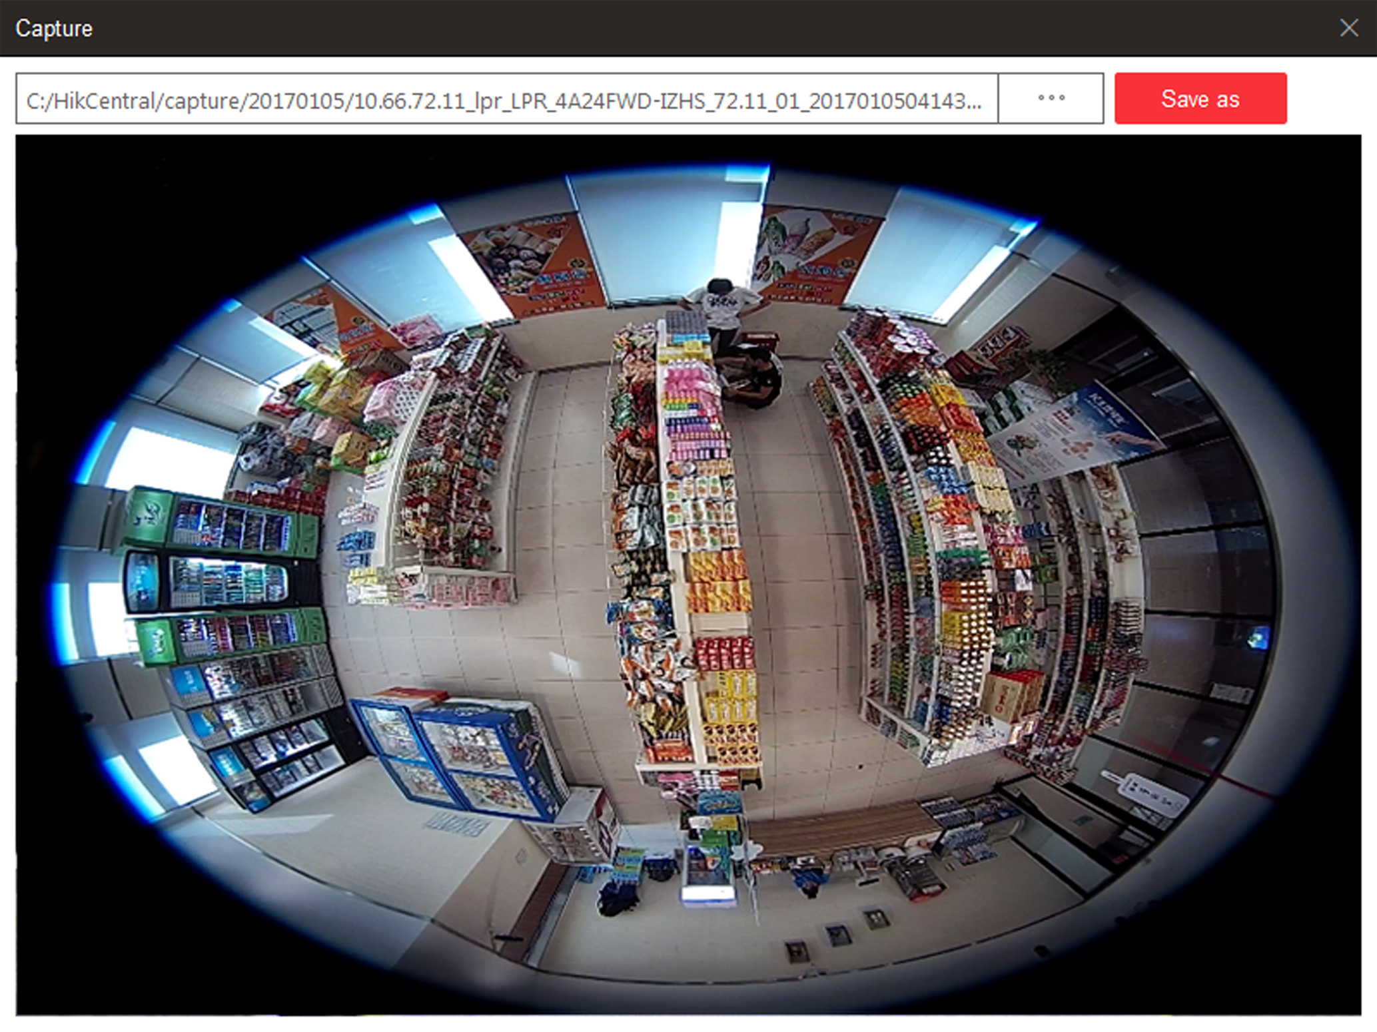
Figure 5-6 Edit Captured Picture

Figure 5-7 Edit Captured Picture
3. Drag on the captured picture to draw as desired, such as marking the suspicious person.
4. Optional: Click Browse to select the saving path and click Save.
Note
The picture cannot be saved if the free space is less than 512 MB.

5.7.5 View Captured Pictures
The captured pictures in live view are stored on the PC on which the Control Client is running.
Perform the following steps to view the captured pictures.
Steps
1. On the Control Panel, click Local Pictureto enter the Local Picture page.
2. Click to select the camera(s) to be searched from the camera list, and click Close to close the camera selection window.
3. Set the time period for the search in the Time field.
4. Click Search.
The pictures captured between the start time and end time will display.
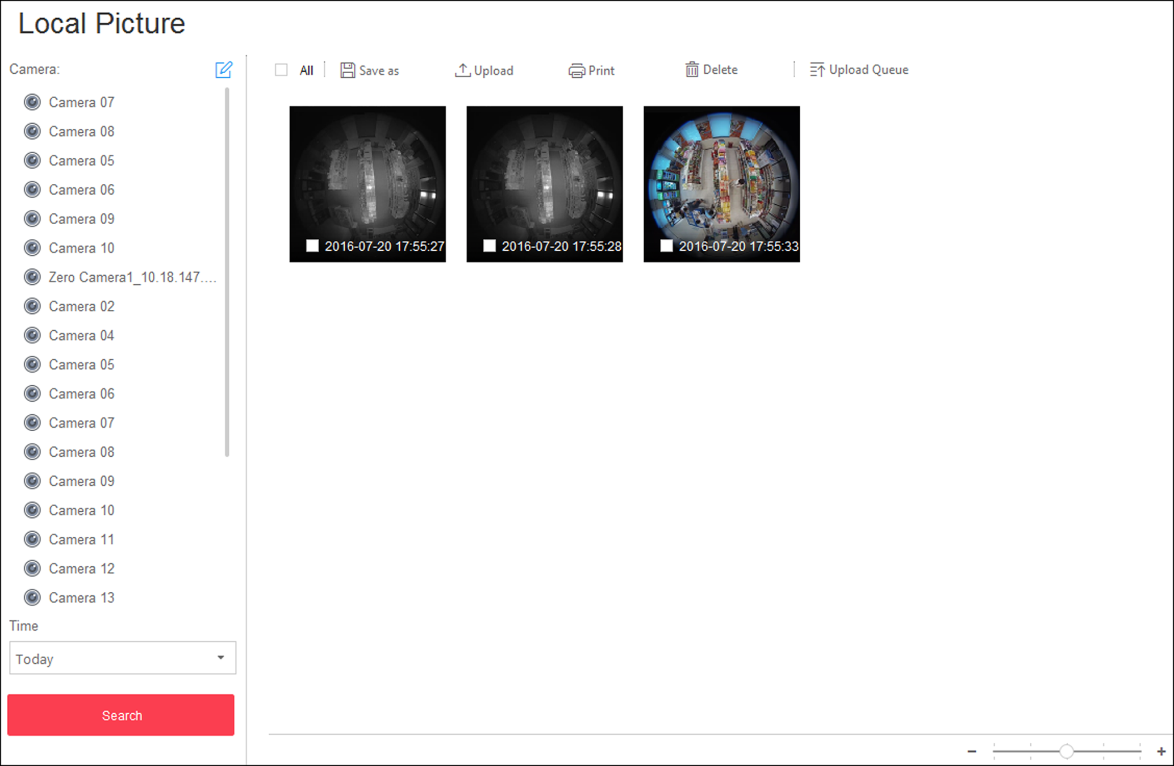
Figure 5-8 Local Picture

Figure 5-9 Local Picture
5. Optional: Double-click the captured picture to enlarge it for a better view.
6. Optional: Select the picture(s) or click All to select all the found picture(s). You can:
Print Pictures | Click Print to print the selected pictures to a printer connected via the network.
Save Picture to Local PC | Click Save As and then specify a local path to save the selected picture(s).
Delete Picture | Click Delete to delete the selected picture(s).

5.8 View Fisheye Camera's Live Video
Dewarping refers to the process of perspective correction of an image, to reverse the effects of geometric distortions caused by the fisheye camera lens. Dewarping allows the user to cover a wide area with a single device, but also to have a "normal" view of an otherwise distorted or reversed image. A dewarped fisheye device will function as regular PTZ device, and can be controlled by clicking and dragging the mouse inside the dewarped image.
Perform this task when you need to start live view and perform PTZ control for fisheye camera.
Steps
Note
Fisheye dewarping mode is not supported if GPU hardware decoding is enabled.

1. Start the live view for a fisheye camera (refer to Start Live View in Area Mode and Start Live View in View Mode).
2. Move the mouse to the live view display window and click to enter the fisheye dewarping mode.
3. Drag on the live video to adjust the view angle.
4. Scroll the mouse wheel to zoom in or out the view.
5. Use the PTZ panel to perform PTZ control of the camera.
Note
- For details about PTZ control, refer to PTZ Control.
- Fisheye camera doesn't support pattern.

5.9 View ANPR Camera's Live Video
You can view the live video of ANPR camera via the Control Client. During live view, the license plate number of the passing vehicle is recognized and displayed on the right side of the live view window. You can mark the suspicious vehicle, add a new vehicle to the vehicle list, and search the passing vehicle information.
Before You Start
Add an ANPR camera to the system via the Web Client. For adding camera, refer to User Manual of HikCentral Web Client.
Perform this task when you need to view ANPR camera's live video.
Steps
1. Click Monitoring on My Dashboard to enter Monitoring page.
Note
If Playback page is shown, click Go to Live View at the bottom to enter Live View page.

2. Start the live view of ANPR camera.
- Drag the ANPR camera from the device list on the left to the display window to start live view.
- Double-click the ANPR camera name in the device list on the left to start live view.
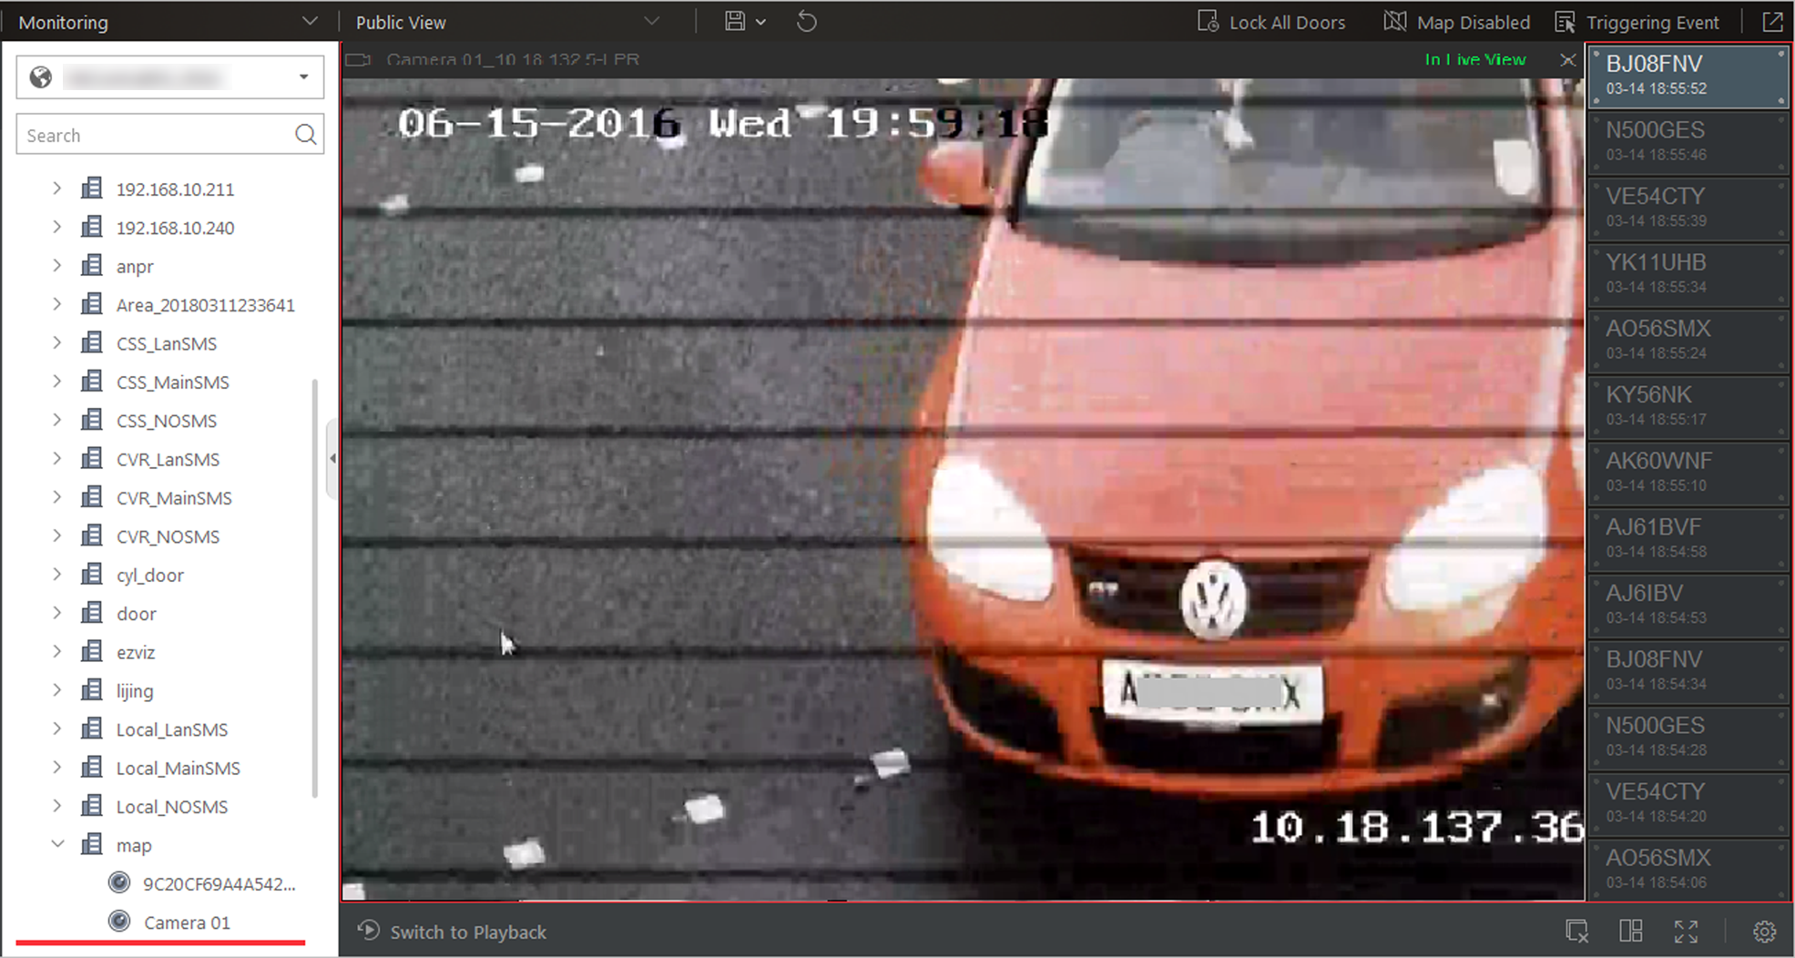
Figure 5-10 Live View of ANPR Camera
3. Perform the following operation(s) after starting the live view of ANPR camera.
Mark Vehicle | If you think the vehicle is suspicious, move the cursor to the recognized license plate number and click to mark the vehicle. The marked vehicles can be filtered out later when searching the related vehicle passing information in Vehicle Search module.
Add Vehicle to Vehicle List | If client recognizes a vehicle that is not added to the vehicle list, you can add it to the vehicle list manually. Move the cursor to the recognized license plate number and click to add the vehicle. See Add Recognized Vehicle to Vehicle List for details.
Search Vehicle | Move the cursor to the recognized license plate and click to enter the Vehicle Search page to search the related vehicle passing information recorded by the camera. For details, refer to Search Recognized Vehicles.

5.10 View UVSS's Live Video
You can view the live video of Under Vehicle Surveillance System (UVSS) via the Control Client. The undercarriage picture of the passing vehicle is captured and displayed on the live view window. The license plate number of the passing vehicle is recognized and displayed on the right side of the live view window. You can mark the vehicle, add the vehicle to the vehicle list, and search the passing vehicle information.
Before You Start
Add a UVSS to the system via Web Client. Refer to User Manual of HikCentral Web Client for details.
Perform this task when you need to view UVSS's live video.
Steps
1. Click Monitoring on My Dashboard to enter Monitoring page.
Note
If Playback page is shown, click Go to Live View at the bottom to enter Live View page.

2. Start the live view of UVSS.
- Drag the UVSS from the device list on the left to the display window to start live view.
- Double-click the UVSS name in the device list on the left to start live view.
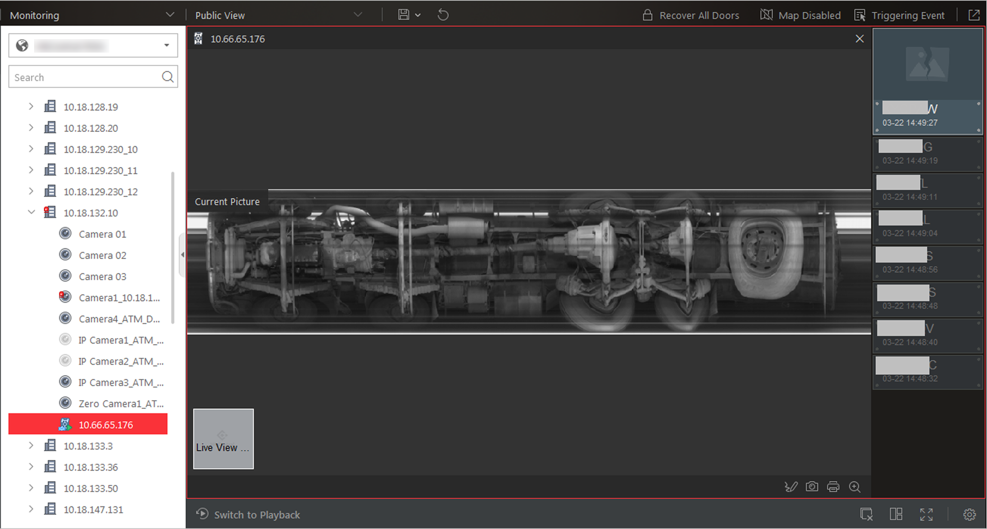
Figure 5-11 Live View of UVSS
You can view the live video of the UVSS linked camera, the undercarriage picture, and recognized license plate number of the passing vehicles.
3. Perform the following operation(s) after starting live view of UVSS.
Mark on Undercarriage Picture | Click on the toolbar and draw on the undercarriage picture to mark important information such as explosive.
Mark Vehicle | If you think the vehicle is suspicious, move the cursor to the recognized license plate number and click to mark the vehicle. The marked vehicles can be filtered out later when searching the related vehicle passing information in Vehicle Search module.
Add Vehicle to Vehicle List | If client recognizes a vehicle that is not added to the vehicle list, you can add it to the vehicle list manually. Move the cursor to the recognized license plate number and click to add the vehicle. See Add Recognized Vehicle to Vehicle List for details.
Search Vehicle | Move the cursor to the recognized license plate and click to enter the Vehicle Search page to search the related vehicle passing information. For details, refer to Search Recognized Vehicles.

5.11 Add Recognized Vehicle to Vehicle List
During the live view of ANPR camera or Under Vehicle Surveillance System (UVSS), the license plate number of the passing vehicle can be recognized. If the recognized vehicle is not added to the vehicle list, you can add it to the vehicle list manually For example, if the vehicle belongs to an VIP visitor, you can add it to the VIP vehicle list. If the vehicle belongs to a habitual thief, you can add it to the blacklist if needed.
Before You Start
You should add a vehicle list via the Web Client. Refer to User Manual of HikCentral Web Client for details.
Perform this task when you need to add the vehicle to the vehicle list.
Steps
Note
Only when the recognized vehicle is not added to the vehicle list, you can add it to the list.

1. Click Monitoring on My Dashboard to enter Monitoring page.
Note
If Playback page is shown, click Go to Live View at the bottom to enter Live View page.

2. Start live view of ANPR camera or UVSS.
- Drag the ANPR camera or UVSS from the device list on the left to the display window to start live view.
- Double-click the ANPR camera name or UVSS name in the device list on the left to start live view.
The detected license plate number is recognized and displayed on the right side of the live view window.
3. Move the cursor to the recognized license plate number, click , and click to display the Add to Vehicle List window.
Note
You can also click after searching for the passing vehicle information on Vehicle Search page to display the Add to Vehicle List window.

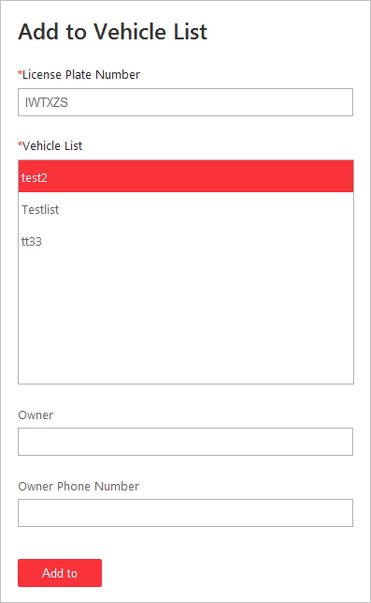
Figure 5-12 Add to Vehicle List
4. Select the vehicle list you want to add the vehicle to.
5. Optional: Edit the license plate number, owner, and owner phone number as desired.
6. Click Add to to add the vehicle to the vehicle list.

5.12 View Detected and Matched Face in Live View
During live view of face recognition cameras, the detected faces will be displayed in the window. After setting the face comparison group and apply it to the camera, the face picture matched with the face in the face comparison group will display, showing the person details, captured picture, matched person's original picture, and similarity. If the detected person is not in the face comparison group, you can also add it to the face comparison group and apply the group to the device to take effect .
Before You Start
Add the required device and configure the face comparison group. Refer to the User Manual of HikCentral Web Client.
Steps
Note
This function should be supported by the device.

1. Click Monitoring to enter the Monitoring module.
The live view or playback page will display according to previous operation on this page.
2. Optional: Click Go to Live View at the bottom to enter the live view page, if the live view page displays.
3. Start live view.
- Drag the camera from the camera list on the left to the display window.
- Double-click the camera name to start the live view.
If a face is detected, it will display on the right of the window. If he/she is not matched with any persons in the camera's linked face comparison groups, the capture time is marked with an orange background as follows.
Figure 5-13 Mismatched Person
4. View matched persons in different face comparison groups.
Example
For example, you can view the matched persons in blacklist and VIP list at the same time.
1) Click tab to open the face comparison group list.
All the face comparison groups added to the system display.
2) Double click the face comparison group name in the list or drag it to the display window.
A blank panel of the face comparison group will display on the right of the display windows.
If there are persons matched with the person in the face comparison group, the captured and original face pictures will display in this panel in pairs with similarity as follows.
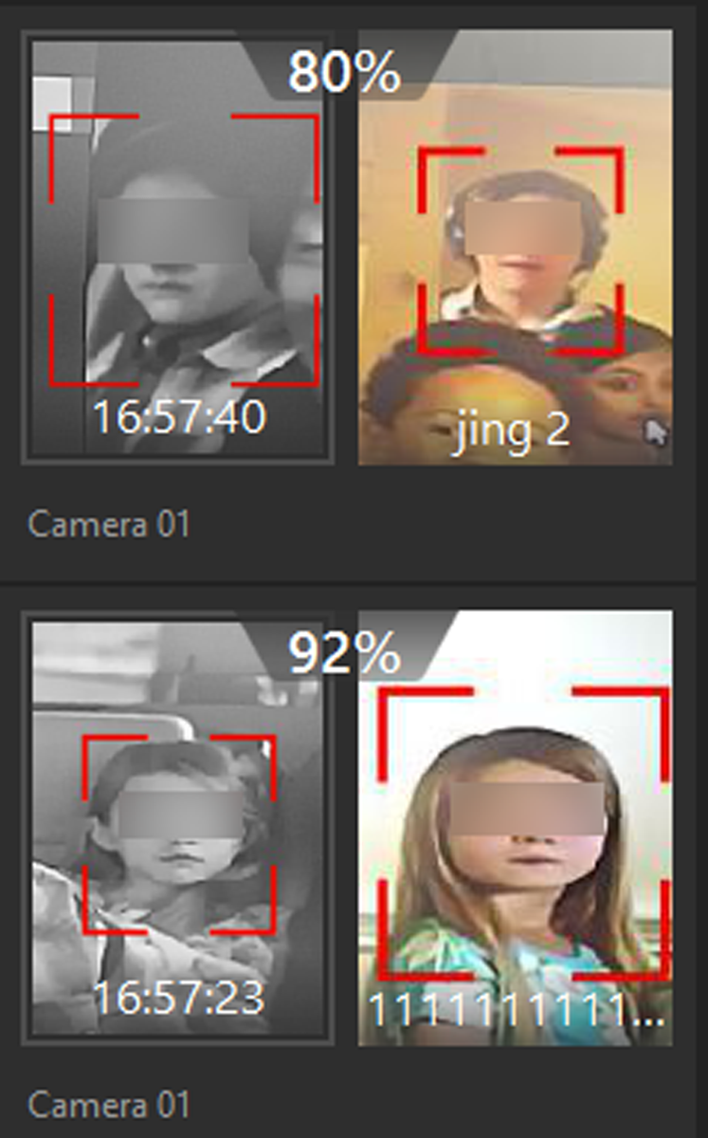
Figure 5-14 Matched Persons
You can view the captured face picture, person's profile (configured in the Web Client) and the similarity. The person's name is shown on the profile.
5. Optional: View all the real-time face comparison events.
1) Click Event List Hidden on the upper right corner to show the event list panel.
2) Click Face Comparison tab to view all the detected faces (including matched and mismatched persons.
Note
For mismatched persons, the picture's capture time is marked with an orange background as follows.
Figure 5-15 Mismatched Person

6. Optional: For the matched persons, view the person details.
- In the matched face picture panel, click to view the matched person details.
- Click the face picture of matched person in the face comparison event list to view the person details.
- In the all events list panel, select the person matched event and click in the Operation column to view the person information.
7. Optional: If there are multiple cameras in live view, you can quickly find the camera which captures certain picture and view its live view.
- In the matched face picture panel, click .
- In the Face Comparison event list, click the captured picture and click Live View.
The camera which captures this picture will be highlighted with a red frame.
8. Optional: For the captured pictures (mismatched or matched person), click the picture and click Search by Picture to search other pictures of this person. Refer to Search Captured Face Picture and Related Video by Picture for more details.

5.13 Add Mismatched Person to Person List
During live view, if a person is detected, but not matched with any persons in the face comparison group, and if you want the person to be recognized for the next time, you can add the person to the face comparison group. For example, if the detected person is a new arrived VIP, you can add the person to the VIP face comparison group and apply this group to the camera. For the next time, the camera will recognize the person's face and match her/him with the person information in the face comparison group.
Steps
1. Click Monitoring to enter the Monitoring module and perform face comparison in live view.
Note
For details, refer to View Detected and Matched Face in Live View.

2. Open the Add to Person List panel.
- In the All Events panel, click in the Operation column to open the Add to Person List page.
- Click the mismatched face pictures in Face Comparison event panel and click Add to Person List.
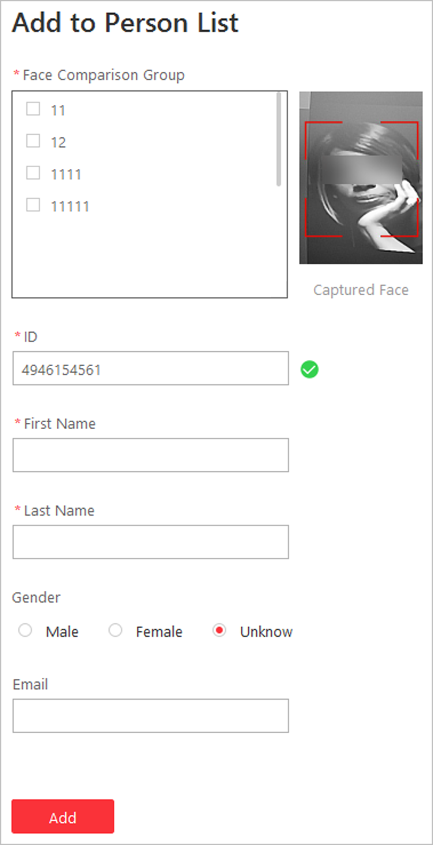
Figure 5-16 Add to Person List
3. Select the face comparison group(s) you want to add this person to.
4. Enter the person details, such as ID, name, gender, etc.
5. Click Add.
What to do next
Log into the Web Client and apply the face comparison group to the camera to take effect.

5.14 Control Access Point in Live View
You can view the live video of the access point's related camera(s). During live view, you can control the access point status, and view the card swiping record in real time. When the access point links two cameras, the video will be displayed in Picture-in-Picture mode, and you can view the live video of the two cameras in one display window.
Before You Start
Link one or two cameras with the access point of the access control device via Web Client in advance.
Steps
1. Click Monitoring to enter the Monitoring module.
The live view or playback page will display according to previous operation on this page.
2. Optional: Click Go to Live View at the bottom to enter the live view page, if the playback page displays.
3. Drag the access point to the display window, or double-click the access point name after selecting the display window.
The display window will play the live view of the linked camera(s) and show the current access point status on the upper right corner. If two cameras are linked, the live video will display in Picture in Picture mode, which means one is at the bottom left of the other one.
Note
- If the access point hasn't linked any camera, the display window will show the access point status only.
- The card swiping record will overlap the display window in real time, if the event happens.

4. Optional: In Picture in Picture mode, click the smaller video view to switch the view position of the two cameras.
Note
The two video views are independent, and the abnormal one cannot influence the other.

5. Optional: Click the icon on the upper right corner of the display window, and switch the access point status among Unlock, Lock, Remain Unlocked, Remain Locked.
Note
If the access point of the turnstile is selected to control in live view, you can respectively switch the access point status for entrance control and exit control.

Unlock
When the access point is locked, unlock the access point and it will be open. After the access point open duration (configured via the Web Client), the access point will be closed and locked again automatically.
Note
For setting the access point's open duration, refer to User Manual of HikCentral Web Client.

Lock
When the access point is unlocked, lock the access point and it will be closed. The person who has the access permission can access the access point with credentials.
Remain Unlocked
The access point will be unlocked (no matter closed or open). All the persons can access the access point with no credentials required (free access).
Remain Locked
The access point will be closed and locked. No person can access the access point even if he/she has the authorized credentials, except the super users.
Note
For setting person's super user privilege, refer to User Manual of HikCentral Web Client.

6. Optional: Perform the follow operations after starting the live video of the access point.
All Access Points Status Control | When the emergency happens, you can click Lock All Doors or Recover All Doors on the top of the live view window to switch all the access point status to normal or locked.
Triggering Event | Click Triggering Event to select the user-defined event. Refer to Manually Trigger User-Defined Event for details.

5.15 View Detected Event in Live View
The detected events, including ANPR events, face comparison event and access event,can display in real-time during live view. You can view the event details, filter the events, and clear the events.
Before You Start
Make sure you have add the required devices and events.
Perform this task to view the detected event in live view.
Steps
1. Click Monitoring on My Dashboard to enter Monitoring page.
Note
If Playback page is shown, click Go to Live View at the bottom to enter Live View page.

2. Start the live view.
3. Click Event List Shown on the top of the display window.
The event list page is unfold from the bottom.
4. Select All Events, Face Comparison, or Access Control to view the corresponding event information.
Note
The all events tab lists the ANPR events, face comparison events and access events.

5. Perform the following operation(s).
View Event Details | Click to view the event details.
Add to List | - If the client recognizes a person that is not added to the person list, you can add her/him to the face comparison group by clicking . Refer to View Detected and Matched Face in Live View for details.  - If the client recognizes a vehicle license plate that is not added to the vehicle list, you can add it to the vehicle list by clicking . Refer to Add Recognized Vehicle to Vehicle List for details.
Subscribe Events of All Resources | In the Face Comparison or Access Control event list, check Subscribe All so that the current Control Client can receive events from all the face comparison groups or access points, and display in the corresponding event list.
Filter Event | Click to select the resource to filter the related event.
Clear Event | Click to clear all the detected events.

5.16 Stop Live View
Stop the live view if needed.
You can perform the following steps to stop the live view.
Steps
1. Select the display window.
2. Click that appears in the upper-right corner when the mouse pointer is over the display window. You can also click in live view toolbar to stop the live view of all the display windows.

5.17 More Functions
There are some other functions supported in the live view, including auxiliary screen preview, digital zoom, two-way audio, camera status, and arming control.
Auxiliary Screen Preview
Live video can be displayed on different auxiliary screens to monitor multiple scenes. Click above the display window area to open an auxiliary screen. Up to four auxiliary screens for live view are supported.
Digital Zoom
Digital zoom is a useful feature for cameras that do not have their own optical zoom capabilities. It lets you zoom a portion of a given image to have a closer look at it.
Move the mouse to the live view display window and click . Use the left key of mouse to drag a rectangle on an area you wish to zoom into in the lower-right/upper-left direction.
Two-way Audio
Move the mouse to the live view display window and click . Two-way audio function enables audio on supported cameras. You can get not only the live video but also the real-time audio from the camera. For other operations, refer to Tools.
Note
This function is not supported by the cameras added in Remote Site.

Camera Status
Move the mouse to the live view display window and click 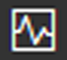. The camera status, such as recording status, signal status, connection number, etc., can be detected and displayed. The default inspection interval for the camera status is 3 minutes.
Arming Control
Move the mouse to the live view display window and click . The status of the enabled event detection (e.g., motion detection, video loss) of the camera displays, such as arming status, alarm name and alarm level. You can click Disarm or Disarm All to disable the event detection and set the disarming duration. You can also click Arm or Arm All to enable the event detection.

5.18 Customize Icons on Live View Window
You can customize the icons shown on the toolbar of the display window and other display settings for live view control.
Perform this task when you need to customize icons on live view window.
Steps
1. Click System on the control panel to enter the System page.
2. Click Application Settings → Live View to enter the Live View Settings page.
3. Customize the live view toolbar.
- Click an icon in the list to add it to the gray frame below to hide the icon. Icons in the gray frame will be hidden in the toolbar of the live view window.
- Click the icon in the gray frame to add it back to the live view toolbar to show an icon on the toolbar.
4. Drag the icons in the icon list to adjust icon positions.
Audio Control | Turn off/on the sound and adjust the volume.
Capture | Take a snapshot of the current video and save in the current PC.
Print | Take a snapshot of the current video and print it.  You can enter some descriptive information.
Record | Record the video files for current live view and save in the current PC.
Playback | Switch to instant playback to view the recorded video files.
Two-Way Audio | Start two-way audio with the camera to get the real-time audio from the device to realize voice talk with the person at the device.
Digital Zoom | Zoom in or out the video for cameras that do not have their own optical zoom capabilities. Click again to disable the function.
PTZ Control | Activate the PTZ icons on the image to pan, tilt, or zoom the image.
Fisheye Dewarping | Available for fisheye camera. In the fisheye dewarping mode, the Control Client will correct the video image and reverse the effects of geometric distortions caused by the fisheye camera lens. See View Fisheye Camera's Live Video.
Camera Status | Show the camera's recording status, signal status, connection number, etc.
Arming Control | Open the arming control window of the camera to arm or disarm the camera's event. The Control Client can receive the armed events or alarms.
Edited Transcoded Stream | Switch the live view stream to main stream, sub-stream (if supported), or smooth stream (if supported).  Note  The smooth stream will show if the device supports smoothing function. You can switch to smooth stream if in low bandwidth situation to make live view more fluent.
Live View on Smart Wall | Display the live video on the smart wall. See Manage Smart Wall for details.
VCA Playback | Display the VCA Search window. You can set VCA rule to search video files and filter the videos by VCA event types. Refer to Search VCA Event Related Video for more details.
Alarm Output | Display the Alarm Output Control page and turn on/off the alarm outputs of the connected camera. See Control Alarm Output for details.

Note
The icons shown on the toolbar in the display window will vary with the device's capabilities.

5. Optional: Set the Always Display Toolbar to ON to always display the toolbar on the live view window.
6. Click Save.

Chapter 6 Playback
You can view the recorded video files on the Monitoring module of the Control Client.

6.1 Normal Playback
You can search video files by area or camera for the Normal Playback and download found video files to local PC. You can also add a tag to mark important video footage, and so on.

6.1.1 Search Video File
You can search video files by camera, by area, or by time for normal playback. And you can also filter the searched video files by video type or by storage location.
Perform this when you need to search a specific video files.
Steps
1. Enter the Monitoring module.
The live view or playback page will display according to previous operation on this page.
2. Optional: Click Go to Playback at the bottom to enter the playback page, if the live view page displays.
Note
The playback window supports up to 16 channels. If exceeding the limit in live video display window, select the channels within 16 before switching to playback.

Today's recorded video files of the selected camera will be played.
3. Optional: Drag the camera or area to the display window, or double-click the camera or area to play the recording of the specified camera(s) in selected window.
4. Click on the toolbar to set the date and time to search video files by time.
Note
In the calendar, the date with video files will be marked with a triangle.

After selecting the date and time, the matched video files will start playing in the display window.
5. Optional: Click on the toolbar to select video type and storage location for playback.
Note
To set the storage location for recording, refer to User Manual of HikCentral Web Client.

6.1.2 Play Video File
After searching the video files for the normal playback, you can play the video via timeline or thumbnails.
Perform this task when you need to play the video files.
Steps
1. Click Monitoring to enter the Monitoring module.
The live view or playback page displays.
2. Optional: Click Go to Playback at the bottom to enter the playback page, if the live view page displays.
Note
The playback window supports up to 16 cameras.

The playback window will play today's recorded video files of the channels in live view.
3. Select a date with videos to start playing video and show the timeline after searching the video files.
Note
The video files of different types are color coded.

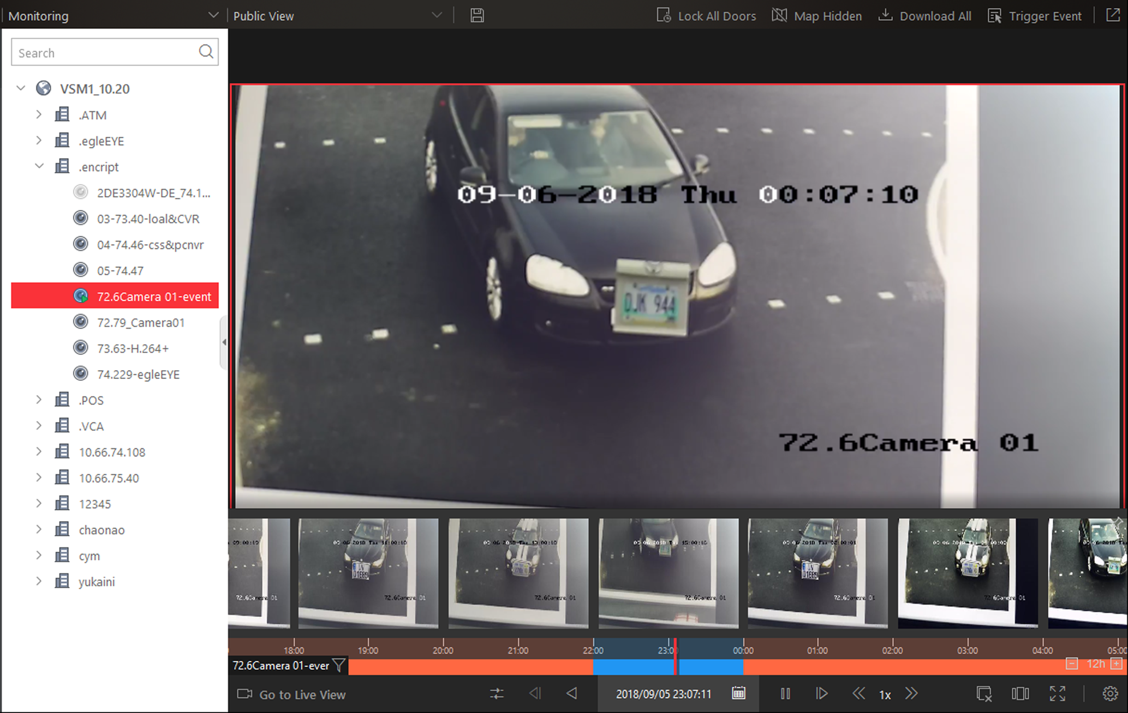
Figure 6-1 Play Video Files
4. Play video in specified time period by timeline or thumbnails.
- Drag the timeline forward or backward to position the desired video segment.
- Move the cursor over the timeline to take a quick view of video thumbnails (if supported by the device) and click the appearing thumbnail to play the specific video segment.
Note
- Click the icon / on the right of the timeline bar, or use the mouse wheel to zoom in or zoom out on the timeline
- Click / to show or hide the thumbnail bar.
- Move the cursor to the top border of the thumbnail bar and drag to adjust the height of the thumbnails when the cursor changes into . You can also click to lock the thumbnail bar above the playback timeline, and click to hide the thumbnail bar automatically.

5. Optional: Move the mouse to the lower edge of the playback window to access the icons for further operations.
Note
For details, refer to Customize Icons on Playback Window.

6.2 Start Playback in View Mode
You can quickly access the playback of the cameras managed in a view.
Perform this task when you start playback in view mode.
Steps
1. Click Monitoring on My Dashboard to enter Monitoring page.
2. Click to enter the view mode.
Note
If the Live View page is shown, click Go to Playback at the bottom to enter the Playback page.

3. Optional: Add a view if no view is available. Refer to Manage View for details.
4. Click a view to quickly start the playback of all the cameras related to the view.
Note
You can also quickly switch the added view from the drop-down view list above the displaying windows.

6.3 View Map in Playback
When you view the resources on the map, you can drag the resources to the display window to view the playback of surveillance scenarios quickly.
Before You Start
Configure the map settings via the Web Client. For details, see User Manual of HikCentral Web Client.
Perform this task when you need to view map in playback.
Steps
1. Click Monitoring on My Dashboard to enter the Monitoring page.
Note
If Live View page is shown, click Go to Playback at the bottom to enter Playback page.

2. Click Map Hidden to display the map.
3. Start playback of the resource on the map. For detailed playback control instructions, refer to Play Video File.
- Drag one resource to the display window to start playback.
- Click , select , and drag on the map to select multiple resources. Drag the selected resources to the display window to start playback.
Note
- Up to 16 resources can be selected.
- The display windows adapt to the number of selected resources.

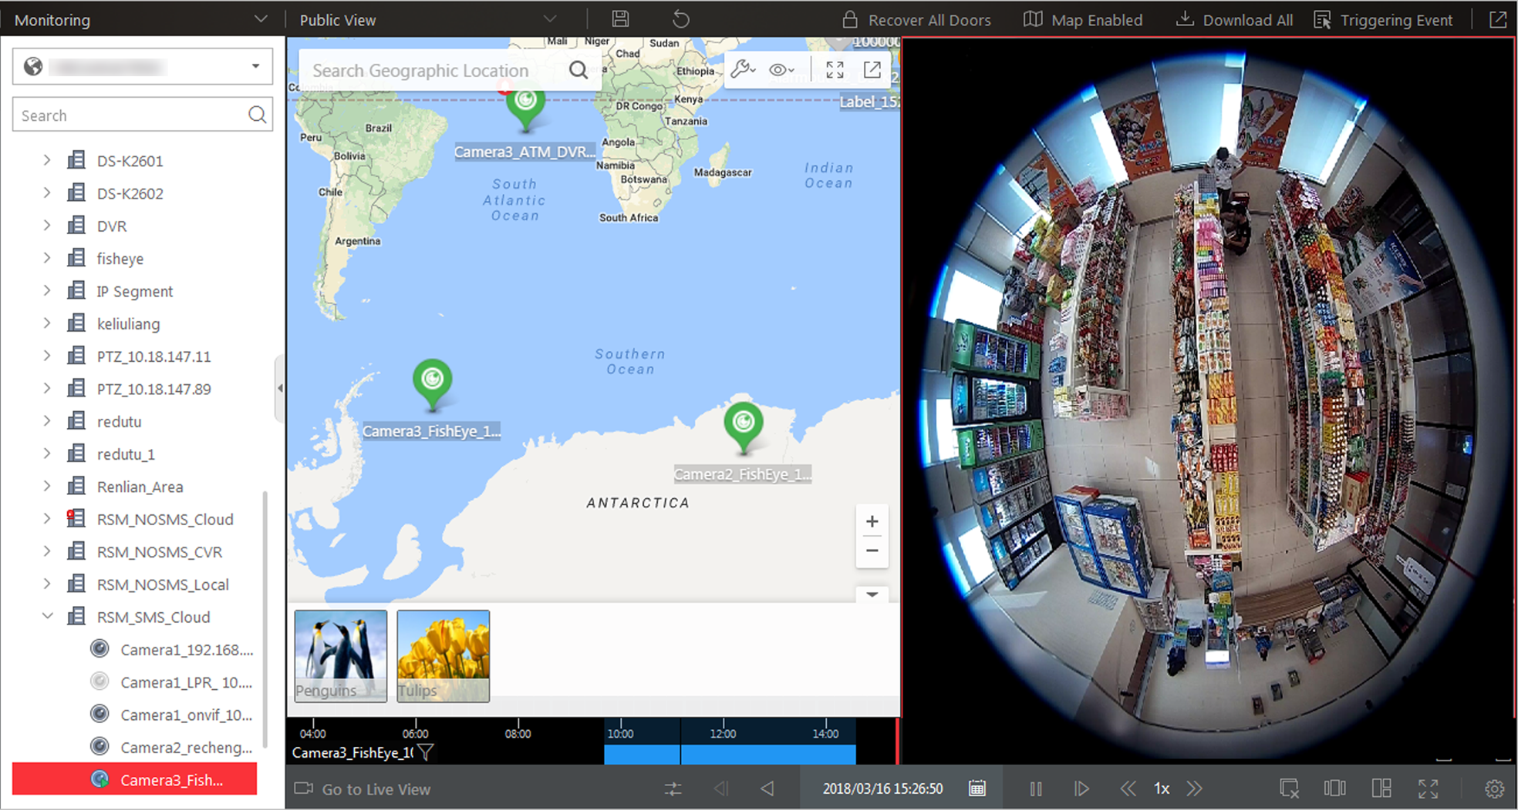
Figure 6-2 View Map in Playback

6.4 Synchronous Playback
You can play the video files of different cameras synchronously.
Perform this task when you need to play video files in synchronization.
Note
Video files from up to 16 cameras can be played simultaneously.

Steps
1. Click Monitoring to enter the Monitoring module.
The live view or playback page displays.
2. Optional: Click Go to Playback at the bottom to enter the playback page, if the live view page displays.
3. Start normal playback of at least two cameras.
Note
For detailed configuration about normal playback and playback control, refer to Normal Playback. Some icons may not be available for synchronous playback.

4. Click on the playback toolbar to enable the synchronous playback.
The cameras displayed in Playback will start synchronous playback.
5. Optional: Click on the playback toolbar to disable synchronous playback.
6. Optional: Move the mouse to the lower edge of the playback window to access the icons for further operations.
Note
For details, refer to Customize Icons on Playback Window.

6.5 Fisheye Playback
You can play the video files of a fisheye camera in fisheye dewarping mode.
Perform this task when you need to play video files of fisheye camera in fisheye dewarping mode.
Steps
Note
Fisheye dewarping mode is not supported if GPU hardware decoding is enabled.

1. Enter the Monitoring module.
The live view or playback page will display according to previous operation on this page.
2. Optional: Click Go to Playback at the bottom to enter the playback page, if the live view page displays.
3. Select a fisheye camera to start playback.
Note
For detailed configuration about playback and playback control, refer to Normal Playback.

4. Move the cursor to the display window and click on the appearing toolbar to enter the fisheye dewarping mode.
5. Drag on the video to adjust the view angle.
6. Scroll the mouse wheel to zoom in or out the view.

6.6 Customize Icons on Playback Window
You can customize the icons shown on the toolbar of the display window for playback control.
Perform this task when you need to customize icons on playback window.
Steps
1. Click System on the control panel to enter the System page.
2. Click Playback to enter the Playback Settings page.
3. Customize playback toolbar.
- Click an icon in the list to add it to the gray frame below to hide the icon. Icons in the gray frame will be hidden in the toolbar of the playback window.
- Click the icon in the gray frame to add it back to the playback toolbar to show an icon on the toolbar.
4. Drag the icons in the icon list to adjust icon positions.
Audio Control | Turn off/on the sound and adjust the volume.
Capture | Take a snapshot of the current video and save in the current PC.
Print | Take a snapshot of the current video and print it.  You can enter some descriptive information.
Clip | Clip the video files for current playback and save in the current PC.
Tag Control | Add custom tag for the video file to mark the important video point. You can also edit the tag or go to the tag position conveniently.
Lock Video | Lock the video file and set the locking duration to avoid deleting the video file and protect the video file from being overwritten when the HDD is full.  Note  For the camera imported from Remote Site, if the video files are stored on the encoding device locally, you cannot lock the video files.
Digital Zoom | Zoom in or out the video for cameras that do not have their own optical zoom capabilities. Click again to disable the function.  Note  When in software decoding mode, you can also capture the zoomed in picture after enabling digital zoom function.
Download Video File | Download the video file of the camera and save them to your PC or connected USB device.
Fisheye Dewarping | Available for fisheye camera for entering the fisheye dewarping mode. See Fisheye Playback.
VCA Playback | Display the VCA Search window. You can set VCA rule to search video files and filter the videos by VCA event types, including VCA Search, Intrusion Detection, and Line Crossing Detection. Refer to Search VCA Event Related Video for more details.
Camera Status | Show the camera's recording status, signal status, connection number, etc.
Stream Switch | Switch the stream to main stream, sub-stream (if supported), or smooth stream (if supported).  If the device supports transcoding playback, start transcoding and you need to set the resolution, frame rate and bitrate for transcoding.  Note  - The smooth stream will show if the device supports smoothing function. You can switch to smooth stream if in low bandwidth situation to make live view more fluent.  - Only video files stored in DVR and I-series NVR support transcoding playback.
Playback on Smart Wall | Click to view the playback on smart wall. See Manage Smart Wall for details.
Frame-Extracting Playback | Extract frames from the video and play the extracted images (frames) one by one.

Note
The icons shown on the toolbar in the display window will vary with the device's capabilities.

5. Optional: Set theAlways Display Toolbar switch to ON to always display the toolbar on the playback window.
6. Click Save.

Chapter 7 Video Search
The video files stored on local devices or Recording Server can be searched.

7.1 Search Tagged Video Footage
You can search for the camera's tagged video footage.
Perform this task when you need to search the video footage which is added with tag.
Note
For adding tag to the video file, refer to Play Video File.

Steps
1. Click Video Search to enter the Video Search page.
2. Click Video Clip tab to search for video footage.
3. Select the search type as Tag.
4. Optional: Enter the keyword of tag name to search.
5. Select cameras.
1) Click in this camera panel.
2) Select a current site or Remote Site from the drop-down site list to show its cameras.
3) Check the cameras you want to search.
4) Click Close.
Note
- Up to 16 resources can be selected for search at the same time.
- The icon and represent the current site and remote site, respectively.

6. Optional: Move the mouse to the selected camera and click to switch the storage location between Main Storage or Auxiliary Storage.
7. Set the time period for search in Time field.
- Select the predefined time period in the drop-down list.
- Select Custom Time Interval to specify the start time and end time for the search.
8. Click Search to find the related video footage.
The search results will be displayed and grouped by different cameras. You can switch between thumbnail and list mode to view.

9. Optional: Start remote playback of the searched video footage.
- For list mode, click the object in Time Range column
- For thumbnail mode, click the image of the searched result.
Play the previous video footage among the searched results.
Play the next video footage among the searched results.
Play in Order
After playing the current video footage, continue to play the next one automatically.
Note
Refer to Normal Playback for more details of playback.

10. Optional: Download the searched video footage to local storage.
- During playback, click 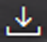 to download the current video footage.
- Select the video footage and click Download to download all the selected video footage.
1) (Optional) For downloading single video footage, set the time range of the video footage to download.
2) Set the saving path to store the downloaded video files.
3) Set the file format of the downloaded file.
MP4
MP4 format supports encryption. You can set a password to encrypt the video file for security purpose.
Only VSPlayer supports playing video files in MP4 format. You can check Download VSPlayer to download the player with the video files.
AVI
Besides VSPlayer, other player also supports playing the video files in AVI format.
You can check Download VSPlayer to download the player with the video files.
EXE
Package the video files with the VSPlayer into one EXE file. The selected video footage of one camera will be merged to one MP4 file.
After downloading, double click the EXE file and the VSPlayer will launch. The merged video files of different cameras will be displayed in the playlist.
Note
Up to 16 cameras can be selected to download in EXE format for one time.

4) (Optional) If you select the format as MP4 or AVI, you can check Merge Video Files to merge the selected video footage of the same camera to one video file.
Note
Up to 2 GB files can be merged.

5) Click Download to add the downloading task to the download center.
Note
For details about managing the downloading tasks, refer to Manage Downloading Tasks.

7.2 Search Locked Video Footage
You can search for the camera's locked video footage.
Perform this task when you need to search for the locked video footage.
Note
For locking the video file, refer to Normal Playback.

Steps
1. Click Video Search to enter the Video Search page.
2. Click Video Clip tab to search for video footage.
3. Select the search type as Locked File.
4. Select cameras.
1) Click in this camera panel.
2) Select a current site or Remote Site from the drop-down site list to show its cameras.
3) Check the cameras you want to search.
4) Click Close.
Note
- Up to 16 resources can be selected for search at the same time.
- The icon and represent the current site and remote site, respectively.

5. Optional: Move the mouse to the selected camera and click to switch the storage location between Main Storage or Auxiliary Storage.
6. Set the time period for search in Time field.
- Select the predefined time period in the drop-down list.
- Select Custom Time Interval to specify the start time and end time for the search.
7. Click Search to find the related video footage.
The search results will be displayed and grouped by different cameras. You can switch between thumbnail and list mode to view.

8. Optional: Start remote playback of the searched video footage.
- For list mode, click the object in Time Range column
- For thumbnail mode, click the image of the searched result.
Play the previous video footage among the searched results.
Play the next video footage among the searched results.
Play in Order
After playing the current video footage, continue to play the next one automatically.

Note
Refer to Normal Playback for more details of playback.

9. Optional: Download the searched video footage to local storage.
- During playback, click to download the current video footage.
- Select the video footage and click Download to download all the selected video footage.
1) (Optional) For downloading single video footage, set the time range of the video footage to download.
2) Set the saving path to store the downloaded video files.
3) Set the file format of the downloaded file.
MP4
MP4 format supports encryption. You can set a password to encrypt the video file for security purpose.
Only VSPlayer supports playing video files in MP4 format. You can check Download VSPlayer to download the player with the video files.
AVI
Besides VSPlayer, other player also supports playing the video files in AVI format.
You can check Download VSPlayer to download the player with the video files.
EXE
Package the video files with the VSPlayer into one EXE file. The selected video footage of one camera will be merged to one MP4 file.
After downloading, double click the EXE file and the VSPlayer will launch. The merged video files of different cameras will be displayed in the playlist.
Note
Up to 16 cameras can be selected to download in EXE format for one time.

4) (Optional) If you select the format as MP4 or AVI, you can check Merge Video Files to merge the selected video footage of the same camera to one video file.
Note
Up to 2 GB files can be merged.

5) Click Download to add the downloading task to the download center.
Note
For details about managing the downloading tasks, refer to Manage Downloading Tasks.

7.3 Search Interval Video Footage
You can search for the video footage according to the configured interval.
Perform this task when you need to search for the interval video footage.
Steps
1. Click Video Search to enter the Video Search page.
2. Click Video Clip tab to search for video footage.
3. Select the search type as Interval.
4. Set the interval.
5. Select cameras.
1) Click in this camera panel.
2) Select a current site or Remote Site from the drop-down site list to show its cameras.
3) Check the cameras you want to search.
4) Click Close.
Note
- Up to 16 resources can be selected for search at the same time.
- The icon and represent the current site and remote site, respectively.

6. Optional: Move the mouse to the selected camera and click to switch the storage location between Main Storage or Auxiliary Storage (if configured).
7. Set the time period for search in Time field.
- Select the predefined time period in the drop-down list.
- Select Custom Time Interval to specify the start time and end time for the search.
8. Click Search to search the related videos.
The search results will be displayed and grouped by different cameras. You can switch between thumbnail and list mode to view.
9. Optional: Start remote playback of the searched video footage.
- For list mode, click the object in Time Range column.
- For thumbnail mode, click the image of the searched result.
Play the previous video footage among the searched results.
Play the next video footage among the searched results.
Play in Order
After playing the current video footage, continue to play the next one automatically.

Note
Refer to Normal Playback for more details of playback.

10. Optional: Download the searched video footage to local storage.
- During playback, click to download the current video footage.
- Select the video footage and click Download to download all the selected video footage.
1) (Optional) For downloading single video footage, set the time range of the video footage to download.
2) Set the saving path to store the downloaded video files.
3) Set the file format of the downloaded file.
MP4
MP4 format supports encryption. You can set a password to encrypt the video file for security purpose.
Only VSPlayer supports playing video files in MP4 format. You can check Download VSPlayer to download the player with the video files.
AVI
Besides VSPlayer, other player also supports playing the video files in AVI format.
You can check Download VSPlayer to download the player with the video files.
EXE
Package the video files with the VSPlayer into one EXE file. The selected video footage of one camera will be merged to one MP4 file.
After downloading, double click the EXE file and the VSPlayer will launch. The merged video files of different cameras will be displayed in the playlist.
Note
Up to 16 cameras can be selected to download in EXE format for one time.

4) (Optional) If you select the format as MP4 or AVI, you can check Merge Video Files to merge the selected video footage of the same camera to one video file.
Note
Up to 2 GB files can be merged.

5) Click Download to add the downloading task to the download center.
Note
For details about managing the downloading tasks, refer to Manage Downloading Tasks.

7.4 Search Segmented Video Footage
You can search for the camera's video footage in specific number of segment.
Perform this task when you need to search the video footage and segment it into specific number of segments.
Steps
1. Click Video Search to enter the Video Search page.
2. Click Video Clip tab to search for video footage.
3. Select the search type as Segment.
4. Enter the number of segments.
5. Select cameras.
1) Click in this camera panel.
2) Select a current site or Remote Site from the drop-down site list to show its cameras.
3) Check the cameras you want to search.
4) Click Close.
Note
- Up to 16 resources can be selected for search at the same time.
- The icon and represent the current site and remote site, respectively.

6. Optional: Move the mouse to the selected camera and click to switch the storage location between Main Storage or Auxiliary Storage.
7. Set the time period for search in Time field.
- Select the predefined time period in the drop-down list.
- Select Custom Time Interval to specify the start time and end time for the search.
8. Click Search to find the related video footage.
The search results will be displayed and grouped by different cameras. You can switch between thumbnail and list mode to view.

9. Optional: Start remote playback of the searched video footage.
- For list mode, click the object in Time Range column
- For thumbnail mode, click the image of the searched result.
Play the previous video footage among the searched results.
Play the next video footage among the searched results.
Play in Order
After playing the current video footage, continue to play the next one automatically.
Note
Refer to Normal Playback for more details of playback.

10. Optional: Download the searched video footage to local storage.
- During playback, click to download the current video footage.
- Select the video footage and click Download to download all the selected video footage.
1) (Optional) For downloading single video footage, set the time range of the video footage to download.
2) Set the saving path to store the downloaded video files.
3) Set the file format of the downloaded file.
MP4
MP4 format supports encryption. You can set a password to encrypt the video file for security purpose.
Only VSPlayer supports playing video files in MP4 format. You can check Download VSPlayer to download the player with the video files.
AVI
Besides VSPlayer, other player also supports playing the video files in AVI format.
You can check Download VSPlayer to download the player with the video files.
EXE
Package the video files with the VSPlayer into one EXE file. The selected video footage of one camera will be merged to one MP4 file.
After downloading, double click the EXE file and the VSPlayer will launch. The merged video files of different cameras will be displayed in the playlist.
Note
Up to 16 cameras can be selected to download in EXE format for one time.

4) (Optional) If you select the format as MP4 or AVI, you can check Merge Video Files to merge the selected video footage of the same camera to one video file.
Note
Up to 2 GB files can be merged.

5) Click Download to add the downloading task to the download center.
Note
For details about managing the downloading tasks, refer to Manage Downloading Tasks.

7.5 Search Transaction Event Triggered Video Footage
You can search for the video footage triggered by transaction event which contains POS information.
Perform this task when you need to search the transaction event triggered video footage.
Steps
1. Click Video Search to enter the Video Search page.
2. Click Video Clip tab to search for video footage.
3. Select the search type as Transaction Event.
4. Enter the keywords that are contained in the POS information.
Note
- You can enter up to three keywords, and you should separate each one with a space.
- If you enter more than one keyword for search, you can select "|" to search the POS information containing any of the keywords, or select "&" to search the POS information containing all keywords.

5. Optional: Select Case Sensitive to search the POS information with case-sensitivity.
6. Select the device and camera in the Camera field to search the transaction information.
7. Optional: Click to switch the storage location between Main Storage or Auxiliary Storage, and switch the stream between Main Stream or Sub-Stream.
8. Set the time period for search in Time field.
- Select the predefined time period in the drop-down list.
- Select Custom Time Interval to specify the start time and end time for the search.
9. Click Search to find the related video footage.
The search results will be displayed and grouped by different cameras. You can switch between thumbnail and list mode to view.

10. Optional: Start remote playback of the searched video footage.
- For list mode, click the object in Time Range column
- For thumbnail mode, click the image of the searched result.
Play the previous video footage among the searched results.
Play the next video footage among the searched results.
Play in Order
After playing the current video footage, continue to play the next one automatically.

Note
Refer to Normal Playback for more details of playback.

11. Optional: Download the searched video footage to local storage.
- During playback, click to download the current video footage.
- Select the video footage and click Download to download all the selected video footage.
1) (Optional) For downloading single video footage, set the time range of the video footage to download.
2) Set the saving path to store the downloaded video files.
3) Set the file format of the downloaded file.
MP4
MP4 format supports encryption. You can set a password to encrypt the video file for security purpose.
Only VSPlayer supports playing video files in MP4 format. You can check Download VSPlayer to download the player with the video files.
AVI
Besides VSPlayer, other player also supports playing the video files in AVI format.
You can check Download VSPlayer to download the player with the video files.
EXE
Package the video files with the VSPlayer into one EXE file. The selected video footage of one camera will be merged to one MP4 file.
After downloading, double click the EXE file and the VSPlayer will launch. The merged video files of different cameras will be displayed in the playlist.
Note
Up to 16 cameras can be selected to download in EXE format for one time.

4) (Optional) If you select the format as MP4 or AVI, you can check Merge Video Files to merge the selected video footage of the same camera to one video file.
Note
Up to 2 GB files can be merged.

5) Click Download to add the downloading task to the download center.
Note
For details about managing the downloading tasks, refer to Manage Downloading Tasks.

7.6 Search ATM Event Triggered Video Footage
You can search for the video footage triggered by ATM event.
Perform this task when you need to search for the ATM event triggered video footage.
Steps
1. Click Video Search to enter the Video Search page.
2. Click Video Clip tab to search for video footage.
3. Select the search type as ATM Event.
4. Enter the card number that is contained in the ATM information.
5. Select the device and camera to search the ATM information in the Camera field.
6. Optional: Click to switch the storage location between Main Storage or Auxiliary Storage, and switch the stream between Main Stream or Sub-Stream.
7. Set the time period for search in Time field.
- Select the predefined time period in the drop-down list.
- Select Custom Time Interval to specify the start time and end time for the search.
8. Click Search to find the related video footage.
The search results will be displayed and grouped by different cameras. You can switch between thumbnail and list mode to view.

9. Optional: Start remote playback of the searched video footage.
- For list mode, click the object in Time Range column
- For thumbnail mode, click the image of the searched result.
Play the previous video footage among the searched results.
Play the next video footage among the searched results.
Play in Order
After playing the current video footage, continue to play the next one automatically.

Note
Refer to Normal Playback for more details of playback.

10. Optional: Download the searched video footage to local storage.
- During playback, click to download the current video footage.
- Select the video footage and click Download to download all the selected video footage.
1) (Optional) For downloading single video footage, set the time range of the video footage to download.
2) Set the saving path to store the downloaded video files.
3) Set the file format of the downloaded file.
MP4
MP4 format supports encryption. You can set a password to encrypt the video file for security purpose.
Only VSPlayer supports playing video files in MP4 format. You can check Download VSPlayer to download the player with the video files.
AVI
Besides VSPlayer, other player also supports playing the video files in AVI format.
You can check Download VSPlayer to download the player with the video files.
EXE
Package the video files with the VSPlayer into one EXE file. The selected video footage of one camera will be merged to one MP4 file.
After downloading, double click the EXE file and the VSPlayer will launch. The merged video files of different cameras will be displayed in the playlist.
Note
Up to 16 cameras can be selected to download in EXE format for one time.

4) (Optional) If you select the format as MP4 or AVI, you can check Merge Video Files to merge the selected video footage of the same camera to one video file.
Note
Up to 2 GB files can be merged.

5) Click Download to add the downloading task to the download center.
Note
For details about managing the downloading tasks, refer to Manage Downloading Tasks.

7.7 Search VCA Event Related Video
You can search video files where VCA events occur. And you can play or download the found video files. The VCA events include motion detection, intrusion, and line crossing.
Perform this task when you need to search the video files where VCA events occur.
Steps
Note
- This function should be supported by the device.
- Video files stored on a Hybrid Storage Area Network do not support VCA event search.

1. Access the VCA Event search page and three ways are selectable.
Access from Live View Page | - Enter the Live View page, and start the live view of the camera (refer to Start Live View in Area Mode.  - Move the cursor to the display window and click to pop up the VCA Event search page.
Access from Playback Page | - Enter the Playback page, and start playback of the camera (refer to Normal Playback).  - Move the cursor to the display window and click to pop up the VCA Event search page.
Access from Video Search Page | Click Video Search → VCA Search → VCA Event enter the VCA Event search page.

2. Select the site (current site or Remote Site) and select the camera to search the video where the VCA event occurs.
Note
Perform this step when you access the VCA Event search page from the Video Search module.

3. In the Time field, set the time period for search.
Note
You can select Custom Time Interval to specify the start time and end time for search.

4. In the Draw VCA Rule field, click to open the rule settings window.
Note
Perform this step when you accessing the VCA Event search page from the Video Search module.

5. Select the VCA type, and draw the detection region.
- Motion Detection: Click and drag on the display window to set the grid rectangle as the detection region.
- Line Crossing: Click and drag on the display window to set the detection line.
- Intrusion: Click on the display window to set the vertex(es) for the detection region and right-click to finish drawing.
6. Optional: Click Clear to delete the drawn region.
7. Click OK to save the settings.
Note
Perform this step when you accessing the VCA Event search page from the Video Search module.

8. Adjust the sensitivity for detecting the event. The larger the sensitivity is, the more sensitive the detection is.
9. Click Search to search the videos during which the VCA events occurring in the defined region will be displayed.
The search results will be displayed and grouped by different cameras. You can switch between thumbnail and list mode to view.
10. Optional: Start remote playback of the searched video footage.
- For list mode, click the object in Time Range column.
- For thumbnail mode, click the image of the searched result.
Play the previous video footage among the searched results.
Play the next video footage among the searched results.
Play in Order
After playing the current video footage, continue to play the next one automatically.

Note
For playback control instructions, refer to Normal Playback. Some icons may not be available for VCA event playback.

11. Optional: Download the searched video footage to local storage.
- During playback, click to download the current video footage.
- Select the video footage and click Download to download all the selected video footage.
1) (Optional) For downloading single video footage, set the time range of the video footage to download.
2) Set the saving path to store the downloaded video files.
3) Set the file format of the downloaded file.
MP4
MP4 format supports encryption. You can set a password to encrypt the video file for security purpose.
Only VSPlayer supports playing video files in MP4 format. You can check Download VSPlayer to download the player with the video files.
AVI
Besides VSPlayer, other player also supports playing the video files in AVI format.
You can check Download VSPlayer to download the player with the video files.
EXE
Package the video files with the VSPlayer into one EXE file. The selected video footage of one camera will be merged to one MP4 file.
After downloading, double click the EXE file and the VSPlayer will launch. The merged video files of different cameras will be displayed in the playlist.
Note
Up to 16 cameras can be selected to download in EXE format for one time.

4) (Optional) If you select the format as MP4 or AVI, you can check Merge Video Files to merge the selected video footage of the same camera to one video file.
Note
Up to 2 GB files can be merged.

5) Click Download to add the downloading task to the download center.
Note
For details about managing the downloading tasks, refer to Manage Downloading Tasks.

7.8 Search Captured Face Picture and Related Video by Picture
The captured face pictures can be stored in VSM server or on the Recording Server. You can search for the target person in the captured pictures by person face credential or by uploading a face picture. You can also view the search results' related video files.
Steps
1. Click Video Search → VCA Search, and select Face Picture to enter the face picture search page.
2. In the Time field, set the time period for search.
You can select Custom Time Interval to specify the start time and end time for search.
3. Select Captured Pictures in the Search in field.
4. Select the camera(s) to search the face picture.
1) Click in this camera panel.
2) Select a current site or Remote Site from the drop-down site list to show its cameras.
3) Check the cameras you want to search.
4) Click Close.
Note
Up to 16 resources can be selected for search at the same time.

5. Set a picture for search the face picture, and you can choose to use the added person's face credential or upload one as desired.
- Enter a keyword of person name or person ID in the Person Name/ID field to search in the added persons and select a face credential.
- Click Upload Picture to upload a face picture from local PC.
Note
The uploaded picture should be in JPG format and picture size should be no larger than 1 GB.

The recognized face area will be marked on the face picture.
6. Drag the slider to set the similarity.
7. Click Search.
The search results will be displayed and grouped by different cameras. You can switch between thumbnail and list mode to view.
8. Optional: Perform the following operations for the searched pictures.
View Picture and Video | Click the picture to view the large picture and the related video (if available).  Note  For playback control instructions, refer to Normal Playback. Some icons may not be available for face picture playback.
Add to Person List | Click and set the required parameters to add the person to the person list. For details about how to set the parameters, refer to the Manage Person of HikCentral Web Client User Manual.
Secondary Search | Click to set the found picture as the source picture for face picture search again.

9. Optional: Download the searched video footage to local storage.
- During playback, click to download the current video footage.
- Select the video footage and click Download to download all the selected video footage.
1) (Optional) For downloading single video footage, set the time range of the video footage to download.
2) Set the saving path to store the downloaded video files.
3) Set the file format of the downloaded file.
MP4
MP4 format supports encryption. You can set a password to encrypt the video file for security purpose.
Only VSPlayer supports playing video files in MP4 format. You can check Download VSPlayer to download the player with the video files.
AVI
Besides VSPlayer, other player also supports playing the video files in AVI format.
You can check Download VSPlayer to download the player with the video files.
EXE
Package the video files with the VSPlayer into one EXE file. The selected video footage of one camera will be merged to one MP4 file.
After downloading, double click the EXE file and the VSPlayer will launch. The merged video files of different cameras will be displayed in the playlist.
Note
Up to 16 cameras can be selected to download in EXE format for one time.

4) (Optional) If you select the format as MP4 or AVI, you can check Merge Video Files to merge the selected video footage of the same camera to one video file.
Note
Up to 2 GB files can be merged.

5) Click Download to add the downloading task to the download center.
Note
For details about managing the downloading tasks, refer to Manage Downloading Tasks.

7.9 Search Matched Face Picture and Related Video
You can search for the captured face pictures which are matched with the faces in specified face comparison groups.
Steps
1. Click Video Search → VCA Search.
2. Select Face Picture as the search type.
3. Select Matched Pictures in the Search in field.
4. Select the face comparison groups to search for the matched face pictures.
5. In the Time field, set the time period for search.
Note
You can select Custom Time Interval to specify the start time and end time for search.

6. Click Search.
The matched persons will be displayed and grouped by different face comparison groups, and you can view the person details. The face pictures of the matched persons (similarity larger than the threshold of the face comparison group) are displayed on the right of the person details with similarity.
7. Optional: Enter a similarity on the upper right corner and press Enter key to filter the pictures.
The pictures the similarity of which is higher than this similarity will show.
8. Optional: Perform the following operations for the searched pictures.
View Picture and Video | Click the picture to view the large picture and the related video (if available).  Note  For playback control instructions, refer to Normal Playback. Some icons may not be available for face picture playback.
Secondary Search | Click to set the found picture as the source picture for face picture search again.

9. Optional: Download the searched video footage to local storage.
- During playback, click to download the current video footage.
- Select the video footage and click Download to download all the selected video footage.
1) (Optional) For downloading single video footage, set the time range of the video footage to download.
2) Set the saving path to store the downloaded video files.
3) Set the file format of the downloaded file.
MP4
MP4 format supports encryption. You can set a password to encrypt the video file for security purpose.
Only VSPlayer supports playing video files in MP4 format. You can check Download VSPlayer to download the player with the video files.
AVI
Besides VSPlayer, other player also supports playing the video files in AVI format.
You can check Download VSPlayer to download the player with the video files.
EXE
Package the video files with the VSPlayer into one EXE file. The selected video footage of one camera will be merged to one MP4 file.
After downloading, double click the EXE file and the VSPlayer will launch. The merged video files of different cameras will be displayed in the playlist.
Note
Up to 16 cameras can be selected to download in EXE format for one time.

4) (Optional) If you select the format as MP4 or AVI, you can check Merge Video Files to merge the selected video footage of the same camera to one video file.
Note
Up to 2 GB files can be merged.

5) Click Download to add the downloading task to the download center.
Note
For details about managing the downloading tasks, refer to Manage Downloading Tasks.

Chapter 8 Manage Downloading Tasks
You can view the ongoing or completed downloading task information and manage all the tasks (e.g., video downloading, vehicle information downloading), such as starting, stopping, deleting and so on, in the Download Center.
Perform this task when you need to manage the downloading task.
Steps
1. Click Download Center on the My Dashboard to enter Download Center page.
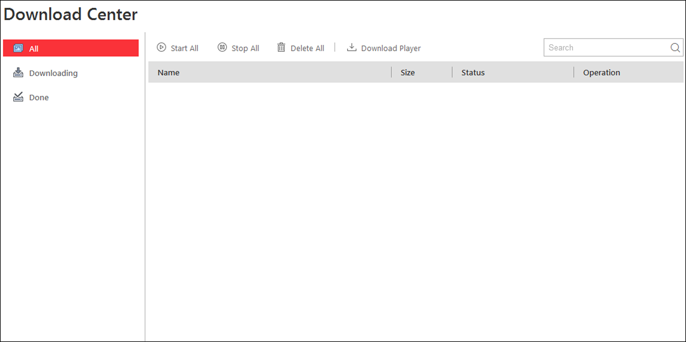
Figure 8-1 Download Center
2. Click All to check all the downloading tasks.
3. Optional: Perform the following operation(s) for the downloading tasks.
Pause Downloading | Select an ongoing downloading task and click Pause.
Resume Downloading | Click Start to resume the downloading, or click Start All to resume all the paused tasks.
Delete Downloading Task | Click to remove the downloading task, or click Delete All to delete all the downloading records.  For completed downloading task, you can also select to delete the downloaded video files.
View Downloaded Video | For completed downloading task, click Open File in Operation column to view the downloaded video files.

4. Click Downloading to check the ongoing downloading tasks.
5. Click Done tab to check the completed downloading tasks.
6. Optional: Click Download Player to download the player to your PC for playing the downloaded video files.

Chapter 9 Check Alarm and Event
The alarm information (for example, motion detection alarm information) received by the Control Client displays. You can check the detailed information of the event or alarm, view the alarm linked video, manage the related information, and so on.
Note
You should configure the event or alarm settings via the Web Client before you can check the related information and linkage actions via the Control Client. For detailed configuration of event and alarm settings, refer to User Manual of HikCentral Web Client.

9.1 Perform Arming Control
You can arm or disarm the selected device(s). After arming the device, the current Control Client can receive the triggered alarm information from the device. For the security control device, you can also bypass or recover bypass for the alarm inputs, and clear the alarms for the security control partition.
Perform the task when you need to realize the arming control of devices.
Steps
1. Click Alarm Center → Arming Control to open the Arming Control window.
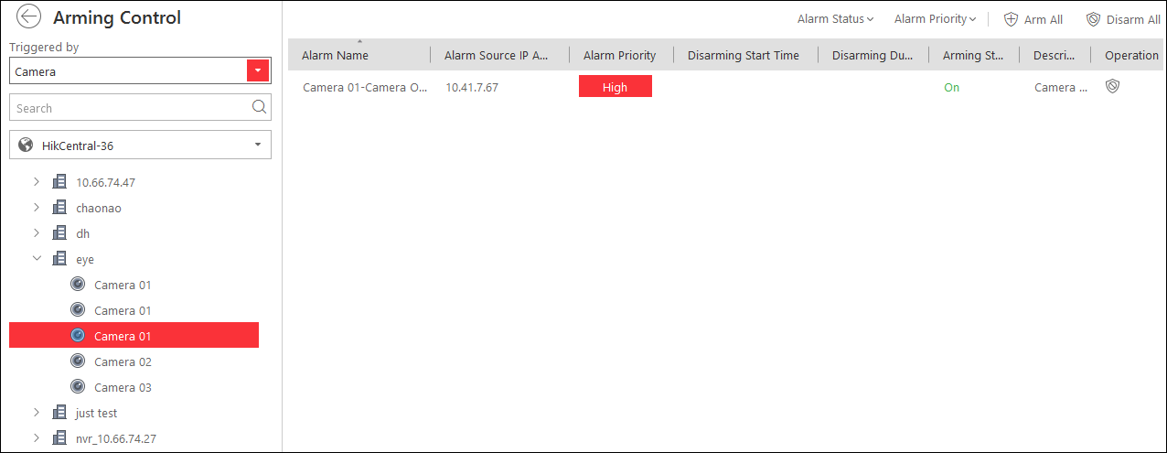
Figure 9-1 Arming Control
2. Set the filter condition on the left.
3. Select the resource for arming control.
All the configured alarms of the selected resource will display.
4. Perform arming control.
Disarm | Click icon or Disarm All to disable the alarm and set the disarming start time and duration.  For example, if you set the disarming duration as 1 hour, the alarm cannot be received by Control Client, but will be recorded as the log within 1 hour. The event detection will be enabled again in 1 hour after the disarming start time.  Note  For the alarm input source, you can also disarm the security control partition by hovering over the security control partition and clicking → Disarm to disable the alarm detection for the device and the Control Client.
Arm | Click icon or Arm All to enable the alarm detection.  For the alarm input source, you can set the Instant Arming, Stay Arming or Away Arming for arming the security control partition by hovering over the security control partition and clicking to select.
Instant Arming
It is used when people leave the detection area. The zone will be immediately triggered when it detects event or alarm with no delay and notify the security personnel.
Stay Arming
It is used when people stay inside the detection area. During stay arming, all the perimeter burglary detections (such as perimeter detector, magnetic contacts, curtain detector in the balcony) will be turned on. Meanwhile, the detectors inside the detection area are bypassed (such as PIR detectors). People can move inside the area and not trigger an event or alarm.
Away Arming
It is used when people leave the detection area. Event or alarms will be activated when the zone is triggered or tampered. For delayed zone, the alarm will not be activated when the zone detects triggering event during entry/exit delay.
Bypass | When some exception occurs for the zone, and other zones can work normally, you need to bypass the exceptional zone to turn off the protection of it. Otherwise, you cannot arm the security control partition which the zone belongs to.  Select alarm input as triggered source and find the alarm inputs of the security control partition. Hover over the alarm input and click to bypass the alarm input.
Bypass Recovery | When you want to recover the zone that is bypassed to make it work normally, select alarm input as triggered source and find the alarm input (zone) of the security control partition. Hover over the alarm input and click to recover alarm input to normal status.
Clear Alarm | Select alarm input as triggered source and hover over the security control partition to click to clear the generated alarms of the security control partition.

Note
The disarming and arming control in Alarm Center only controls the alarm detection on the current Control Client.

9.2 Search and View Resource's Alarm
The alarm information, such as motion detection, video loss, and video tampering alarm, of the connected cameras and alarm inputs displays.
Before You Start
Arm the device first before the Control Client can receive the alarm information from the device. For details, refer to Perform Arming Control.
Perform the task when you need to search and view resource's alarm.
Steps
1. Enter the Alarm Center page and you can view the real-time alarms received by the Control Client.
Alarm Time (Control Client)
The Control Client time when the alarm starts.
Alarm Source
The resource that occurred the alarm.
Triggering Event/Alarm
Display the type of the event that triggered alarm.
Operation
Search
Enter the Alarm & Event Search module to search the recorded video files of the event and the related camera's video files of the alarm.
Two-Way Audio
Start two-way audio with the camera
Download
Download the alarm details, including alarm information, alarm picture, linked video, linked map, etc.
Display on Smart Wall
Display the alarm video on smart wall.
Note
The available operation changes according to the alarm linkage of the camera. For detailed configuration, refer to User Manual of HikCentral Web Client.

2. Set the filter conditions to display the required alarms only.
Mark Status
Mark the alarm information and the marked items can be filtered.
Alarm Priority
The priority including low, medium, high and custom level which indicates the urgent degree of the alarm.
Alarm Status
The status of the alarm, including Start, Unacknowledged; Start, Acknowledged; Stop, Unacknowledged; Stop, Acknowledged. Start means the alarm has not stopped yet and Acknowledged means the alarm has been acknowledged by the user.
Alarm Displayed on Smart Wall
Filter the alarms which are set to be displayed on the smart wall.
The alarms will be automatically filtered by the configured conditions and display in the list.
3. Select an alarm to view.
The alarm linked video (if any) shows on display window and the alarm source linked map (if any) appears as well.
4. Optional: Perform one or more of the following operations.
Play Video from Alarm Time | Click Go to Alarm Time to play the video from the alarm time.
Get Live View of Related Camera | Click Live View to view the live video of the related cameras.
Display Linked Video on Smart Wall | Click Display on Smart Wall to play the videos on smart wall.  Note  For setting the related camera of the alarm, refer to User Manual of HikCentral Web Client.
Display Alarm Related Video and Related Map | Click Display Related Video & Map to show the Related Video or Related Map window.
Turn On/Off Alarm Sound | When the Control Client receives an alarm, the PC running the Control Client will play the alarm sound. You can turn on/off the alarm sound by clicking Operation and checking or unchecking Audio On
Disable Pop-up Alarm Window | For the alarm configured with pop-up window, a window will pop up, showing the alarm details, when the Control Client receives the alarm. You can disable or enable the pop-up window by clicking Operation and checking or unchecking Pop-up Window Disabled
Sort Alarms | Click on the column name of the alarm list and select a property to sort the alarms by the selected property.
View History Alarm | Click History Alarm to enter the Alarm & Event Search module to search the history alarms.

9.3 Search Event/Alarm Logs
You can search the event and alarm log files of the added resource for checking.
Before You Start
You should configure the event and alarm settings via Web Client. See User Manual of HikCentral Web Client for details.
Perform this task when you need to search event or alarm logs.
Steps
1. Enter the Alarm & Event Search module and click the Alarm Search or Event Search tab.
2. Select the types of event source.
Note
The Remote Site is only available for the Central System with Remote Site Management module (based on the license you purchased).

3. Set search conditions for different event source types.
4. Set the time range for search.
- Select a predefined time period for search.
- Select Custom Time Interval and specify the start time and end time for search.
5. Click Search.
The matched event or alarm logs display on the list.
6. Optional: Perform the following operation(s) after searching alarms or events.
View Alarm Details | Click the Name field of the searched event or alarm to view the details and the linked picture, video, and map.
View Event Details | Click the Name field of the searched event to view the details and linked video.
Save Logs to PC | Click to download the log to your PC.
Export Alarms or Events | Click Export and select the format to save the found events or alarms to your PC.

9.4 Manually Trigger User-Defined Event
The system provides user-defined event which is used if the event you need is not in the provided system-monitored event list, or the generic event cannot properly define the event received from third-party system. On the Control Client, you can trigger a user-defined event manually and it will activate a series of actions according to the settings on Web Client.
Before You Start
Add the user-defined event to the system and determine what happens when you manually trigger it, such as setting it as the alarm source, as start/end of the alarm's arming schedule, or as the alarm linkage actions. For details, refer to User Manual of HikCentral Web Client.
Perform this task if you need to trigger a user-defined event manually on the Control Client.
Steps
1. In the Monitoring or Alarm Center module, click Trigger Event.
The user-defined events added to the system will display.
2. Select the event you want to trigger and click OK.

9.5 View Pop-up Window Triggered by Alarm
After enabling the alarm linkage of Trigger Pop-up Window on the Web Client, and enabling the pop-up window function on the Control Client, the alarm window will open when the corresponding event/alarm is triggered.
Before You Start
Make sure you have enabled the alarm linkage of Trigger Pop-up Window on the Web Client, and enabled the pop-up window function in the Alarm Center on the Control Client. For setting this alarm linkage, refer to the User Manual of HikCentral Web Client.
Perform the task when you need to view the pop-up window triggered by alarm.
Steps
1. View the alarm details including alarm source, alarm time, triggered event type, alarm status, etc., in the pop-up window when alarm is triggered.
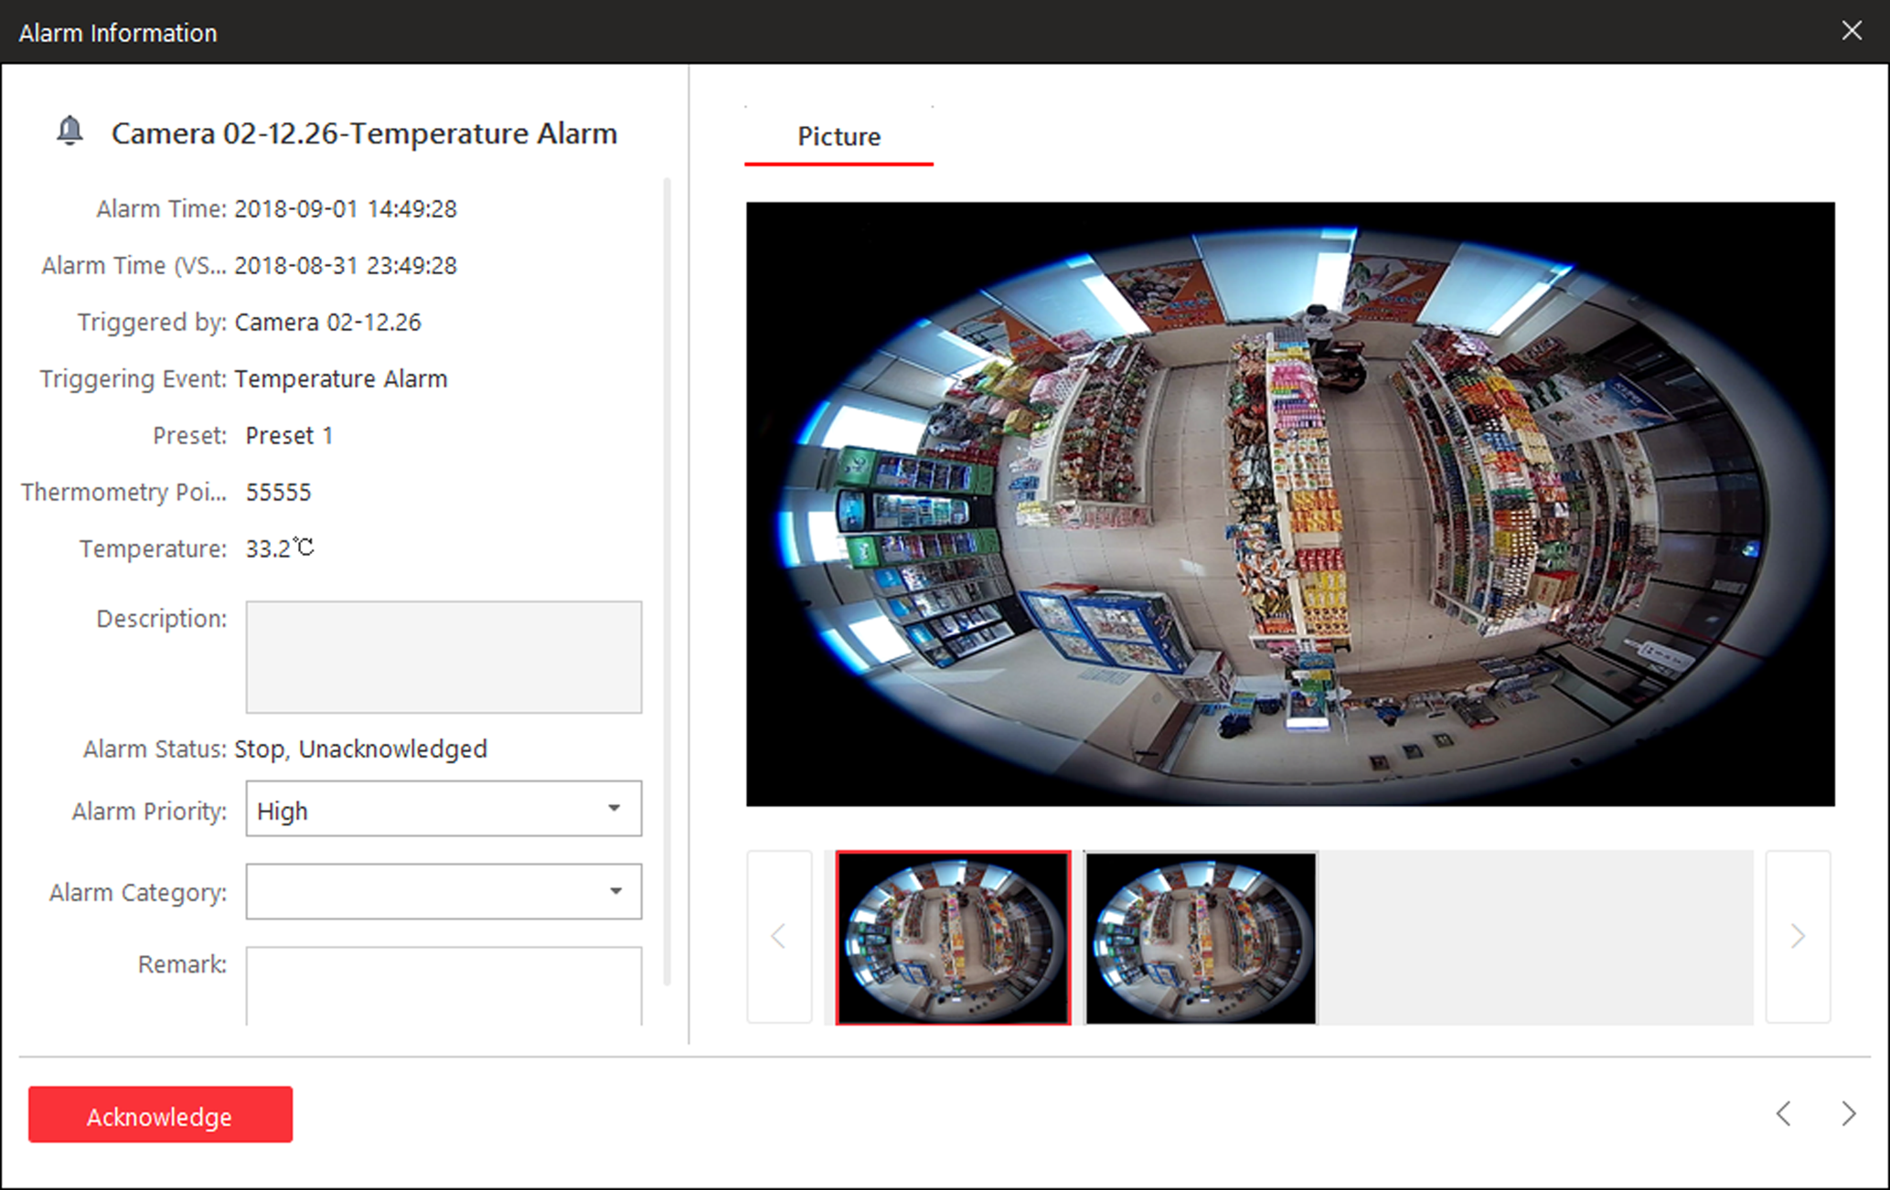
Figure 9-2 Alarm Triggered Pop-Up Window
2. Optional: Set the alarm priority, the alarm category, and input the note for the alarm according to actual needs.
3. Click Picture/Video/Map tab to view the alarm related cameras' captured pictures, the playback or live view when alarm occurs, and view the camera/alarm input location on the map (if configured).
Note
When viewing the recorded video files of the related camera, you can click Go to Alarm Time to play the video from the alarm time. You can also click Live View to view the live video of the related cameras, or click Display on Smart Wall to play the playback on smart wall.

4. Click the Acknowledge to acknowledge the alarm.
The alarm status becomes Acknowledged.
5. Optional: Click to view the previous or next alarm information.
6. Optional: Uncheck Enable Pop-up Window to disable pop-up window when new alarm triggers.
Note
When the pop-up window remains open, the later alarm, if alarm priority is higher, will be displayed in the pop-up window, replacing the earlier one.

7. Optional: If an alarm input alarm is triggered on a panic alarm station, a window will open as follows. You can handle this panic alarm if needed.
Note
You should first set an alarm for the alarm input of the panic alarm station via the Web Client. For details, refer to User Manual of HikCentral Web Client.

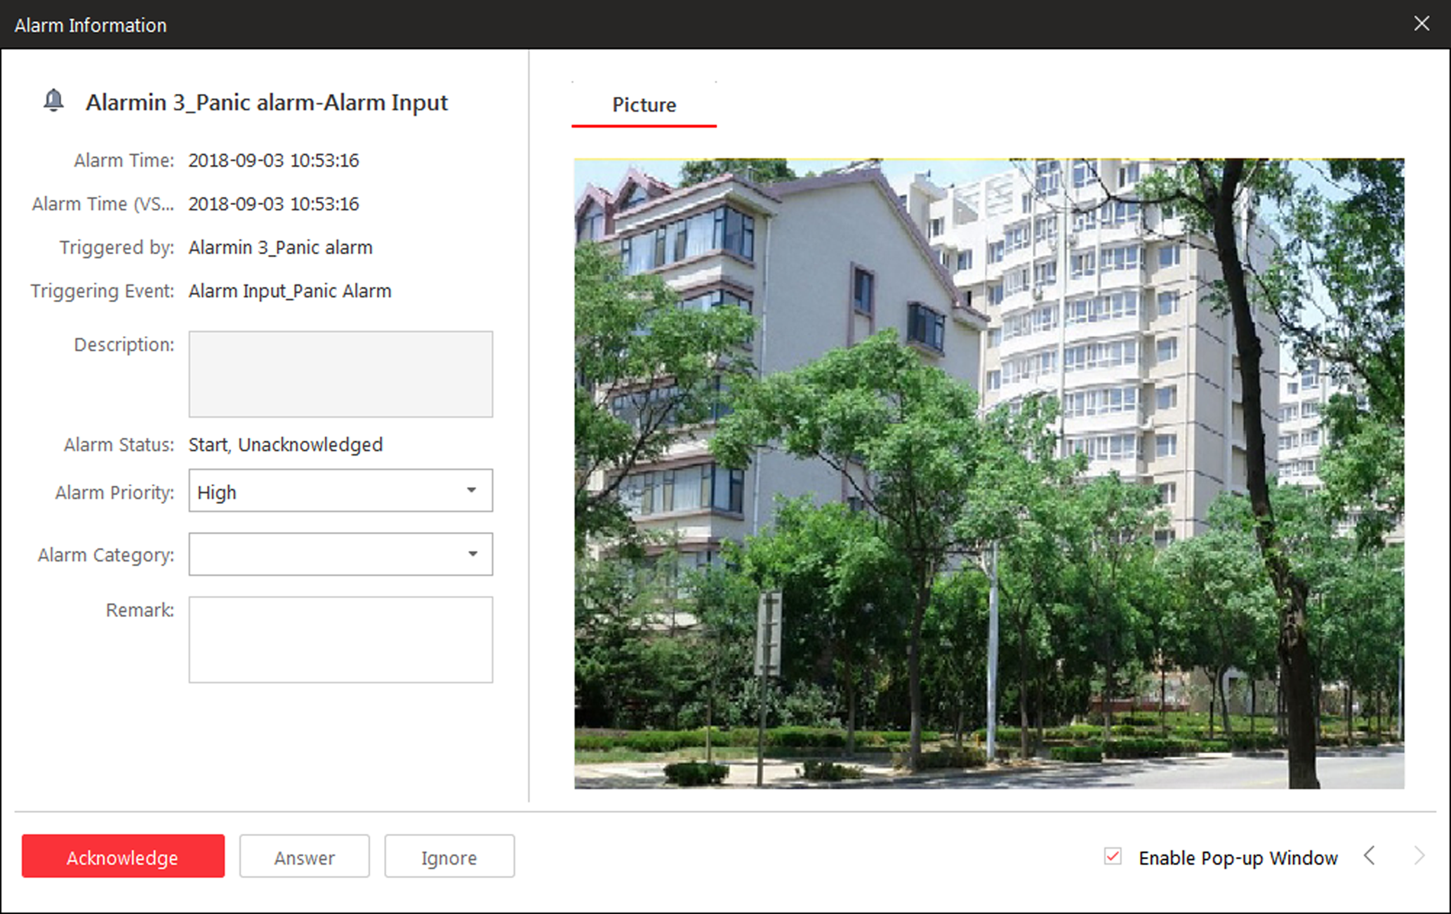
Figure 9-3 Panic Alarm
Perform Voice Talk | Click Answer to answer this panic alarm and talk with the person who triggers this panic alarm.  This panic alarm is usually triggered in emergency situation.
Ignore Alarm | Click Ignore to ignore this alarm. For example, it is a false alarm.

Chapter 10 Map Management
After properly configuring the map settings via the Web Client and enabling the map function on Monitoring module, you can view and manage the map, such as zooming in or zooming out the map, locating the resources on the map. You can view and operate the added resources on the map, such as getting the live view and playback of the cameras, UVSSs, and doors, setting the arming control for cameras, alarm inputs, UVSSs, and doors, and so on.
Note
- If the GIS map doesn't show properly, all the current site's and Remote Site's E-map thumbnails are displayed. Click one E-map to view details.
- If you enable the GIS map function of the Central System via Web Client, you enter the configured GIS map. All the current site's and Remote Site's E-map thumbnails are displayed under the GIS map. Click one E-map to view details.

10.1 Operate Hot Spot
The resources (including cameras, alarm inputs, alarm outputs, access points, and UVSSs) added on the map are called the hot spots. The hot spots show the locations of the resources. You can operate the hot spot, such as starting live view of the camera, UVSS, and door, arming or disarming the resources.

10.1.1 Preview Hot Spot
You can view locations of the cameras, alarm inputs, alarm outputs, access points, and Under Vehicle Surveillance Systems (UVSSs). You can also set the arming control and view the history alarms of the surveillance scenarios through the hot spots.
Before You Start
Configure the map settings via the Web Client. For details, see User Manual of HikCentral Web Client.
Perform this task when you need to preview hot spot.
Steps
1. Click Monitoring on My Dashboard to enter the Monitoring page.
2. Click Map Hidden to display the map.
3. Click the hot spot and a window opens displaying the related functions.
Note
If there is an alarm triggered on the hot spot, the alarm icon will appear on the top left corner of the hot spot icon 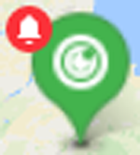.

4. Operate in the pop-up dialog.
- For camera and UVSS hot spot: Check the live view and playback of the camera, view its status, area, and remark, set the arming control, and view the history alarms.
Note
- To view the live view and playback of the camera, the user should be assigned with permissions of live view and playback of the camera. For details, please refer to the User Manual of HikCentral Web Client.
- For details about arming control, see Perform Arming Control.
- For details about viewing history alarms, see View History Alarm.

- For alarm input hot spot: View its status, area, and remark, set the arming control, and view the history alarms.
- For alarm output hot spot: Turn on or off the linked alarm output.
- For access point hot spot: Check the live view and playback of the access point's related camera(s), view the access point's basic information, control the door status, set the arming control, and view the history alarms and access records.

10.1.2 Perform Arming Control
You can arm or disarm the hot spots via the arming control function. After arming the device, the current Control Client can receive the triggered alarm information from the hot spot.
Before You Start
Configure the map settings via the Web Client. For details, see User Manual of HikCentral Web Client.
Perform the task when you need to realize the arming control of hot sports.
Steps
1. Click Monitoring on My Dashboard to enter the Monitoring page.
2. Click Map Hidden to show the map.
3. Click the hot spot.
A window on which the related functions of the hot spot display is opened.
4. Click Arming Control to activate the Arming Control window.
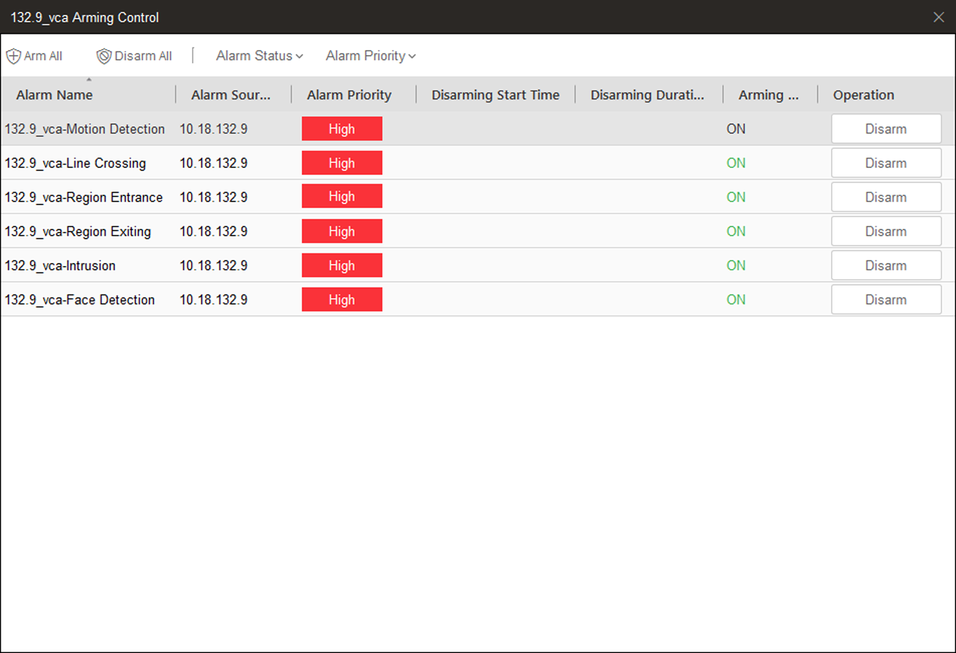
Figure 10-1 Arming Control Page
The information of the enabled alarms (e.g., motion detection, video loss) displays, such as alarm name, alarm priority and source IP address.
5. Perform arming control of the selected hot spot.
- Click Disarm or Disarm All to disable the alarm(s) and set the disarming start time and duration.
Note
For example, if you set the disarming duration as 1 hour and the start time as 2018-03-26 18:05, then the event detection will be enabled again after 2018-03-26 19:05.

- Click Arm or Arm All to enable the alarm(s).

10.1.3 View History Alarm
When an alarm is triggered, it will be recorded in the system. You can check the history log related to an alarm, including the alarm source details, alarm category, alarm triggered time, etc.
Perform this task when you need to view the history alarm.
Steps
1. Click Monitoring on My Dashboard to enter the Monitoring page.
2. Click Map Hidden to display the map.
3. Click the hot spot.
A dialog pops up on which the related functions of the hot spot display.
4. Click History Alarm to activate the History Alarm window.
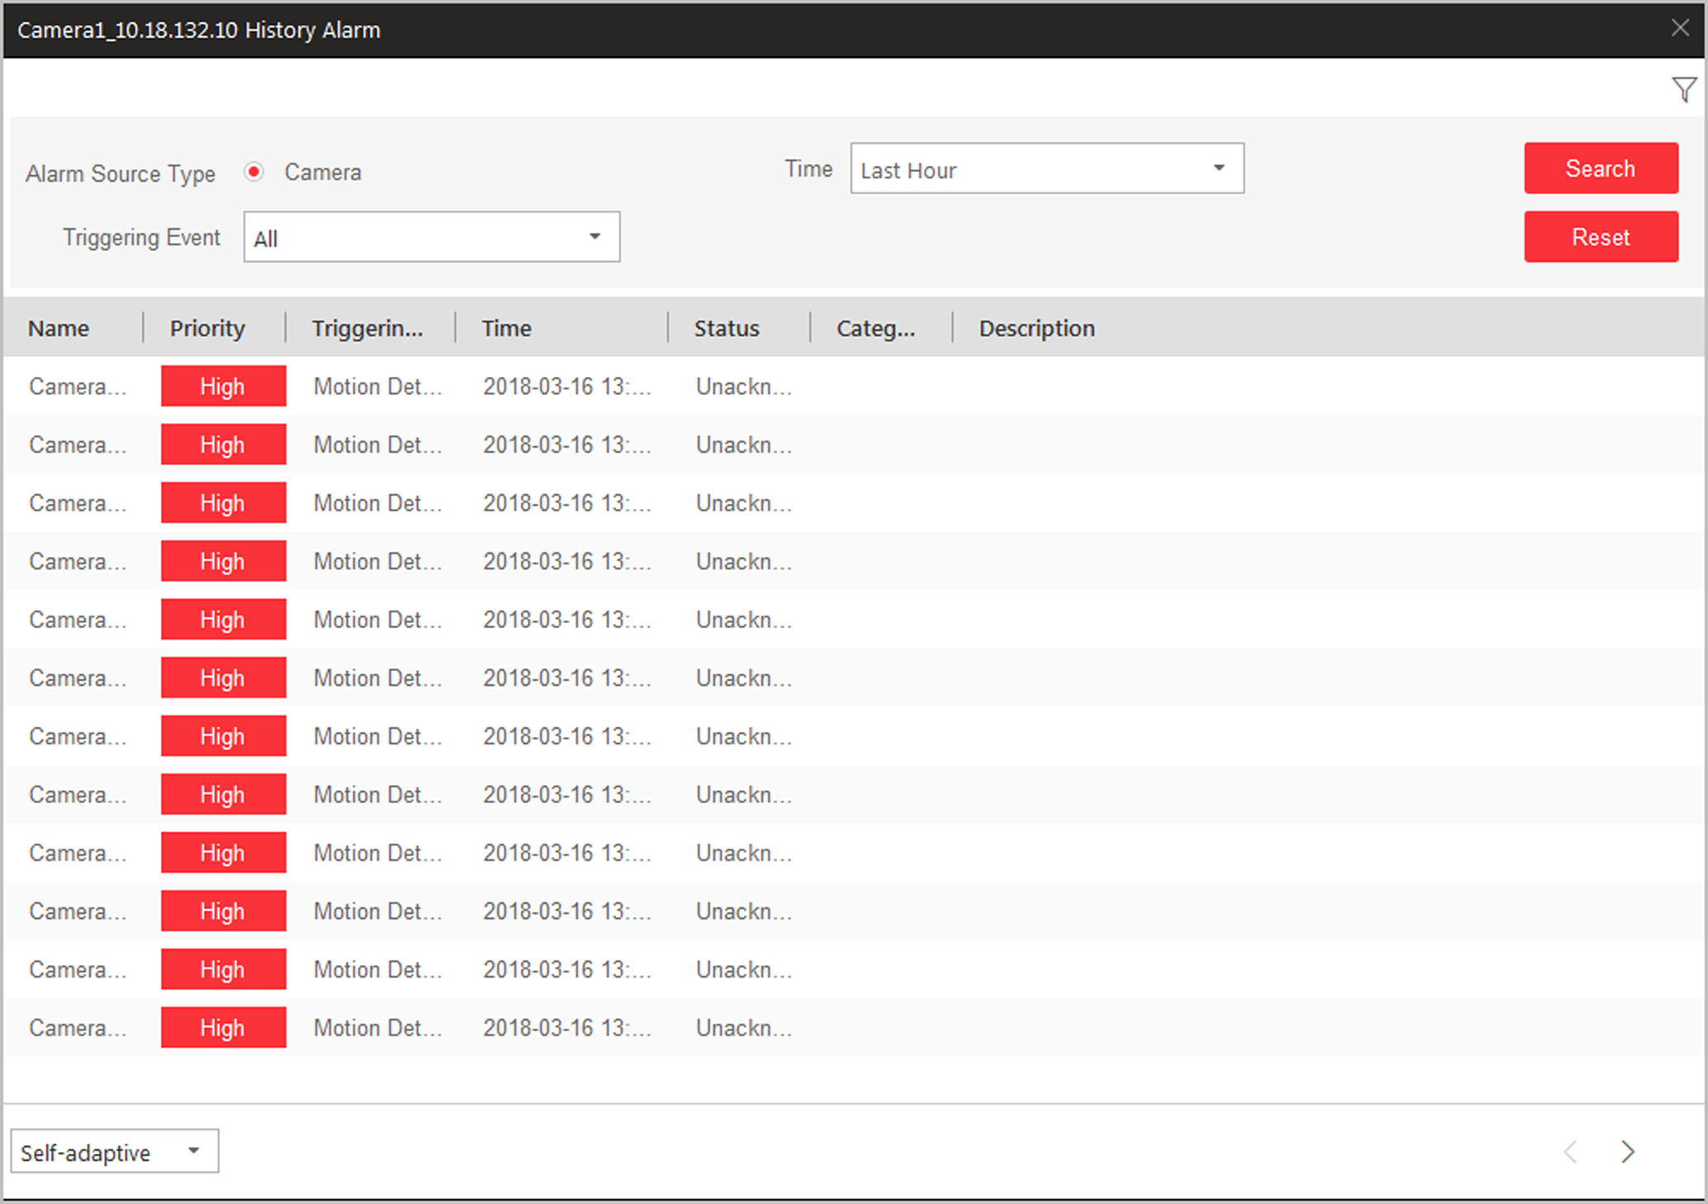
Figure 10-2 History Alarm
5. Set the search conditions.
6. Set the time period for searching the alarms.
7. Select the triggering event from the drop-down list.
8. Click Search to start searching the logs of the alarm.
The search results will display in the list and you can check the history alarm's detailed information.

10.2 Preview Hot Region
The hot region function links a map to another map. When you add a map to another map as a hot region, an icon of the link to the added map is shown on the main map. The added map is called child map while the map to which you add the hot region is the parent map.
Before You Start
Configure the map settings via the Web Client. For details, see User Manual of HikCentral Web Client
Perform this task when you need to preview the hot region.
Steps
1. Click Monitoring on My Dashboard to enter the Monitoring page.
2. Click Map Hidden to display the map.
3. Click the hot region and a window opens displaying the related functions.
Note
If there is an alarm triggered in the hot region, the alarm icon will appear on the top left corner of the hot region icon .

4. Click the E-map thumbnail to jump to the child map and view the elements added on the E-map.

10.3 Operate Map
On the Map page, you can perform one or more operations of the followings, such as zooming in or out map, selecting resource(s) on map, adding label, printing map, displaying map in full screen mode, and so on.
Zoom in/Zoom out Map
Use the mouse wheel or click or to zoom in or zoom out on the map.
Select Resource(s) on Map
Click , select , and drag on the map to select resource(s).
Add Label
Click , select to add a label with description to the map.
Capture
Click , select , and drag on the map to select an area. You can save this area as a picture to local PC.
Print Map
Click and select to print the map.
Filter
Click and select the object type you want to show on the map.
Locate Resource on Map
Move the cursor to the resource or site in the device list and click to locate the resource on the map. The located resources can be displayed in the center of the map.
Note
Only when the resource is added to the map, you can locate the resource on map.

Drag Resources on Map for Live View or Playback
See View Map in Live View or View Map in Playback for details.

Chapter 11 Search Recognized Vehicles
If the added Automatic Number-Plate Recognition (ANPR) camera or Under Vehicle Surveillance System (UVSS) is properly configured, and the vehicle license plate number is recognized by the camera, you can search the related vehicle passing information.
Perform the this task when you need to search for a vehicle.
Steps
1. Enter the Vehicle Search page.
- Click Vehicle Search on My Dashboard to enter the Vehicle Search page.
- Start live view of the ANPR camera or UVSS, move the cursor to the recognized license plate number, and click to enter the Vehicle Search page.
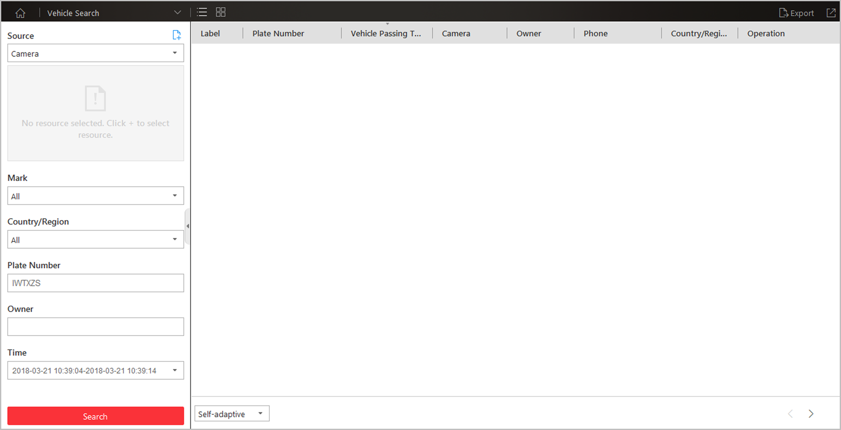
Figure 11-1 Vehicle Search Page
2. Set the search conditions.
1) Select Camera or Under Vehicle Surveillance System from the drop-down list.
2) Select the resources to search the vehicle passing records.
Note
For camera, you can click , select the current site or a Remote Site from the drop-down list and select the ANPR camera(s).

3) Optional: Set the mark information, country or region, plate number, and vehicle owner for search.
Note
You can enter the keywords of plate number and vehicle owner name to fuzzy search the vehicles.

4) Set the time for search.
- Select to search the vehicles today, yesterday, current week, last 7 days, and last 30 days.
- Click Custom Time Interval to set the search time range.
3. Click Search.
The vehicle passing records that match the search conditions will display in the list.
Note
You can click or to switch between List Mode and Thumbnail Mode.

4. Optional: Perform the following operations after search.
Mark Vehicle | Click to mark the vehicle. The marked vehicles can be filtered when searching the related vehicle passing information recorded by the camera or UVSS.
Add to List | If the vehicle is not added to the vehicle list, you can add the new vehicle to the vehicle list manually. Click to add the vehicle. SeeAdd Recognized Vehicle to Vehicle List for details.
Download Vehicle Information | Click to download the vehicle information. For details about downloading, refer to Manage Downloading Tasks.
View Picture | Click the Plate Number column and click Picturetab to view the captured vehicle picture or undercarriage picture.
View Video | Click the Plate Number column and click Video to view the linked video file of the passing vehicle.  Note  - When viewing the video file of passing vehicles, you can control the playback.  - Click Go to Monitoring to switch to Monitoring page.  - Click to export the video file to the local PC.
Export Vehicle Information | Click Export in the upper-right corner to export the searched vehicle records to a PDF file.  Note  Up to 500 vehicle records with captured pictures can be exported at one time. Up to 100,000 vehicle records without pictures can be exported at one time.
Edit | Click Edit to modify the recognized license plate number as needed.

Chapter 12 Search Access Event
You can search the person information of the access events triggered on the added access points (doors or turnstiles) via the Control Client by setting the search conditions.
Before You Start
Configure the access event on the Web Client. For details, refer to User Manual of HikCentral Web Client.
Steps
1. Click Access Control on My Dashboard.
2. Click to select the access point(s) to search the triggered events.
3. Set the search conditions.
Access Mode
The access event type.
Person Name (Optional)
Enter the person name for search. The access event is triggered by this person.
Access Result
The event's result, including access granted and access failed.
Time
The access event which occurred during the time period will be displayed.
Note
You can select Custom Time Interval to specify the start time and end time for search.

4. Click Search.
The matched access records will display.
5. Optional: Click the person name in the Name column to view the event details, including the recorded video of the access point's related camera (if configured), person information, and access information.
6. Optional: Click in the Operation field to download the event information, including the event details, the person information, person profile, and recorded video file (if configured).
7. Click Export to export the searched access control events details (including person name, person ID, event time, access result, and access mode) and you can save it in your PC.
Note
The exported file is in CSV format.

Chapter 13 Manage Smart Wall
A smart wall is a special multi-monitor setup that consists of multiple jointed screens, cameras or signal sources, or decoding outputs tiled together contiguously or overlapped in order to form one large screen. In monitoring center, to view the video streams from multiple encoding devices synchronously, you can display them on smart wall to have a better view. Events defined on the server can also trigger that one or more cameras are shown on the Smart Wall. For example, if a door is opened, the Smart Wall can be configured to display the nearest cameras.
The following icons are available on the Smart Wall window.

Icon | Description
 | Enter the Alarm Center to view the detected alarms and perform further operations, such as searching related video files of the alarm, displaying on smart wall, and downloading the alarm details. Refer to Check Alarm and Event for details.
 | When the smart wall settings on the VSM server are changed (e.g., more smart walls are added), a red dot will appear on this icon. Click it to synchronize the smart wall information.
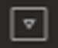 | Set to switch the stream type automatically according to current network situation, display the window No. on the smart wall, or view the details of the smart wall.
 | Save the current settings to the view or to other view. In this way, you can easily view the required live videos on the smart wall by calling this view.
/ | Unlock or lock the window. When you lock the window, you cannot display the video on this window or stop decoding and displaying on the window.
 | Set the window division for the selected display window of smart wall. Click on the split window to enlarge the window.
/ | Display three/two smart walls in line.
 | Display the smart wall in the center of the window.

13.1 Decode and Display
After setting the smart wall via Web Client, the video streams from the camera can be decoded by the configured decoding outputs, and then you can display the decoded videos on the smart wall.
Before You Start
Add the smart wall via Web Client. For details, refer to User Manual of HikCentral Web Client.
Steps
1. Click Smart Wall on My Dashboard to enter the Smart Wall page.
2. Select Camera or Signal Source as the encoding device type.
3. Select the site to display the cameras added on this site.
Note
It is only available for the central system with Remote Site Management module (based on the license you purchased).

4. Drag the camera or signal source from left panel to the display window of smart wall.
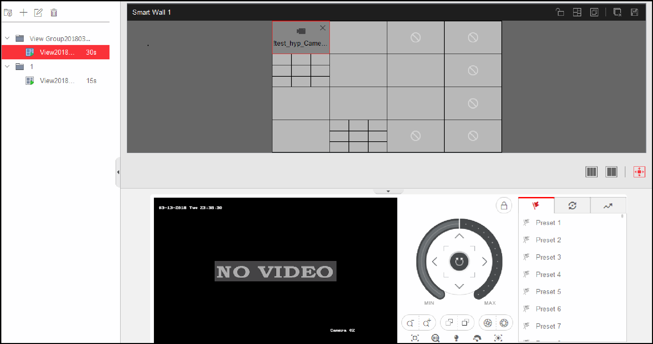
Figure 13-1 Display Live Video on Smart Wall
The video stream from the camera is decoded and displayed on the smart wall.
5. Optional: Select a display window which is linked with the camera to display the live video on the large window at the bottom of the page, and then perform the following operation(s).
View Camera Status | Click to show the camera's frame rate, resolution, and stream format.
Switch Stream | Click 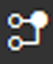 or to switch the live view stream to main stream or sub-stream.
Enable PTZ Control | Click to enable PTZ (pan, tilt, zoom) control function on the display window. And then you can control PTZ and set preset, patrol, and pattern. See PTZ Control for details.
Switch to Playback | Click to switch to playback mode. For details, refer to Play Video File.
Stop Decoding and Displaying | Click or to stop the decoding and displaying for the specified window or all windows.  Note  For the locked windows and alarm linked windows, you cannot stop the decoding and displaying.

13.2 View Settings
You can set the view and organize the views into a group for displaying the video on smart wall conveniently. You can also perform the view auto-switch for the view group on the smart wall.

13.2.1 Add View Group
A view group of a smart wall is to manage multiple views in a group for performing view auto-switch.
Steps
1. Click Smart Wall on My Dashboard to open the Smart Wall window.
2. Click to open the View window.
3. Select Public View or Private View to add this view group.
Note

- The view groups and views belonging to the public view can be seen by all the system users.
- The view groups and views belonging to the private view can only be seen by the user who add it.

4. Click to open Add View Group window.
5. Edit the group name or use the default one.
6. Click Save to add the group.
7. Optional: Perform the following operation(s) after adding the view group.
Edit View Group | Select the view group and click to edit the view group name.
Delete View Group | Select the view group and click to delete the group.

13.2.2 Add View
You can add the frequently used cameras and smart walls as the custom view and organize the views into the view group for displaying the video on smart wall conveniently.
Steps
1. Click Smart Wall on My Dashboard to open the Smart Wall window.
2. Drag the cameras to the display window of the smart wall.
3. Click to open the View window.
4. Select a view group.
5. Click to open Add View window.
6. Enter the view name or use the default one.
7. Click OK to save the view.
8. Optional: Perform the following operation(s) after adding the view.
Start Decoding and Displaying | Click the view to start decoding and displaying the video of the cameras on smart wall conveniently.
Edit View | Click to edit the name of the view.
Delete View | Click to delete the view.

13.3 Perform View Auto-Switch
To fast and conveniently view multiple configured views on the smart wall, you can perform the view auto-switch to switch the added views belonging to the same view group automatically in a specific auto-switch interval.
Before You Start
Add at least two views into one view group, see Add View for details.
Steps
1. Click Smart Wall on My Dashboard to open the Smart Wall window.
2. Click to open the View window.
3. Set the auto-switch interval beside the view name.
4. Click beside the view group name.
The views in the selected view group starts switching automatically.

13.4 Perform Auto-Switch of an Area's Cameras
You can display multiple cameras of one area in turn on the smart wall.
Before You Start
The cameras are added to one area. See User Manual of HikCentral Web Client.
Steps
1. Click Smart Wall on My Dashboard to open the Smart Wall window.
2. Click to open the Camera window.
3. Drag an area on the left panel to the window linked with the decoding output.
The cameras in the selected area starts switching automatically on the smart wall. The auto-switching cycle can be shown in the live view window on the current Control Client and other Control Client(s).
4. Optional: Click << or >> in the toolbar of the video view to set the auto-switch interval: 20 s, 40 s, 1min, 3min, 5min.

13.5 Create a Roaming Window
Windowing is to open a virtual window on the screen(s). The window can be within a screen or span multiple screens. You can move the window on the valid screens as desired and this function is called roaming. With windowing and roaming function, you can create custom window and the window size and position will not be limited by the actual screen(s).
Steps
1. Click Smart Wall on My Dashboard to open Smart Wall window.
2. Click and drag on the screens which are linked to decoding outputs to open a window.
Note
Screens linked to BNC outputs are not available for opening a window.

Figure 13-2 Open a Window
3. Optional: Perform the following operation(s) after opening a window.
Roam | Click on the window and hold the mouse to move the window on the valid screens.
Adjust Window Size | Move your cursor to the window edges and adjust the window size when the cursor becomes directional arrow.
Enlarge Window | Double-click the window and it will be enlarged to fill the spanned screens and display on the top layer. Double-click again to restore.
Display Window on Top Layer | Select one window when there're overlapped windows and right-click the window to display it on the top layer.

13.6 View and Export Window No. and Camera ID
When displaying live view on smart wall, you can use a keyboard for convenience operations such as starting live view on smart wall, PTZ control, etc. If you want to display certain camera's live view in certain window on the smart wall, you should press the camera's identifier number and target window number on the keyboard, which are called Camera ID and Window No.
In the Web Client, you can set a unique ID for each camera added in the system. For details, refer to User Manual of HikCentral Web Client.
In the Control Client, click Smart Wall on the control panel, and click → Window No. & Camera ID → Display Window No. to show the number of each window.
If you want to export a document which contains the IDs of all the cameras and smart wall information (such as smart wall name, row and column, etc.) as a reference, click → Window No. & Camera ID → View Window No. and Camera ID to generate a document.
Click Download to download this document and save it in local PC. You can print it if necessary.
Note
- The exported file is in PDF format.
- The exported document also contains smart wall No., which are used for selecting smart wall via DS-1200KI keyboard.

Chapter 14 Report
Reports, created for a specified period, are essential documents, which are used to check whether a business runs smoothly and effectively. In HikCentral, reports can be generated daily, weekly, monthly, annually, and by custom time period. You can use reports as basis in creating decisions, addressing problems, checking tendency and comparison, etc.

14.1 Generate People Counting Report
People counting statistics is to calculate the number of line crossing people in a specific area and a certain time period by the people counting camera(s). You can view the people counting statistics in a line chart or histogram, and generate reports for exporting the detailed data to local storage.
Before You Start
Properly configure the camera with a people counting rule for the required area. To configure the people counting rule,please refer to user manual of people counting camera.
Steps
1. Click People Analysis → People Counting to enter the people counting report page.
2. Select people counting camera(s) for statistics.
1) Click in the camera panel.
2) Select a current site or Remote Site from the drop-down site list to show its people counting cameras.
Note
Only people counting cameras will be displayed here.

3) Check the people counting camera(s) for statistics.
The cameras will be added to the camera list.
4) Click Close.
3. Select camera(s) for the report in the camera list.
Note
Up to 20 people counting cameras can be selected for statistics at the same time.

4. Select the report type as daily report, weekly report, monthly report, annual report, or customize the time interval for a report.
Daily Report
Daily report shows data on a daily basis. The system will calculate the number of people in each hour of one day.
Weekly Report, Monthly Report, Annual Report
As compared to daily report, weekly report, monthly report, and annual report can be less time-consuming, since they are not to be submitted every day. The system will calculate the number of people in each day of one week, in each day of one month, and in each month of one year.
Custom Time Interval
Users can customize the days in the report to analyze the number of people in each day of the custom time interval.
5. Set the time or time period in the Time field for statistics.
Note
For custom time interval report, you need to set the start time and end time to specify the time period.

6. Click Generate Report.
The statistics of all the selected people counting cameras are displayed in the right panel.
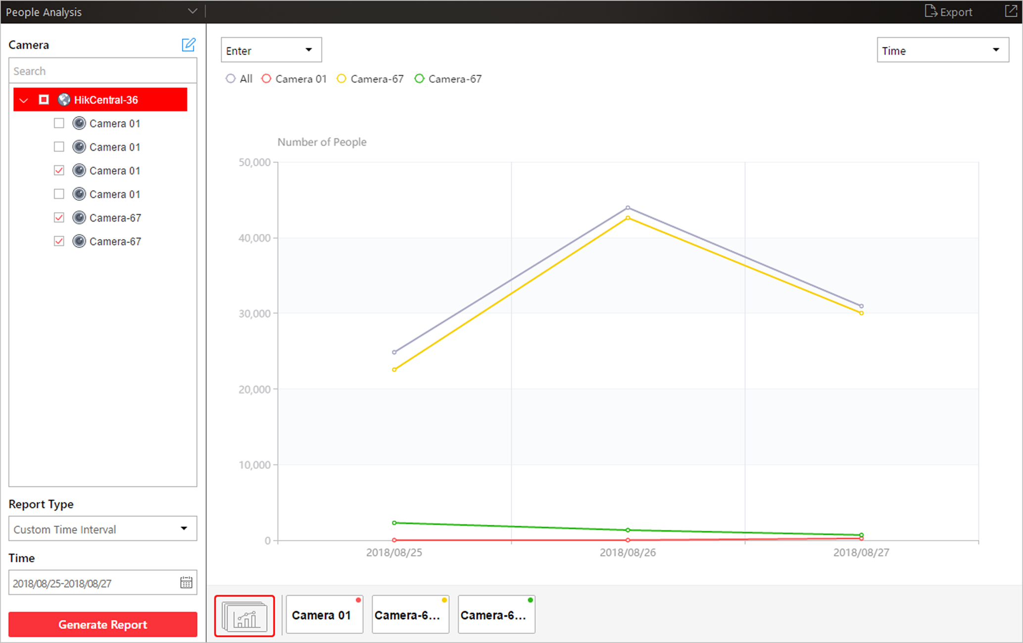
Figure 14-1 People Counting Report
7. Optional: Perform the following operation(s) after generating the people counting report.
Show/Hide Certain Data | Click the legend to show or hide the data of certain element, such as certain camera.
View Entered/Exited/Both Entered and Exited Statistics | Select Enter, Exit, or Enter and Exit from the drop-down list. The total statistics and all the selected cameras' statistics are displayed and marked with different colors.
View Both Entered and Exited Statistics of Single Camera | Click the camera name on the page below to view the chart of single camera.
Switch Between Line Chart and Histogram | Select Trend or Item for Comparison on the upper-right corner to switch the between line chart (displaying the trend for the number of people on different time points) or histogram (for comparison).
Play Linked Video | Click the line or rectangle on the line chart or histogram to play the linked video.

8. Optional: Export the report and save it in local PC.
1) Click Export.
The following panel will display with camera selected and time configured according to the range you defined in step 2 to 5.
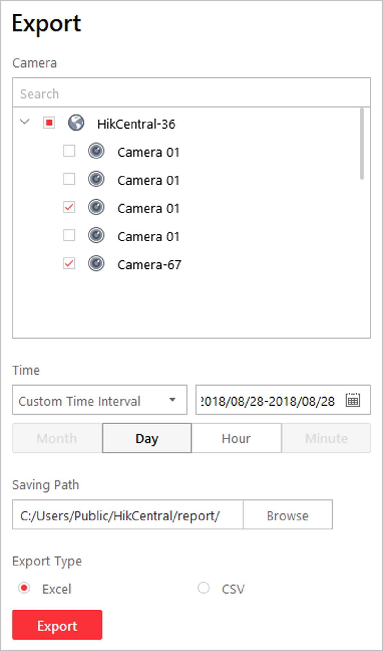
Figure 14-2 Export People Counting Report
2) (Optional) Select the camera and set the report type and report time if needed.
3) Select shorter time period to view more detailed data of each camera.
Example
For example, if you select Daily Report, you can select Day, Hour, or Minute and it will export 1, 24, or 24×60 records respectively for each camera.
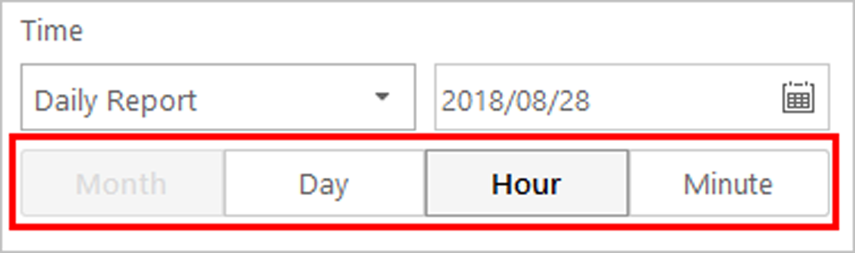
Figure 14-3 Set Level of Detail for Data of Each Camera
4) Click Browse to set the saving path on local PC.
5) Set the format of the exported file as Excel or CSV.
6) Click Export and the task will be displayed in the Download Center,

14.2 Generate Queue Analysis Report
For cameras which support queue management, you can generate a report to show the number of queue exceptions and number of persons in each queue, and show the queue status including waiting duration and queue length.
Before You Start
Add a camera which supports queue management to the system and configure queue regions. To configure the queue region, refer to user manual of the camera.
Steps
1. Click People Analysis → Queue Analysis to enter the queue analysis report page.
2. Select camera(s) for statistics.
1) Click in the camera panel.
2) Select a current site or Remote Site from the drop-down site list to show its cameras.
Note
Only cameras which support queue management will be displayed here.

3) Check the camera(s) for statistics.
The cameras will be added to the camera list.
4) Click Close.
3. Select the queue regions configured on the camera and the system will collect the queue data in these queue regions.
Note
For configuring the queue, refer to the user manual of the camera.

4. Select the report type as daily report, weekly report, monthly report, or annual report.
Daily Report
Daily report shows data on a daily basis. The system will calculate the queue data detected in each hour of one day.
Weekly Report, Monthly Report, Annual Report
As compared to daily report, weekly report, monthly report, and annual report can be less time-consuming, since they are not to be submitted every day. The system will calculate the queue data detected in each day of way week, in each day of one month, and in each month of one year.
5. Set the time or time period in the Time field for statistics.
6. Optional: Select the analysis type and set the report range.
Waiting Duration
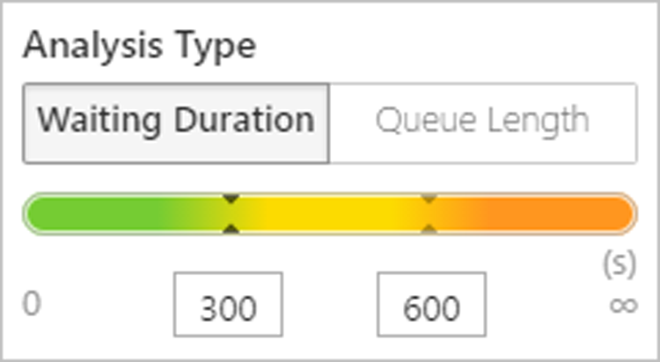
Figure 14-4 Set Range for Waiting Duration
The report can show the number of persons in each queue who have waited for specified duration at different time points.
For example, if you set the report range as 300s and 600s, the report will show that in each queue, how many persons have waited for less than 300s, how many persons have waited for 300 to 600s, and how many persons have waited for more than 300s.
Queue Length
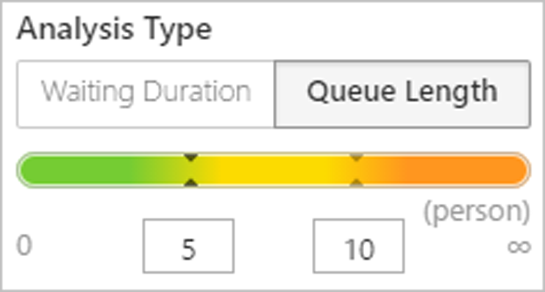
Figure 14-5 Set Range for Queue Length
The report will show how many seconds each queue status (number of persons in different ranges) lasts.
For example, if you set the report range as 5 persons and 10 persons, the report will show that in each queue, how many seconds the status lasts when there are less then 5 persons, how many seconds the status lasts when there are 5 to 10 persons, and how many seconds the status lasts when there are more than 10 persons.
7. Click Generate Report.
A chart are displayed in the right panel, showing the number of exceptions (waiting timeout or people amount exceeding) of different queues.
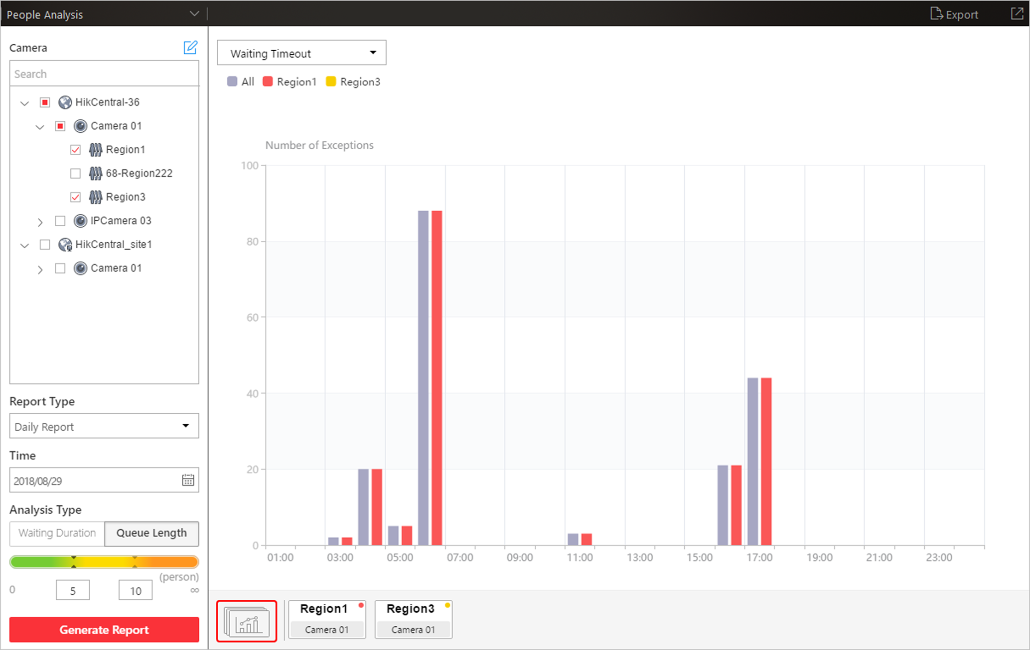
Figure 14-6 Queue Analysis Report
8. Optional: Perform the following operation(s) after generating the report.
Show/Hide Certain Data | Click the legend to show or hide the data of certain element, such as queue.
View Queue Analysis Report of Single Queue | Click the queue icon on the page below to view the report of the single queue, including the number of exceptions, number of people in the queue, and waiting durations .
Switch Between Number of Exceptions, Number of People, and Queue Length | Click 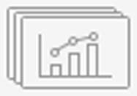 on the page below to view the report of all the selected queues.  If you select the analysis type as Waiting Duration, click the drop-down list to view the number of waiting timeout exceptions or number of people in different queues.  If you select the report type as Daily Report, and set the analysis type as Queue Length, click the drop-down list to view the number of people amount exceeding exceptions or queue length of different queues.

9. Optional: Export the report and save it in local PC.
1) Click Export.
The following panel will display with camera and queue selected and time configured according to the range you defined in step 2 to 5.
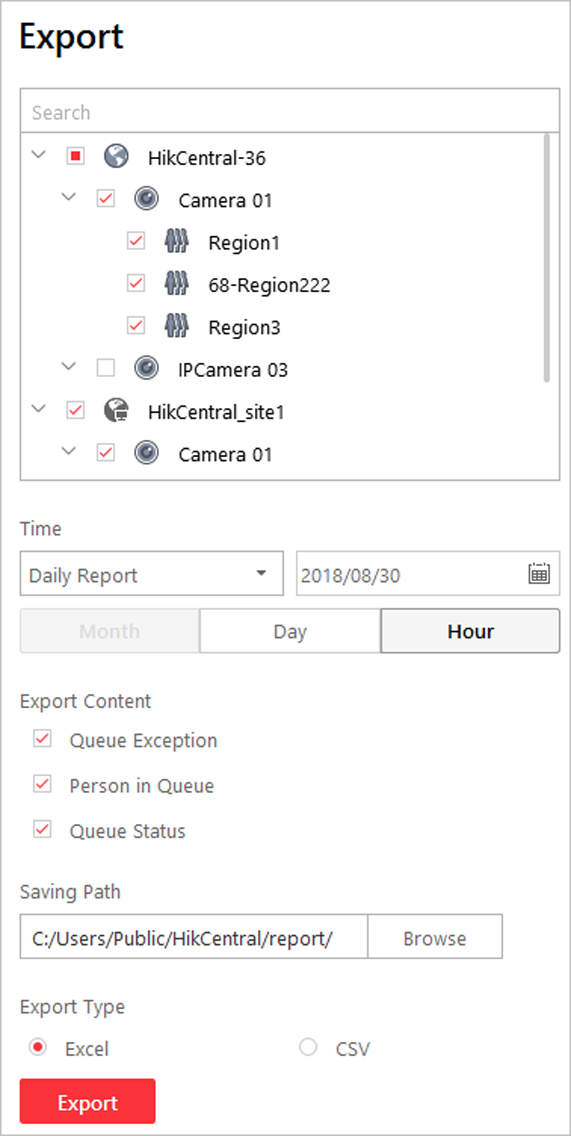
Figure 14-7 Export Queue Analysis Report
2) (Optional) Select the camera and queue, and set the report type and report time if needed.
3) Select shorter time period to view more detailed data of each queue.
Example
For example, if you select Daily Report, you can select Day or Hour and it will export 1 or 24 records respectively for each queue.
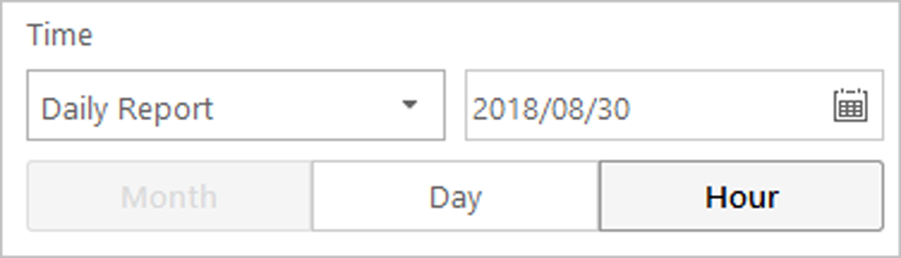
Figure 14-8 Set Level of Detail for Data of Each Queue
4) Select the content to export.
Queue Exception
The number of exceptions (people amount exceeding and waiting timeout) of each queue.
People Amount Exceeding
The number of persons in the queue exceeds the configured threshold.
Waiting Timeout
The waiting duration for the persons in the queue exceeds the configured threshold.
Person Amount in Queue
The number of persons in each queue.
Queue Status
The status of each queue, including persons' waiting duration and number of persons (queue length) in the queue.
5) Click Browse to set the saving path on local PC.
6) Set the format of the exported file as Excel or CSV.
7) Click Export and the task will be displayed in the Download Center,

14.3 Generate Heat Map Report
Heat map is a graphical representation of data represented by colors. The heat map function of the camera is usually used to analyze the visit times and dwell time of customers in a configured area.
Before You Start
Add a heat map network camera to the system and properly configure the camera with heat map rule for the required area. To add a heat map network camera, please refer to the User Manual of HikCentral Web Client. To configure the heat map rule, please refer to the user manual of heat map network camera.
Note
Heat map is not supported to analyze the cameras on Remote Site.

Perform this task when you need to generate heat map report.
Steps
1. Click Heat Map on My Dashboard to enter the Heat Map page.
2. Select a heat map camera in the area panel.
Note
Only the heat map camera will be displayed here.

3. Select the report type as daily report, weekly report, monthly report, annual report, or customize the time interval for a report.
Daily Report
Daily report shows data on a daily basis. The system will calculate the number of people in each hour of one day.
Weekly Report, Monthly Report, Annual Report
As compared to daily report, weekly report, monthly report, and annual report can be less time-consuming, since they are not to be submitted every day. The system will calculate the number of people in each day of way week, in each day of one month, and in each month of one year.
Custom Time Interval
Users can customize the days in the report to analyze the number of people in each day of the custom time interval.
4. Optional: Click to specify the time or time period for statistics.
Note
For custom time interval report, you need to set the start time and end time to specify the time period.

5. Click Generate Report.
The heat map of the camera is displayed. In the heat map, the red color block (255, 0, 0) indicates the most welcome area, and blue color block (0, 0, 255) indicates the less-popular area.
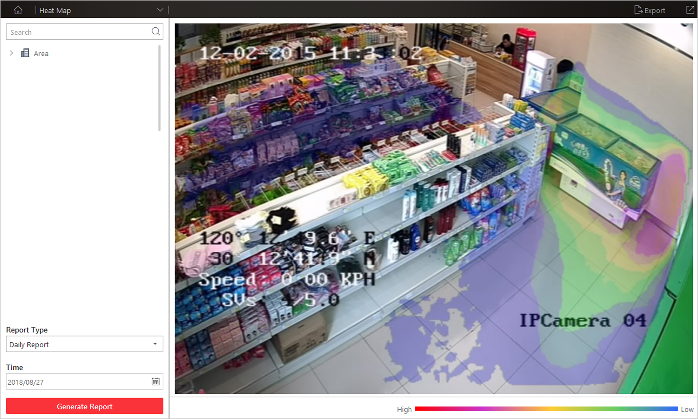
Figure 14-9 Heat Map Report
6. Optional: Click Export to save the heat map report in PDF format to a local PC.

14.4 Generate Temperature Report
For thermal cameras, you can generate a report to show the number of exceptions (temperature too high or too low) and maximum/minimum temperature of different thermometry points on different presets.
Steps
1. Click Temperature on My Dashboard to enter the temperature report page.
2. Select thermal camera(s) for statistics.
1) Click in the camera panel.
2) Select a current site or Remote Site from the drop-down site list to show its thermal cameras.
Note
Only thermal cameras will be displayed here.

3) Check the thermal camera(s) for statistics.
The cameras will be added to the camera list.
4) Click Close.
3. Select the preset(s) configured on the camera and the system will collect the data on the thermometry point in these presets.
Note
For configuring the thermometry point with temperature measurement rules, refer to the user manual of the thermal camera.

4. Select the report type as daily report, weekly report, monthly report, annual report, or customize the time interval for a report.
Daily Report
Daily report shows data on a daily basis. The system will calculate the temperature data detected in each hour of one day.
Weekly Report, Monthly Report, Annual Report
As compared to daily report, weekly report, monthly report, and annual report can be less time-consuming, since they are not to be submitted every day. The system will calculate the temperature data detected in each day of way week, in each day of one month, and in each month of one year.
Custom Time Interval
Users can customize the days in the report to analyze temperature data detected in each day of the custom time interval.
5. Set the time or time period in the Time field for statistics.
Note
For custom time interval report, you need to set the start time and end time to specify the time period.

6. Click Generate Report.
The temperature statistics of all the selected presets are displayed in the right panel.
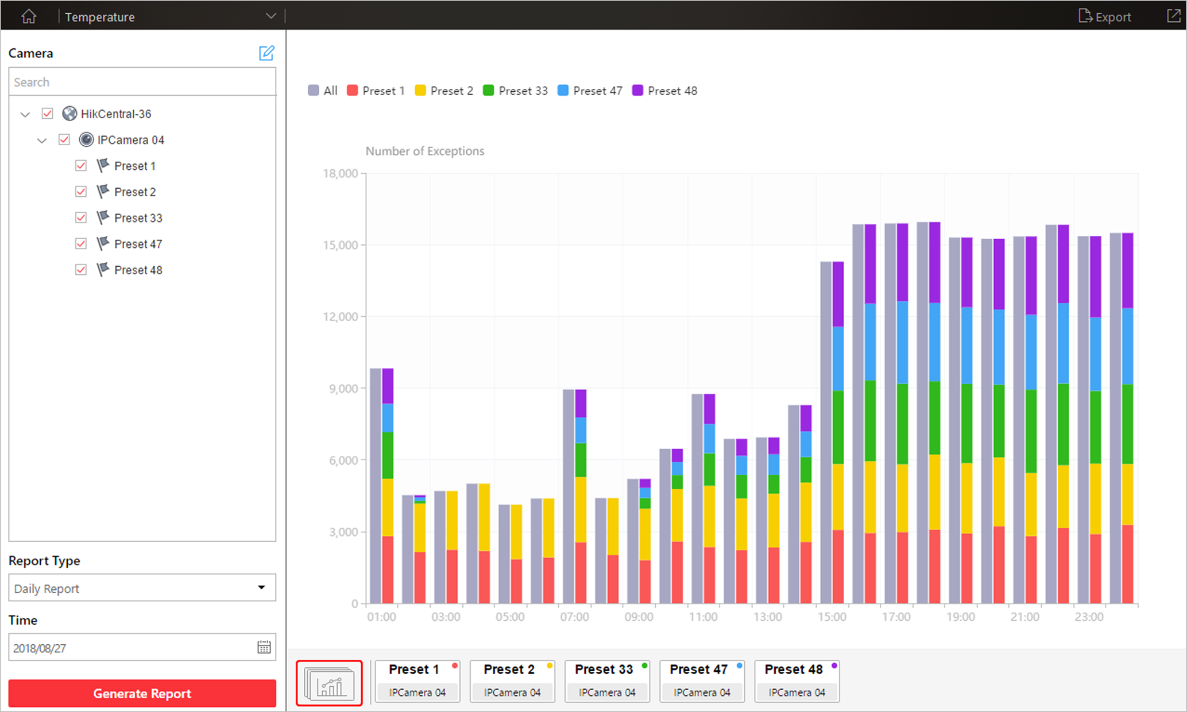
Figure 14-10 Temperature Report
7. Optional: Perform the following operation(s) after generating the temperature report.
Show/Hide Certain Data | Click the legend to show or hide the data of certain element, such as certain preset or thermometry point.
View Temperature Report of Single Preset | Click the preset icon on the page below to view the report in the single preset.
View Temperature Report of Single Thermometry Point | - Click the preset icon on the page below to view the report in the single preset.  - In the Item for Comparison field, select one thermometry point.  - In the Item for Comparison field, select the indicator you want to view in the chart.
High/Low Temperature
Shows the number of exceptions that the temperature at this thermometry point is higher or lower than the pre-defined temperature.
Max. Temperature
Shows the maximum temperature at this thermometry point during the set time period.
The temperature is displayed in line chart, indicating the trend.
Min. Temperature
Shows the minimum temperature at this thermometry point during the set time period.
The temperature is displayed in line chart, indicating the trend.

8. Optional: Export the report and save it in local PC.
1) Click Export.
The following panel will display with camera and preset selected and time configured according to the range you defined in step 2 to 5.
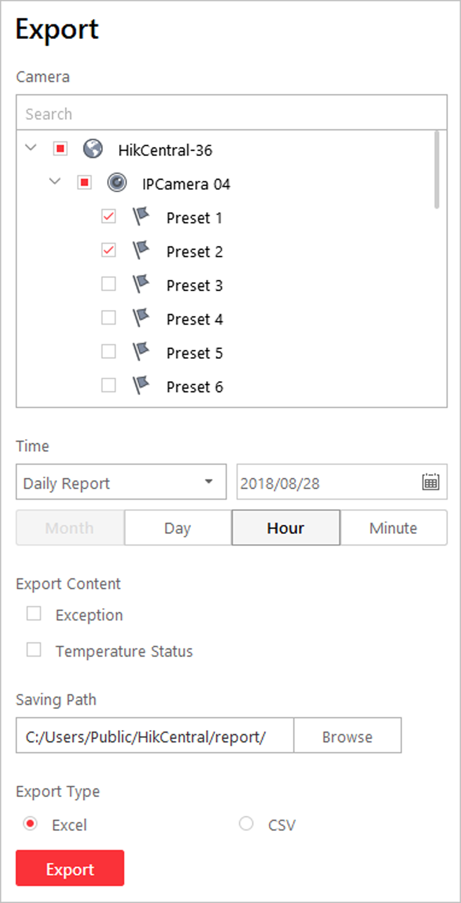
Figure 14-11 Export Temperature Report
2) (Optional) Select the camera and preset, and set the report type and report time if needed.
3) Select shorter time period to view more detailed data of each thermometry point.
Example
For example, if you select Daily Report, you can select Day, Hour, or Minute and it will export 1, 24, or 24×60 records respectively for each thermometry point.
Figure 14-12 Set Level of Detail for Data of Each Thermometry Point
4) Select the content to export.
Temperature Exception
Export the number of exceptions on temperature (temperature too high or too low) of each thermometry point.
Temperature Status
Export the maximum temperature and minimum temperature of each thermometry point.
5) Click Browse to set the saving path on local PC.
6) Set the format of the exported file as Excel or CSV.
7) Click Export and the task will be displayed in the Download Center,

14.5 Generate Vehicle Analysis Report
For ANPR cameras, you can generate a report to show the number of passing vehicles detected by the specified cameras during specified time period.
Steps
1. Click Vehicle Analysis on My Dashboard to enter the vehicle report page.
2. Select the camera(s) for statistics.
1) Click in the camera panel.
2) Select a current site or Remote Site from the drop-down site list to show its ANPR cameras which support this function.
Note
Only ANPR cameras will be displayed here.

3) Check the camera(s) for statistics.
The cameras will be added to the camera list.
4) Click Close.
3. Select camera(s) for the report in the camera list.
Note
Up to 20 ANPR cameras can be selected for statistics at the same time.

4. Select the report type as daily report, weekly report, monthly report, annual report, or customize the time interval for a report.
Daily Report
Daily report shows data on a daily basis. The system will calculate the number of vehicles in each hour of one day.
Weekly Report, Monthly Report, Annual Report
As compared to daily report, weekly report, monthly report, and annual report can be less time-consuming, since they are not to be submitted every day. The system will calculate the number of vehicles in each day of way week, in each day of one month, and in each month of one year.
Custom Time Interval
Users can customize the days in the report to analyze the number of vehicles in each day of the custom time interval.
5. Set the time or time period in the Time field for statistics.
Note
For custom time interval report, you need to set the start time and end time to specify the time period.

6. Click Generate Report.
The passing vehicles statistics detected by all the selected cameras are displayed in the right panel.
7. Optional: Export the report and save it in local PC.
1) Click Export.
The following panel will display with camera selected and time configured according to the range you defined in step 2 to 5.
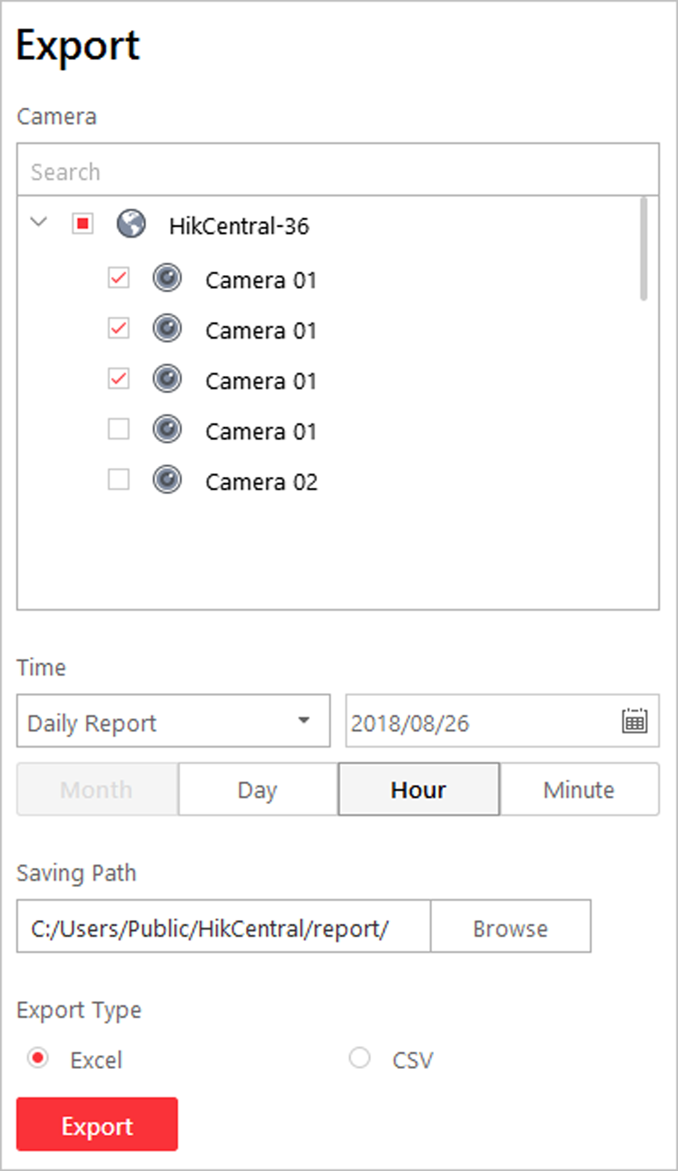
Figure 14-13 Export Vehicle Report
2) (Optional) Select the camera and set the report type and report time if needed.
3) Select shorter time period to view more detailed data of each camera.
Example
For example, if you select Daily Report, you can select Day, Hour, or Minute and it will export 1, 24, or 24×60 records respectively for each camera.
Figure 14-14 Set Level of Detail for Data of Each Camera
4) Click Browse to set the saving path on local PC.
5) Set the format of the exported file as Excel or CSV.
6) Click Export and the task will be displayed in the Download Center,

Chapter 15 Health Monitoring
Health monitoring can allow near-real-time information about the status of the VSM server and added resources (e.g. Recording Servers, Streaming Servers, connected cameras, encoding devices). It is critical to multiple aspects of operating the servers or devices and is especially important for maintenance. When a resource exception occurs, you can enter this module to check the resource status and see which resource is exceptional and view the exception details.
Click Health Monitoring on My Dashboard to enter the Health Monitoring page.
Status Overview
Click Status Overview tab on the left to enter the Status Overview page. You can view the overall status of the resources managed in the system, such as the cameras managed in the Central System, the access points, services. devices, etc.
Click the numbers and status types on the chart to enter the corresponding status page to view the details.
- For VSM server, you can view the incoming or outgoing streaming situation of the Streaming Gateway running on VSM server. If an exception or warning appears in CPU or memory, you can also view the CPU usage or memory usage. Click to view the used space and total space for picture storage.
- The Remote Site status is only available for the Central System with Remote Site Management module (based on the license you purchased).
Camera Status
You can click the camera name to view its status and basic information.
Click in the Operation column to go to the HikCentral Web Client to configure the camera parameters.
Contact the admin user to edit the exceptional configuration of camera's event or alarm via the Web Client if an icon appears near the camera name.
Access Point Status
Click in the Operation column to control the door status.
- Unlock: When the door is locked, unlock the door and it will be open. After the open duration (configured via the Web Client), the door will be closed and locked again automatically.
- Lock: When the door is unlocked, lock the door and it will be closed. The person who has the access permission can access the door with credentials.
- Remain Unlocked: The door will be unlocked (no matter closed or open). All the persons can access the door with no credentials required (free access).
- Remain Locked: The door will be closed and locked. No person can access the door even if he/she has the authorized credentials, except the super users.
UVSS Status
Click in the Operation column to go to the HikCentral Web Client to configure the UVSS parameters.
Remote Site Status
You can click or in the Operation column to switch the mode for accessing the resources on Remote Site between Automatically Judge mode and Proxy mode.
- Automatically Judge: The system will automatically judge the condition of network connection and then set the device access mode accordingly as accessing directly or accessing via Streaming Gateway and Management Service.
- Proxy: The system will access the device via Streaming Gateway and Management Service.
You can click Restore All Network Connections to restore the connection mode of all the added Remote Site's resources to Automatically Judge mode.
The Default Stream in the table refers to the default stream type for accessing the resources on the Remote Site. You can select the Remote Site(s) and click Switch Stream to switch the stream type. When starting live view of the Remote Site's resources in Central System, the Control Client will get this default stream to start live view.
Main Stream: Main stream provides higher quality video, higher resolution, but brings about higher bandwidth usage. Sub-Stream: Sub stream can save on bandwidth, but the video quality is lower than main stream.Smooth Stream: This stream type is usually used in low-bandwidth situation. After switching to smooth stream, the live view and playback will be smoother in slow network performance, but the image quality will be lower accordingly.Restore to Global Stream: If you select Restore to Global Stream, the stream type for accessing the selected Remote Site's resources will be restored to the global stream type you set in System → General.
Recording Server Status
Click the status in Recording Status column to view the recording status of the channels configured to store the video files in this Recording Server.
Click the status in Hardware Status or HDD Status column to view the hardware status and HDD exception details if the status is exceptional.
Streaming Server Status
You can view the streams via each added Streaming Server (including incoming streams and outgoing streams), and view the hardware status such as network status, CPU usage, and RAM usage.
Encoding Device Status
Click the status in Recording Status column to view the recording status of the channels configured to store the video files in this Recording Server.
Click in the Operation column to go to the HikCentral Web Client to configure the encoding device parameters.
Click Switch Device Access Mode to switch the access mode for the Control Client to access the devices.
- Restore Default: Restore the device access mode as configured in the System → Device Access Mode on the Web Client.
- Automatically Judge: Judge the device access mode according to the current network.
- Directly Access: Access the device directly, not via HikCentral Streaming Service.
Note
When the encoding device is in the same LAN with the VSM server, the Direct Access mode is not available.

- Proxy: Access the device via HikCentral Streaming Gateway and HikCentral Management Service. It is less effective and less efficient than accessing directly.
The Default Stream in the table refers to the default stream type for accessing the resources of the encoding device. You can select the encoding device(s) and click Switch Stream to switch the stream type. When starting live view, the Control Client will get this default stream to start live view of the encoding device's resources.
Main Stream: Main stream provides higher quality video, higher resolution, but brings about higher bandwidth usage. Sub-Stream: Sub stream can save on bandwidth, but the video quality is lower than main stream.Smooth Stream: This stream type is usually used in low-bandwidth situation. After switching to smooth stream, the live view and playback will be smoother in slow network performance, but the image quality will be lower accordingly.Restore to Global Stream: If you select Restore to Global Stream, the stream type for accessing the selected encoding device(s) will be restored to the global stream type you set in System → General.
Access Control Device Status
You can view the network status and battery status of the added access control devices.
If the device is turnstile, you can view the status of master lane controller, slave lane controller, and component.
Security Control Panel Status
You can view the managed devices' network status and battery status.
Click in the Operation column to go to the HikCentral Web Client to configure the security control panel parameters.
Decoding Device Status
You can view the network status of the added decoding devices.

Chapter 16 Log Search
Two types of log files are provided: server logs and device logs. The server logs refer to the logs files stored in the VSM server on the Current Site and the Remote Site; the device logs refer to the log files stored on the connected devices, such as encoding device and security control device. You can search the log files, view the log details and backup the log files.

16.1 Search Server Logs for Current Site
You can search the server logs for the current site, which contains error logs, warning logs and information logs. The server logs allow you to view the historical logs for the selected user or service, such as admin user, VSM service, and so on. You can search these log files and view their details.
Perform this task when you need to search the server logs for the current site.
Steps
1. Click Audit Trail on the control panel to enter the Audit Trail page.
2. Select Server Logs on the left navigation bar.
3. Select the current site.
4. Select the major log type and the corresponding minor log type as you desired.
Note
The error logs refer to the log files containing failed or error operations; the warning logs record the license expired event, and the information logs refer to other general logs which record successful or unknown operation results.

5. click and select the user or service as the source which you want to search the logs for.
Note
You can also enter the key words to filter the source.

6. Enter the resource name related to the log.
7. Select the time period.
Note
You can select Custom Time Interval to specify the start time and end time for the search.

8. Click Search.
The matched log files with details are listed on the page.
Note
Please narrow the search condition if there are too many log files.

16.2 Search Server Logs for Remote Site
You can search the server logs for the Remote Site, which contains error logs, warning logs and information logs. The server logs allow you to view the historical logs for the selected user or service, such as admin user, VSM service, and so on. You can search these log files and view their details.
Perform this task when you need to search the server logs for the remote site.
.
Steps
1. Click Audit Trail on the control panel to enter the Audit Trail page.
2. Select Server Logs on the left navigation bar.
3. Select a Remote Site for search.
4. Select the major log type and the corresponding minor log type as you desired.
Note
- The error logs refer to the log files containing failed or error operations; the warning logs record the license expired event, and the information logs refer to other general logs which record successful or unknown operation results.
- For the Remote Site with old version, only information type can be selected.

5. click and select the user or service as the source which you want to search the logs for.
Note
You can also enter the key words to filter the source.

6. Enter the resource name related to the log.
7. Select the time period.
Note
You can select Custom Time Interval to specify the start time and end time for the search.

8. Click Search.
The matched log files with details are listed on the page.
Note
Please narrow the search condition if there are too many log files.

16.3 Search Device Logs
You can search the device logs, which refer to the log files of the connected devices such as encoding devices and security control devices, and stored on the local devices.
Perform this task when you need to search the device logs.
Steps
1. Click Audit Trail on the control panel to enter the Audit Trail page.
2. Select Device Logs on the left navigation bar.
3. Select the device type and device.
4. Select the major log type and the corresponding minor log type as you desired.
5. Select the time period.
Note
You can select Custom Time Interval to specify the start time and end time for the search.

6. Click Search.
The matched log files with details are listed on the page.
Note
Please narrow the search condition if there are too many log files.

16.4 Back Up Logs
After searching for log files, you can export the matched log files to the local storage for backup.
Perform this task when you need to export the log files for backup.
Steps
1. Click Audit Trail on the control panel to enter the Audit Trail page.
2. Search for log files.
Note
For details about log search, refer to Search Server Logs for Current Site, Search Server Logs for Remote Site, or Search Device Logs.

3. Move the curse over Export in the upper right corner and select Excel or CSV for saving log file.
4. Select a local saving path.
5. Click Save to export the matched log files in CSV format.

Chapter 17 Tools
The Control Client provides multiple tools: Smart Wall, VSPlayer, Broadcast, Alarm Output, and Two-Way Audio.
Smart Wall
Play the live view or playback on smart wall. See Manage Smart Wall for details.
VSPlayer
Run the player and play the video files stored on the local PC.
Broadcast
Distribute audio content to the added device if the device has an audio output. See Broadcast to Connected Devices for details.
Alarm Output
Enable alarm output to control the connected external devices by events or alarms, or manually by client. See Control Alarm Output for details.
Two-Way Audio
Enable the voice talk between the Control Client and devices, See Perform Two-Way Audio for details.

17.1 Play Video via VSPlayer
You can run the VSPlayer software and play the video files stored in the local PC via the software.
Perform this task when you need to play video via VSPlayer.
Steps
1. Click VSPlayer on the control panel to run the VSPlayer.
The available video files are listed on the playlist.
2. Double-click the video to play.
3. Optional: Click in the upper-right corner of the VSPlayer page and select User Manual to view the VSPlayer's user manual for more detailed operations.

17.2 Broadcast to Connected Devices
Perform the broadcast function to distribute audio content to the added device if the device has an audio output.
Note
- Your PC should have available microphone for broadcasting audio to the device.
- If the client is performing two-way audio with the device's camera, you cannot start broadcast with the device, and vice versa.
- The Cloud P2P device supports broadcast if it enables DDNS.

On the control panel, select Tool → Broadcast, select the device(s) to broadcast to and click Start Broadcast one by one, then you can broadcast audio to the selected device(s) through the microphone. Or you can click Open All to start broadcasting to all devices.
For stopping broadcasting, select Tool → Broadcast, select the device(s) that you want to cancel broadcast and click Stop Broadcast one by one. Or you can click Close All to stop broadcasting to all devices.

17.3 Perform Two-Way Audio
Two-way audio function enables the voice talk between the Control Client and devices. You can get and play not only the live video but also the real-time audio from the device in the Control Client, and the device can also get and play the real-time audio from the Control Client.
Perform this task when you need to perform the two-way audio function.
Note
This function is not supported by the devices added in remote site.

Steps
1. Click Two-Way Audio on the control panel to open the two-way audio window.
2. Click Select Camera to open the selecting camera window.
3. Select a camera and click OK.
4. Click Start to start the two-way audio.
5. Optional: Click to adjust the microphone volume, and click to adjust the speaker volume.

17.4 Control Alarm Output
An alarm output is an output on the device that can be connected to an peripheral device, such as a light, a barrier, etc. Device can send signal to control the connected external device, e.g., turn on light, open the barrier gate. The connected peripheral device can be controlled automatically by events or alarms, or manually by client, and here we introduce the process for controlling alarm output remotely by client.
On the control panel, select Tool → Alarm Output Control, select the alarm output(s) to control and click Open one by one, then the selected alarm output(s) are enabled. Or you can click Open All to enable all alarm outputs.
For disabling alarm output, select Tool → Alarm Output Control, select the alarm output(s) that you want to disable and click Close one by one. Or you can click Close All to disable all alarm outputs.

Chapter 18 System Settings
The System page contains basic settings and application settings. Use Basic Settings to configure general parameters, image parameters, file saving paths, and keyboard and joystick settings. Use Application Settings to configure alarm sounds, and the icons shown on the Live View toolbar and Playback toolbar.

18.1 Set General Parameters
You can set the frequently-used parameters, including the global stream, picture format, etc.
Steps
1. Click System on the control panel to enter the System page.
2. Click General to enter the General Settings page.
3. Configure the general parameters.
Global Stream
Select the default stream type for live view for global usage. If the network is in good condition, select main stream or sub-stream. If the network is in poor condition, select smooth stream.
If the device doesn't support smooth stream, it will use sub-stream. If the device doesn't support sub-stream, it will use main stream.
If you don't want to adopt global stream settings for certain encoding device, you can enter Health Monitoring → Encoding Device and set its stream type. The Control Client will get this stream type to start live view of the encoding device's resources. For details, refer to Health Monitoring.
Threshold for Main/Sub-Stream
If a window's proportion of the displaying area is larger than the configured threshold, the stream type will be main stream. If the proportion is smaller than the threshold, it will be switched to sub-stream.
For example, if you set the threshold as ¼, when the window division turns to 5-window, the camera's stream type will be switched from main-stream to sub-stream.
Note
This parameter is only available when the Global Stream is set as Main Stream.

Network Timeout
The default waiting time for the Control Client. The operations will be regarded as failure if no response within the configured time.
The minimum default waiting time of the interactions between the Control Client and VSM server is 30s, the minimum time between VSM server and devices is 5s, and the minimum time between the Control Client and devices is 5s.
Picture Format
Set the file format for the captured pictures during live view or playback.
Maximum Mode
Select Maximize or Full Screen as the maximum mode. For selecting Maximize, the client will be maximized and the task bar will display. For selecting Full Screen, the client will be displayed in full-screen mode.
Auto-login
The system will remember the user name and password and log in to the Control Client automatically.
Resume Last Interface
Restore the interface last opened when you run the client next time.
Display Window No.
Display the No. of each window in Monitoring module.

4. Click Save.

18.2 Set Image Parameters
You can set image parameters, including view scale, video caching, etc.
Perform this task when you need to set image parameters.
Steps
1. Click System on the control panel to enter the System page.
2. Click Image to enter the Image Parameters page.
3. Configure the image parameters.
View Scale
The image display mode in each display window in live view or playback.
Window Scale
The scale of the video in live view or playback. You can set it set as 4:3 or 16:9.
Video Caching
Larger frame caching will result in better video performance. It is determined based on network performance, computer performance, and bit rate.
Continuous Decoding
Decode continuously when switching window division between one window and multiple windows.
Enable Highlight
Enable this function to mark the detected objects with green rectangles in live view and playback.
VCA Rule
When On, displays the VCA rule in the live view and playback.
GPU Hardware Decoding
When On, enables the GPU decoding for live view and playback to save CPU resources.
Note
- Your PC must support GPU decoding.
- After enabling GPU decoding, restart live view and playback for GPU decoding to take effect.
- If the client shows a blurred screen after enabling GPU decoding, disable GPU decoding.
- If GPU decoding is enabled, Overlay Transaction Information, fisheye dewarping in live view and playback are not supported.

Overlay Transaction Information
When On, displays the transaction information on the live view and playback image.
Overlay Temperature Information
When On, displays the temperature information on the live view and playback image.
4. Click Save.

18.3 Set File Saving Path
You can set the saving paths for the files you downloaded to your PC (manual recorded or downloaded video files, captured pictures, and package files).
Perform this task when you need to set file saving path.
Steps
1. Click System on the control panel to enter the System page.
2. Click Basic Settings → File to enter the File Saving Path Settings page.
3. Set the local saving path for the files.
Save Video to
The video files refer to the video files recorded manually during live view, the clipped video during playback, the downloaded video files during playback and the video files downloaded from the Download Center page.
Save Picture to
The pictures refer to the captured pictures during live view and playback.
Save Package to
The package files refer to the client installation packages.
4. Click Save.

18.4 Set Keyboard and Joystick Parameters
You can set shortcuts for the following hardware for quick and convenient access to the commonly used actions: DS-1003KI and DS-1004KI keyboard, PC keyboard, USB joystick, and USB keyboard.
Perform this task when you need to set keyboard and joystick parameters.
Steps
Note
For detailed operations of connecting the DS-1003KI, DS-1004KI, and DS-1005KI keyboard to a PC that runs Control Client, refer to the user manual of corresponding keyboard.

1. Click System on the control panel to enter the System page.
2. Click Keyboard and Joystick to enter the Keyboard and Joystick Parameters page.
3. Set parameters for different kinds of keyboard and joystick.
- For DS-1003KI and DS-1004KI keyboards, select the serial port from the drop-down list.
- For PC keyboards, USB keyboards, and USB joysticks, select a function, and double-click the item field to select the compound keys operation or number from the drop-down list to set it as the shortcuts for the function.
4. Click Save.

18.5 Set Alarm Sound
When an alarm, such as a motion detection alarm, video exception alarm, etc., is triggered, you can set the client to give an audible warning, and you can configure the sound of the audible warning for different priority levels.
Perform this task when you need to set alarm sounds.
Steps
1. Click System on the control panel to enter the System page.
2. Click Alarm Center to enter the Alarm Sound Settings page.
3. Select the alarm sound type.
- If you select Voice Engine, the PC will play the voice text configured on the Web Client when the alarm is triggered.
Note
The Voice Engine function should be supported by the operating system of your PC.

- If you select Local Audio Files, follow steps 4 and 5.
4. Click Browse and select audio files from the local PC for different alarm levels.
Note
- For configuring the priority level, refer to the User Manual of HikCentral Web Client.
- The format of the audio file can only be in WAV format.

5. Click 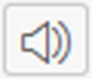 to test the audio file.
6. Click Save.

