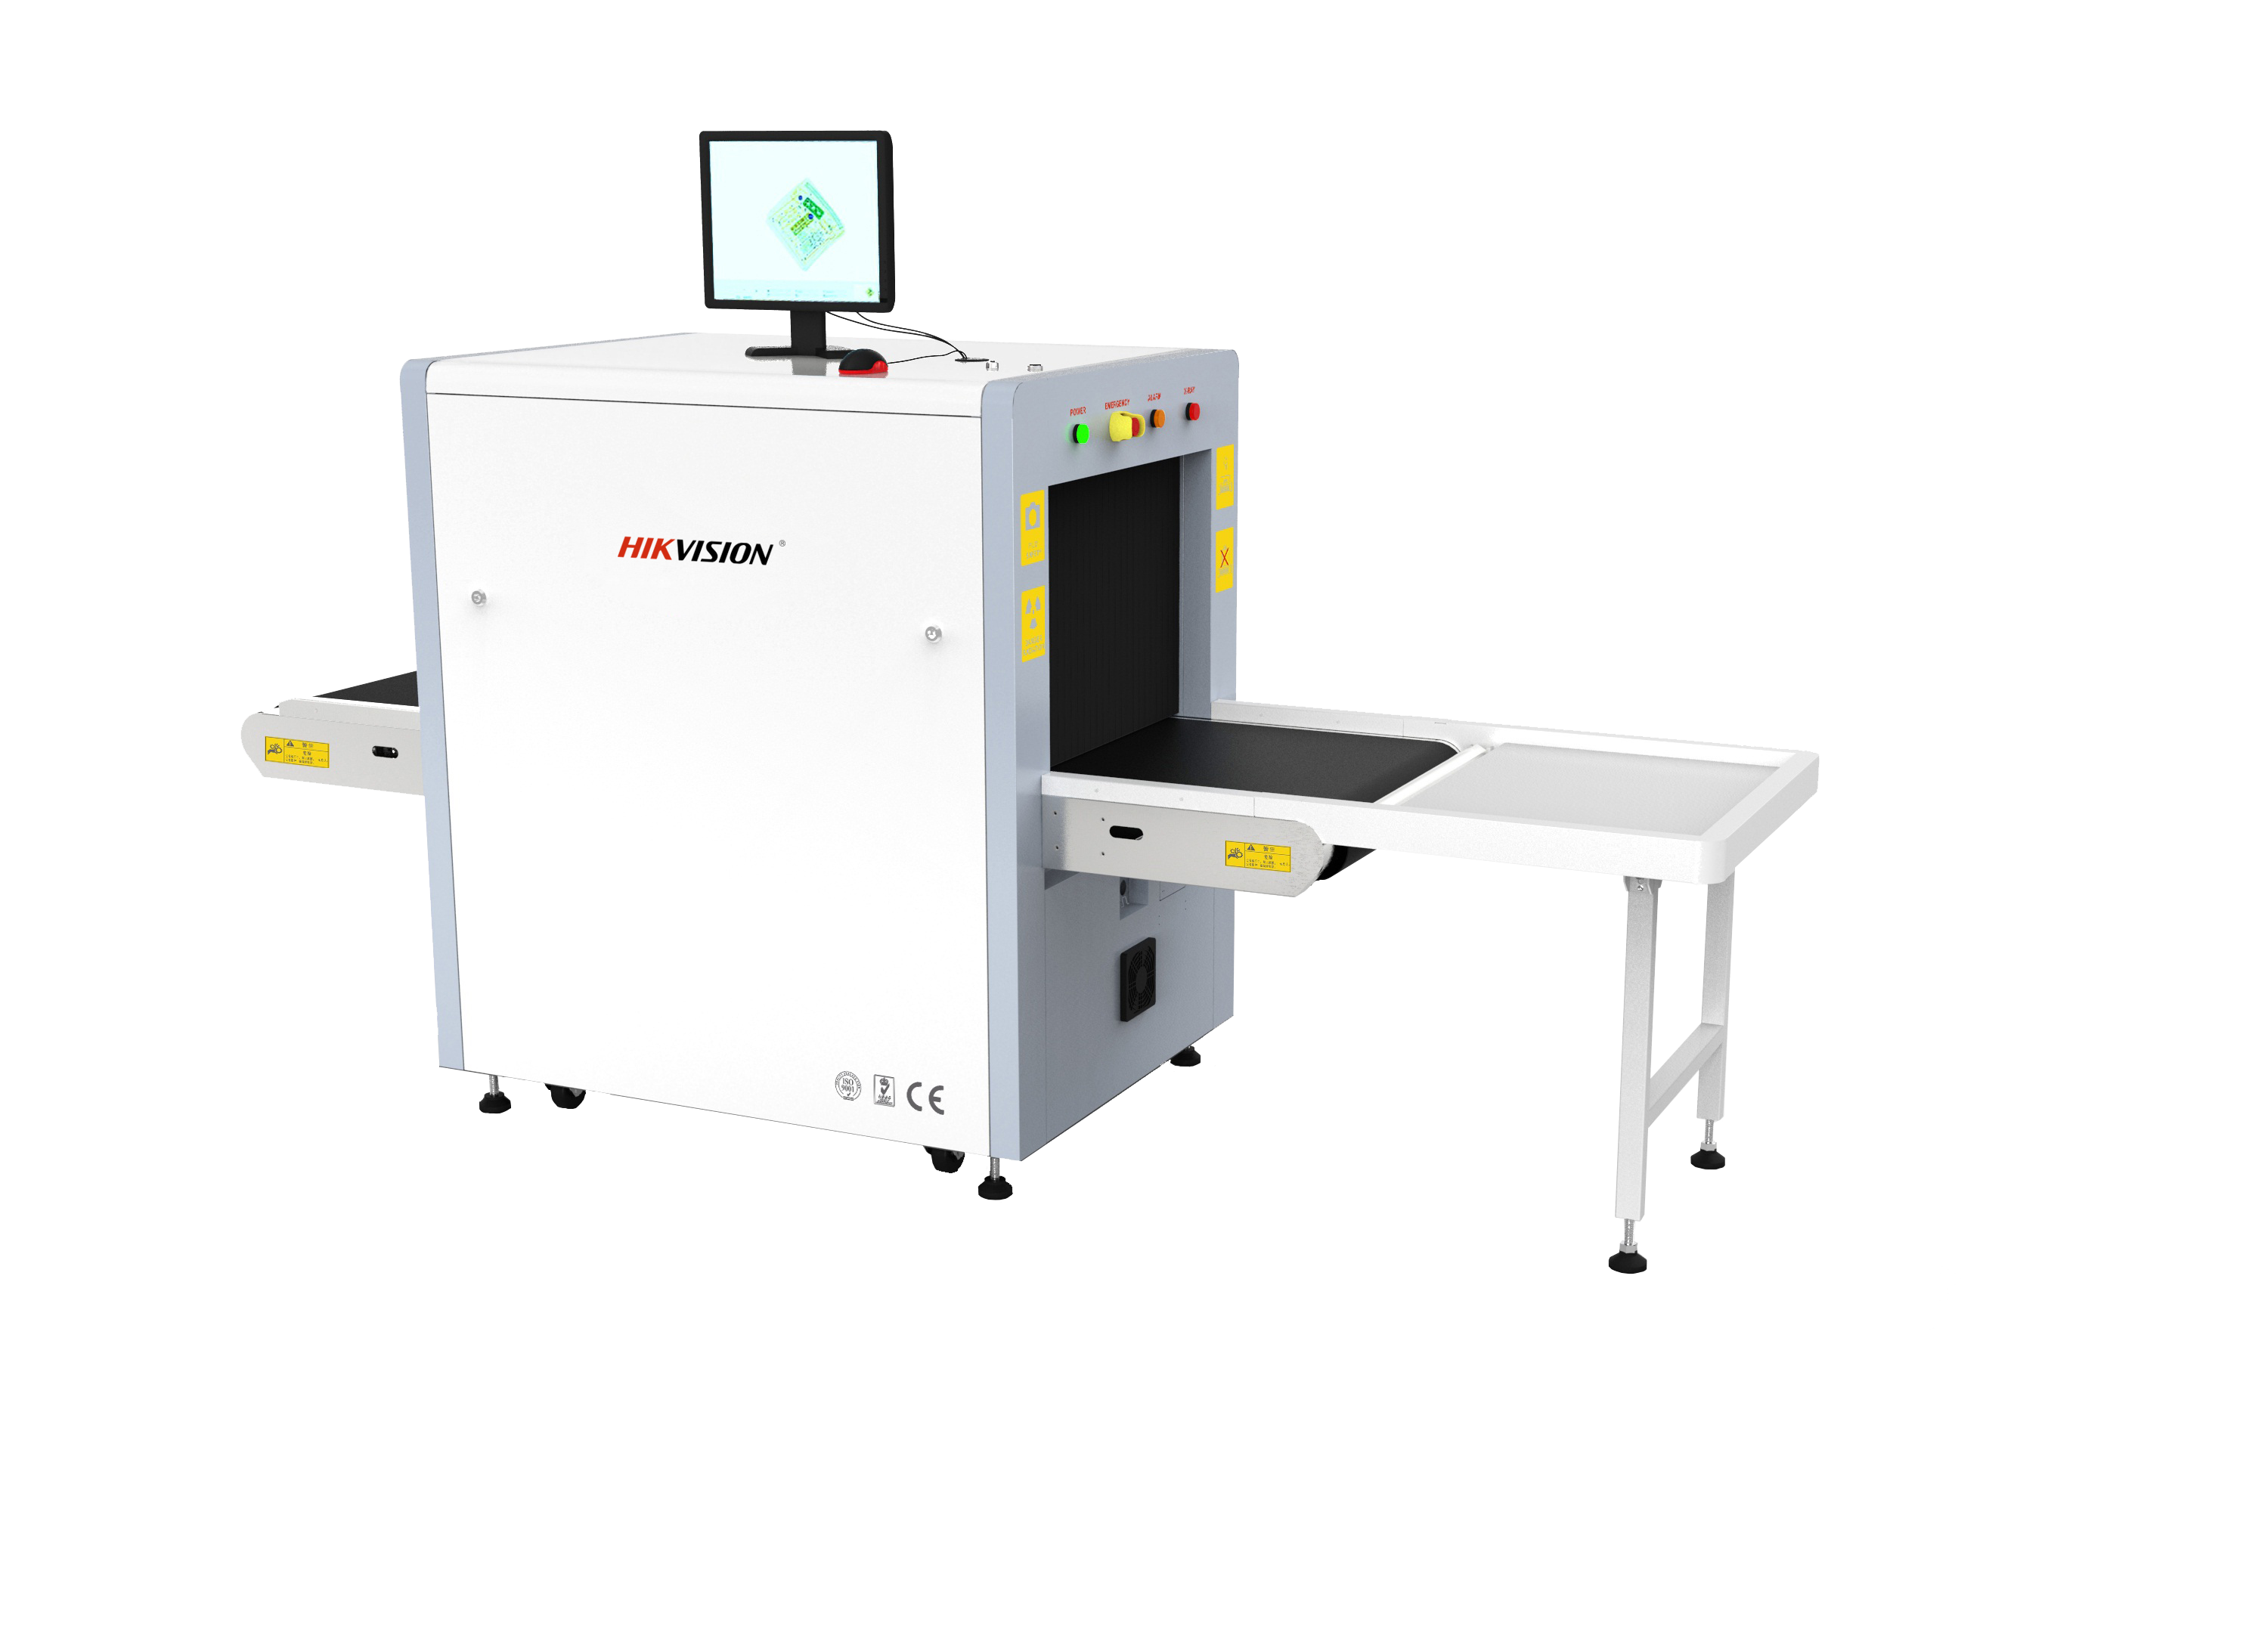
NP-SC6550
X-Ray Security Inspection System

Key Features
- High performance with HD image, strong penetration, precise recognition
- Adopts embedded Linux operating system with multi-core ARM
- Energy saving and environment protection with low power consumption
- Supports real-time monitoring
- Supports multiple image processing mode
- Supports POST (power on self-test)
- 64X zoom in
- One-touch power off
- Energy-saving working mode for conveyor available
- Shock-proof design
- User friendly interface for easy operation

System Functions
X-ray Image processing functions:
Color/Black &White, local enhancement, high penetration, low penetration, super enhancement, inverse color, light increase, light reduce, grey scale scan, image zoom in, edge enhancement.
System functions:
Power on self-diagnosis, multi levels user management, image management, TIP management, curve diagnosis, equipment information query, Multi-format image export, image mirroring, 1-16 times stepless zoom in, operator training, precise positioning of baggage images, clear channel reminder, one key calibration,one-key shutdown

NP-SC6550 X-Ray security inspection system is an advanced security detection system designed for briefcases, postal bags, express mails, hand held parcels, and small packages checking with a world leading x-ray screening and single-energy image processing technology.
With the popular tunnel size of 659mm (W) x 504 (H), compact and movable design, NP-SC6550 is an ideal economical security inspection solution for hotels, government agencies, transportation hubs, logistics industry, courts, prosecutors, prisons, embassies, factories, schools, hospitals, stadiums, exhibition halls, entertainment venues, etc.

Specifications

Model | NP-SC6550
Tunnel size | 659.4mm Wx504 mm H
Conveyor speed | 0.22 m/s
Conveyor height | 700mm
Max. load | 150 kg (330.69 lb)
Penetration (steel) | Standard 8 mm, 11mm by customize
Wire resolution | 40AWG
Spatial resolution | Vertical: 1.0 mm  Horizontal: 1.0 mm
X-ray dose per inspection | < 3.5 μSv
X-ray leakage | < 1 μSv/h
X-ray generator | Anode Voltage: 80 kV, 100% Oil Cooling,  Single generator, vertical beam direction.
Images colors | B/W, Colors
Images storage | 10000 images
Film safety | ISO1600
Working temperature | 5 °C to 40 ° C (41 °F to 104 °F)
Working humidity | 0% to 90%
Operation system | Linux
Power supply | AC 220 V (+ 10% to -15%), 50 Hz (±3 Hz)
Power consumption | 0.8 kw
Dimension (L x W x H) without table | 2195mm x 902 mm x 1362.5 mm (86.42" x 35.51" x 53.64")
Weight | 420 kg (925.94lb)
Extended table | 614mm

Accessories
Extended table | 614mm x1 in exit（Included）
LCD monitor | 17” LCD Color Monitor x1 included
Dedicated Key board &mouse | Standard included
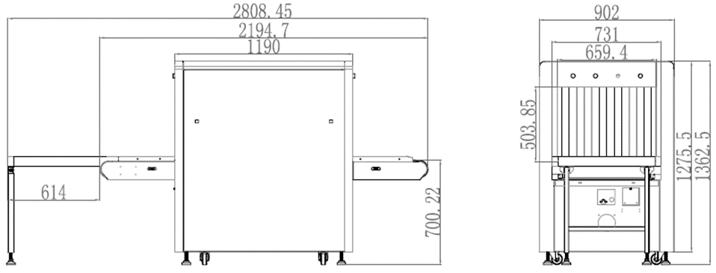
Dimension

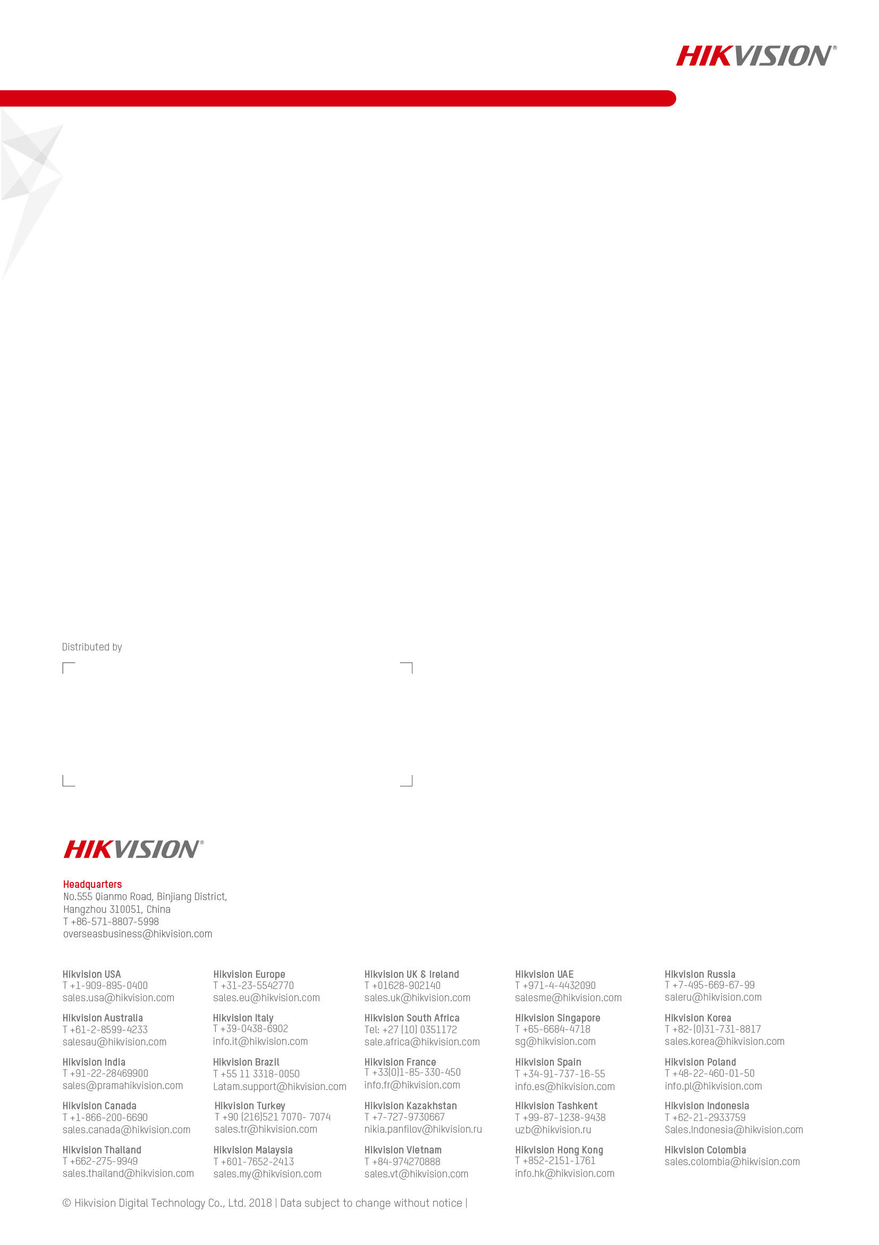
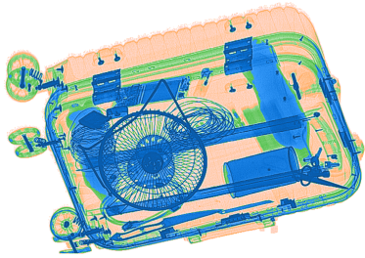
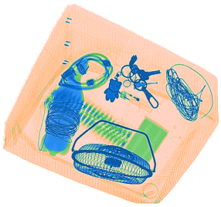
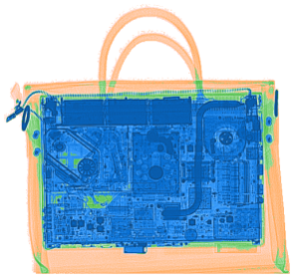
202012

Scanned Images
Available Model
NP-SC6550

