DS-2CD4A24FWD-IZSUHK
2MP Anti-Corrosion Low Light Smart Camera
 |  | 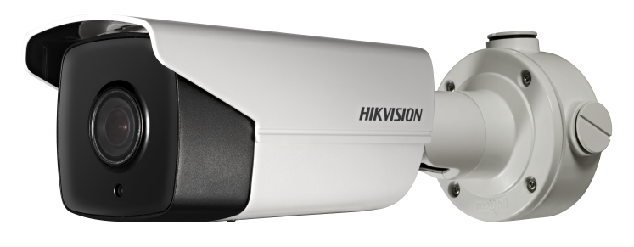
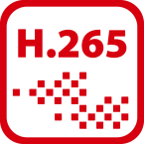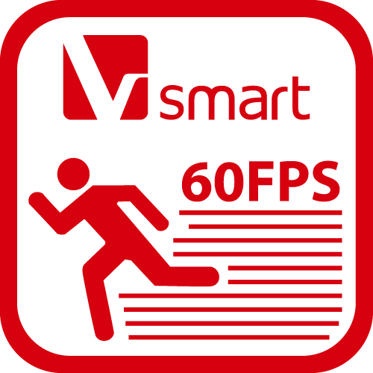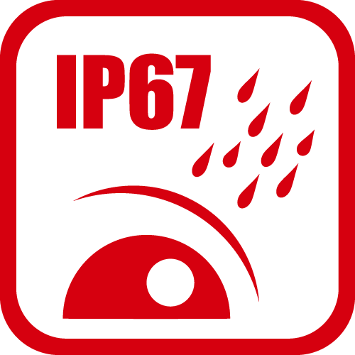

- 1/2.8"Progressive Scan CMOS  - 1920 × 1080 @ 60fps  - Color: 0.005 Lux @ (F1.2, AGC ON), 0.008 Lux @ (F1.5, AGC ON)  - H.265, H.265+, H.264, H.264+  - 120dB WDR  - 3D DNR  - IP67,IK10,NEMA 4X | - IR light range up to 200 m  - P-Iris  - 6 behavior analyses  - Built-in microSD/SDHC/SDXC card slot, up to 128 GB

Specifications
Camera
Image Sensor | 1/2.8" Progressive Scan CMOS
Min. Illumination | Color: 0.005 lux @ (F1.2, AGC ON), 0.008 lux @ (F1.5, AGC ON)  B/W: 0.0005 lux @ (F1.2, AGC ON), 0.0008 lux @ (F1.5, AGC ON), 0 lux with IR
Shutter Speed | 1 s to 1/100,000 s
Slow Shutter | Yes
Day & Night | IR Cut Filter
Digital Noise Reduction | 3D DNR
WDR | 120 dB
Angle Adjustment | Pan: 0 to 360°, tilt: 0 to 100°, rotation: 0 to 360°
Lens
Focal length | 4.7 to 94 mm
Aperture | F1.5 to F3.0
FOV | Horizontal FOV: 55° to 3°, vertical FOV: 31.6° to 1.8°, diagonal FOV: 62° to 3.6°
P-Iris | Yes
Lens Mount | Integrated
IR
IR Range | Up to 200 m
Wavelength | 850 nm
Compression Standard
Video Compression | Main stream: H.265/H.264  Sub-stream: H.265/H.264/MJPEG  Third stream: H.265/H.264
H.264 Type | Baseline Profile/Main Profile/High Profile
H.264+ | Main stream supports
H.265 Type | Main Profile
H.265+ | Main stream supports
Video Bit Rate | 32 Kbps to 16 Mbps
SVC | H.264 and H.265 encoding
Smart Feature-set
Perimeter Protection | Line crossing detection, intrusion detection, region entrance detection, region exiting detection, unattended baggage detection, object removal detection
Exception Detection | Scene change detection, defocus detection, audio detection
Statistics | Counting
Face Detection | Yes
Region of Interest | 4 fixed regions for main stream, sub stream, third stream and dynamic tracking
Image
Max. Resolution | 1920 × 1080
Main Stream | 50Hz: 50fps (1920 × 1080, 1280 × 960, 1280 × 720)  60Hz: 60fps (1920 × 1080, 1280 × 960, 1280 × 720)
Sub Stream | 50Hz: 25fps (1920 × 1080, 1280 × 960, 1280 × 720, 704 × 576, 640 × 480, 352 × 288, 320 × 240)  60Hz: 30fps (1920 × 1080, 1280 × 960, 1280 × 720, 704 × 480, 640 × 480, 352 × 240, 320 × 240)
Third Stream | 50Hz: 25fps (704 × 576, 640 × 480, 352 × 288, 320 × 240)  60Hz: 30fps (704 × 480, 640 × 480, 352 × 240, 320 × 240)
Image Enhancement | BLC, HLC, 3D DNR, Defog, EIS
Image Settings | Rotate mode, saturation, brightness, contrast, sharpness, AGC, and white balance are adjustable by client software or web browser
Target Cropping | Yes
Day/Night Switch | Day/Night/Auto/Schedule/Triggered by Alarm In
Picture Overlay | LOGO picture can be overlaid on video with 128 × 128 24 bit bmp format
Network
Network Storage | microSD/SDHC/SDXC card (128 GB), local storage and NAS (NFS, SMB/CIFS), ANR
Alarm Trigger | Motion detection, video tampering alarm, network disconnected, IP address conflict, HDD full, HDD error
Protocols | TCP/IP, ICMP, HTTP, HTTPS, FTP, DHCP, DNS, DDNS, RTP, RTSP, RTCP, PPPoE, NTP, UPnP, SMTP, SNMP, IGMP, 802.1X, QoS, IPv6, UDP, Bonjour
General Function | One-key reset, anti-flicker, three streams, heartbeat, mirror. password protection, privacy mask, watermark, IP address filter
Firmware Version | 5.5.83
API | ONVIF (PROFILE S, PROFILE G), ISAPI
Simultaneous Live View | Up to 20 channels
User/Host | Up to 32 users. 3 user levels: administrator, operator and user
Client | iVMS-4200, Hik-Connect
Web Browser | IE 8+, Chrome 41.0-44, Mozilla Firefox 30.0-51, Safari 8.0+
Interface
Audio | 1 input (line in/mic in, 3.5 mm), 1 output (3.5 mm), mono sound
Communication Interface | 1 RJ45 10M/100M Ethernet port,  1 RS-485 interface (with –S model)
Alarm | 1 input, 1 output (max. 24 VDC, 1A or 110 VAC, 500 mA)
Video Output | 1Vp-p composite output (75 Ω/BNC)
On-board storage | Built-in micro SD/SDHC/SDXC slot, up to 128 GB
Reset Button | Yes
Audio
Environment Noise Filtering | Yes
Audio Sampling Rate | 8 kHz/16 kHz/32 kHz/44.1 kHz/48 kHz
Audio Compression | G.711/G.722.1/G.726/MP2L2/PCM
Audio Bit Rate | 64 Kbps(G.711)/16 Kbps(G.722.1)/16 Kbps(G.726)/32-192 Kbps(MP2L2)
General
Operating Conditions | -30 °C to 60 °C (-22 °F to 140 °F), -H: -40 °C to 60 °C (-40 °F to 140 °F)  Humidity 95% or less (non-condensing)
Power Supply | 12 VDC ± 20%, three-core terminal block  PoE (802.3at, class 3)
Power Consumption and Current | 12 VDC, 1.3 A, max. 15 W; PoE (802.3at, 42.5 V to 57 V), 0.4 A to 0.2 A, max. 15 W
Protection Level | IP67,IK10,NEMA 4X
Material | Metal
Dimensions | Camera: 348.4 × 114.2 ×111.7 mm (13.7" × 4.5" × 4.4")  With package: 386 × 156 × 155 mm (15.2" × 6.1" × 6.1")
Weight | Camera: 1500 g (3.3 lb.)  With package: 2100 g (4.6 lb.)

Available Model
DS-2CD4A24FWD-IZSUHK (4.7-94 mm)

Dimension
Unit: mm(inch)
Accessories
DS-1275ZJ-SUS  Vertical Pole Mount | DS-1276ZJ-SUS  Corner Mount

05058020181026

